Subscription Philips Sample Use Case:

1. Create OR Search Patient:

Taking Patient ID reference from registered HL7 V2 (via ADT^A01, A04)

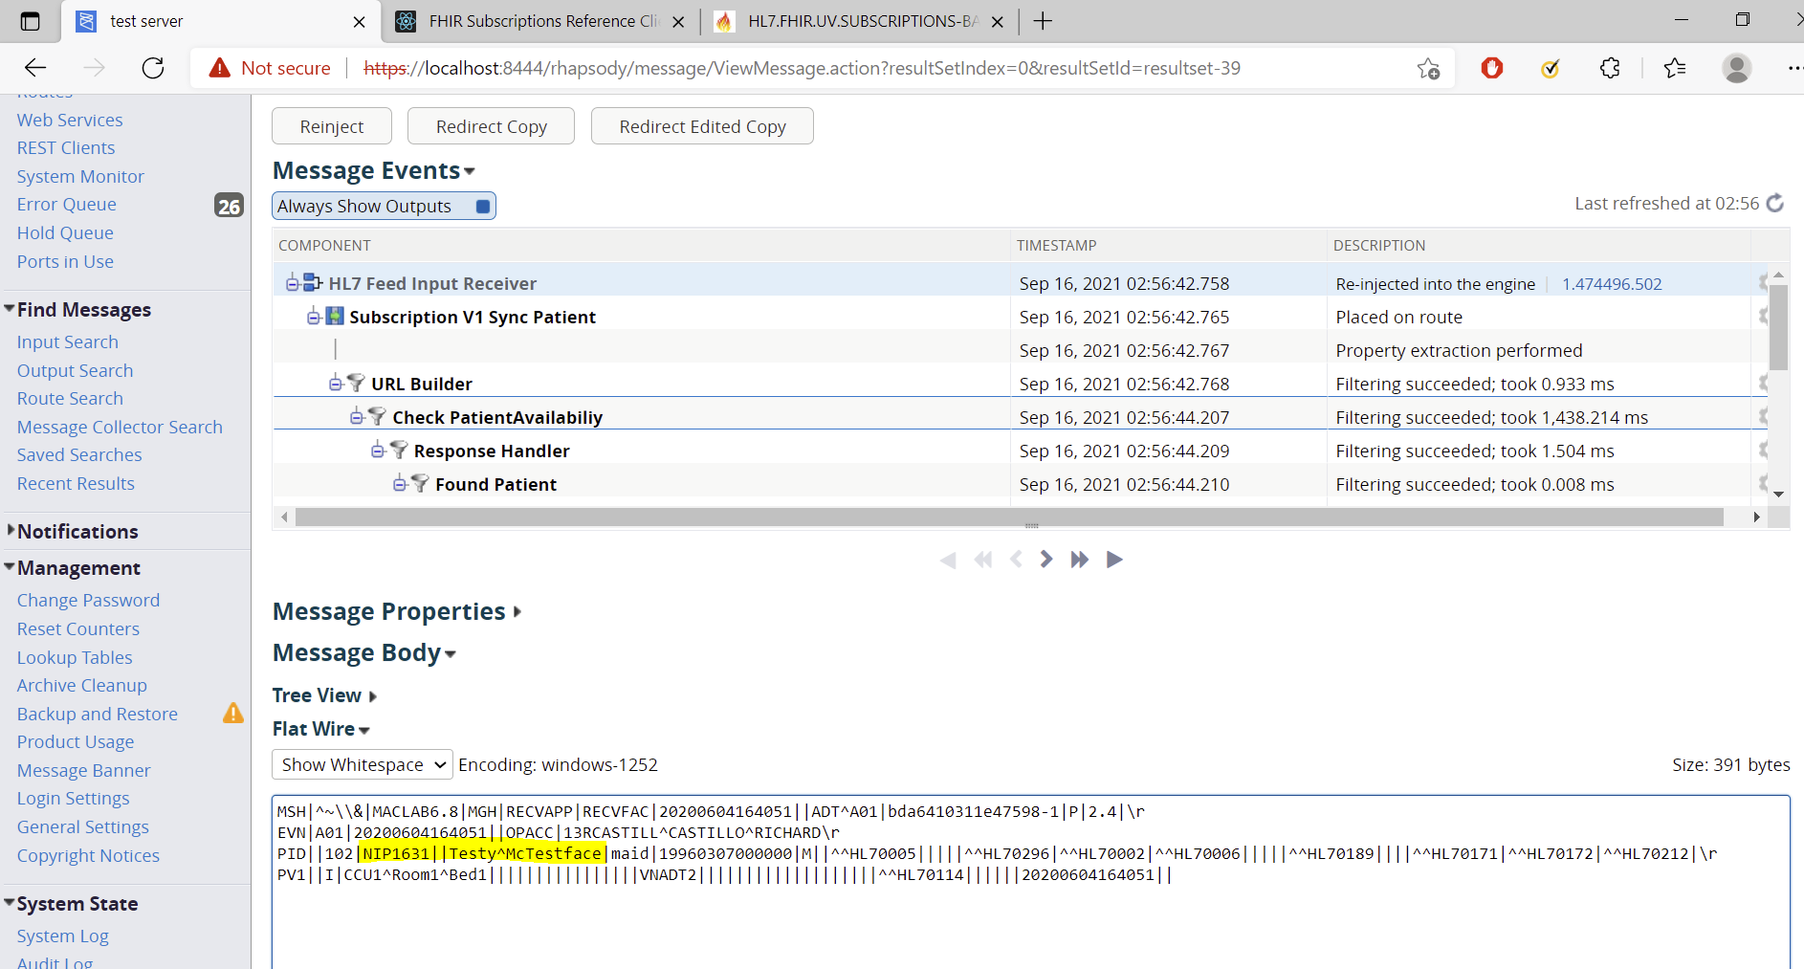

Received Response from Server:

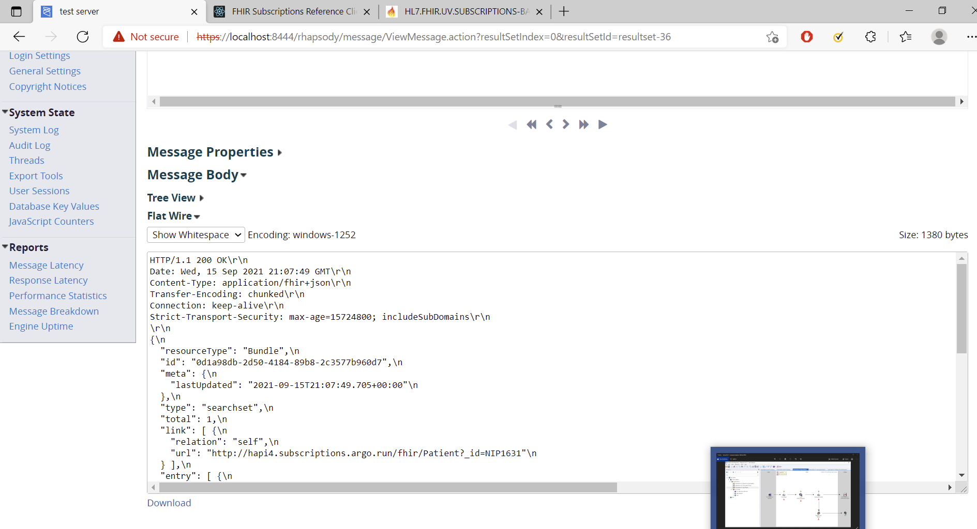

Able to Perform Call for SubscriptionTopic

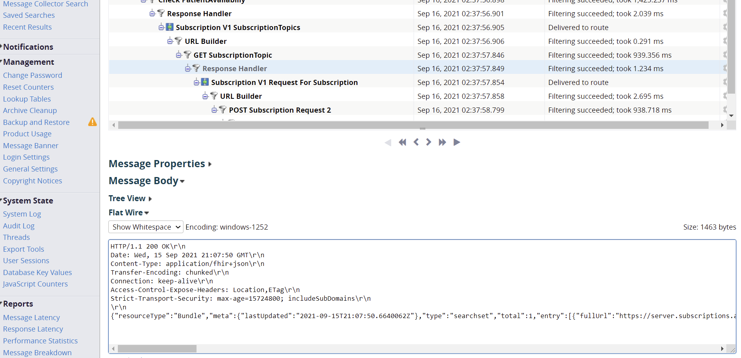

And POSTing Subscription Request

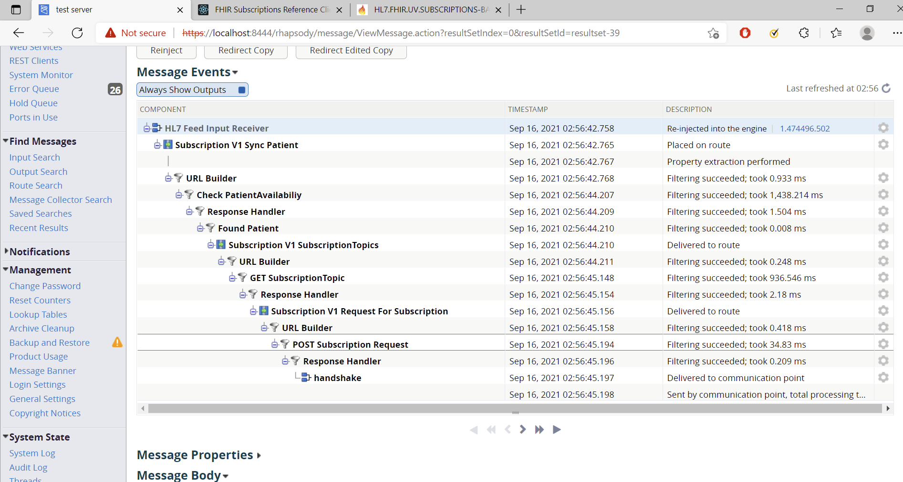

Implementation Snapshots:

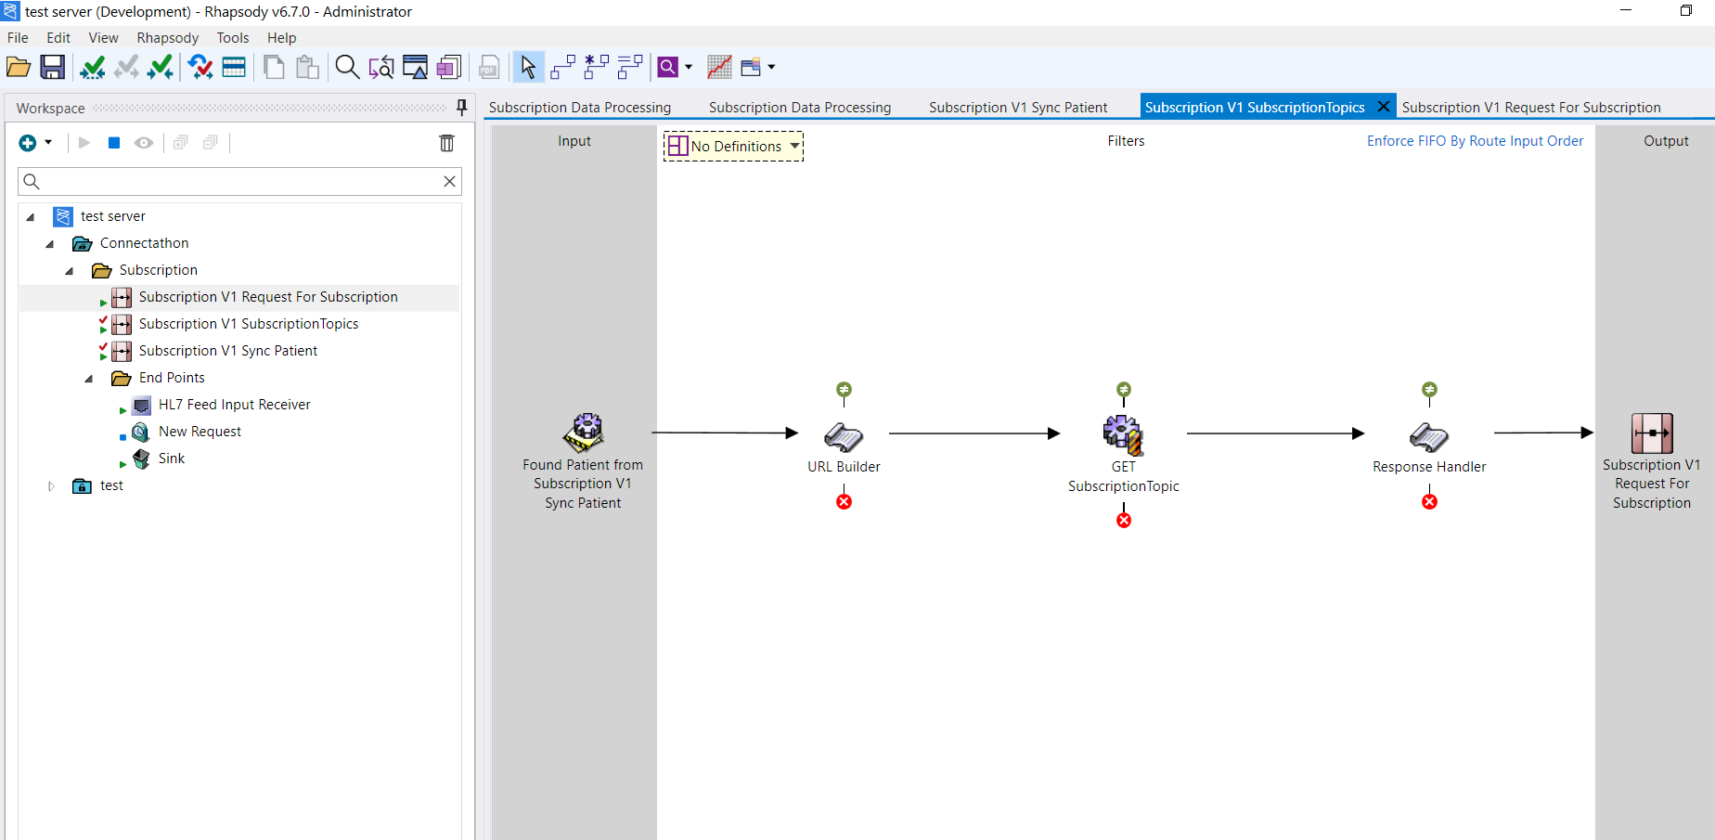

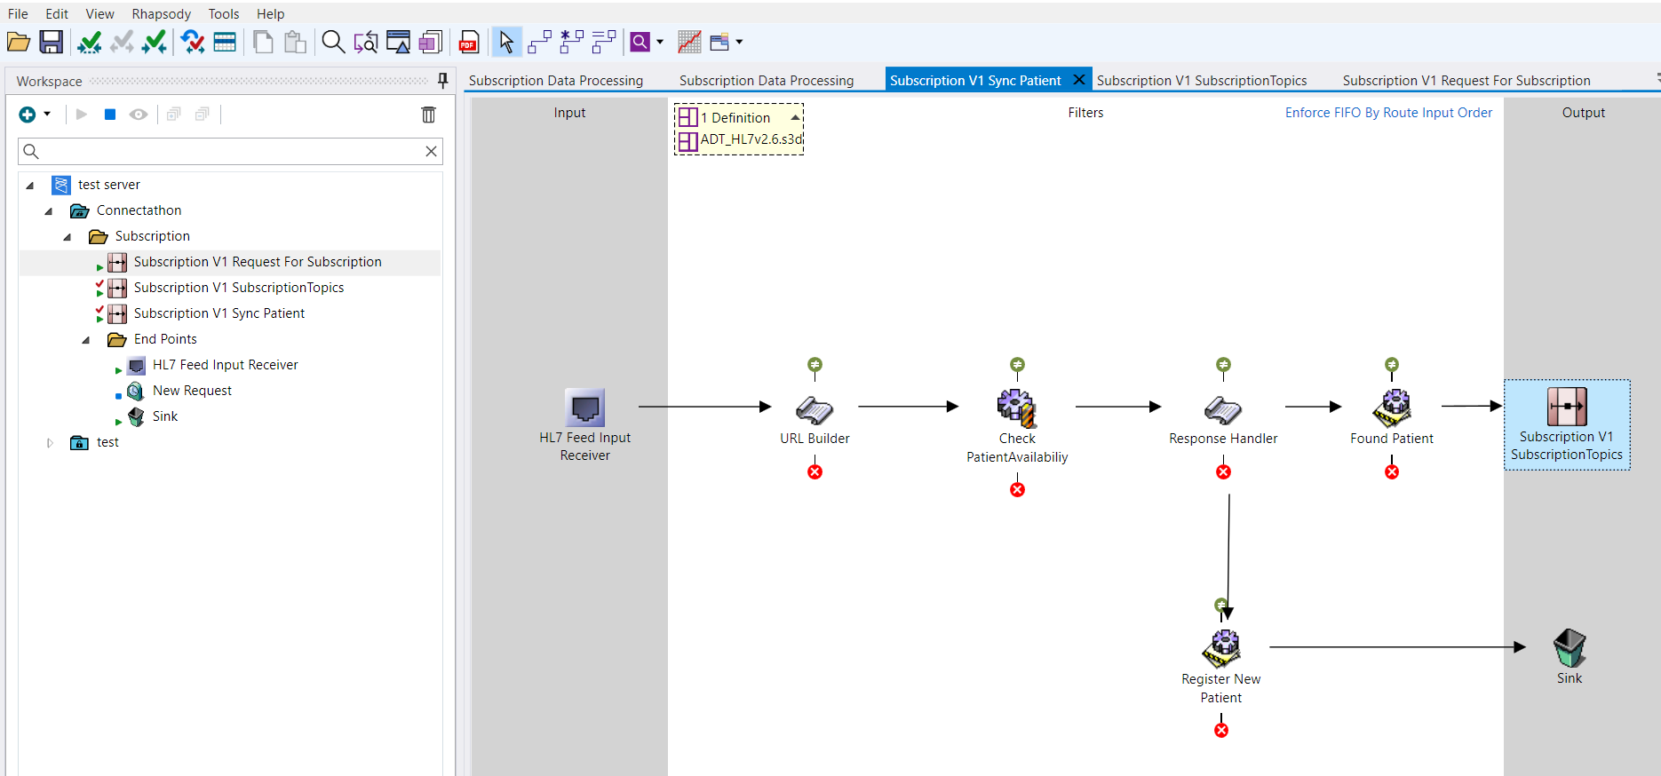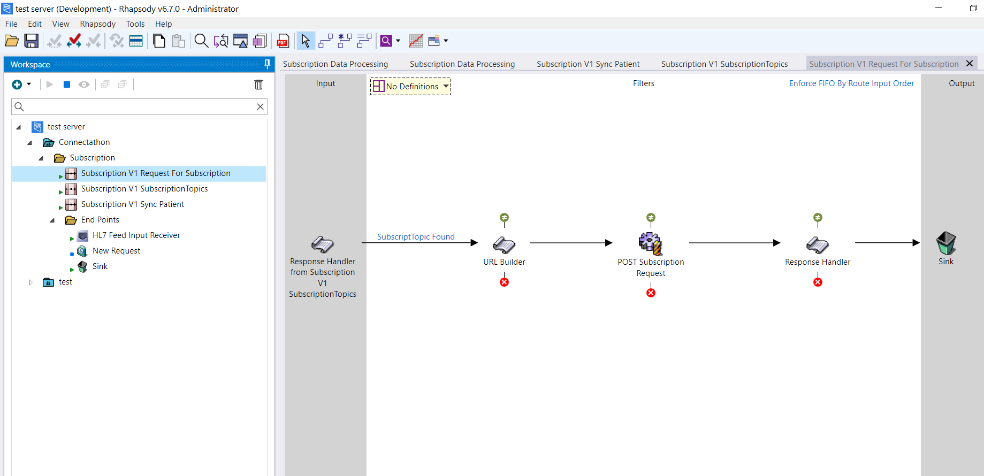

Possible errors encountered:

Error: Caused by: javax.net.ssl.SSLHandshakeException: Received fatal alert: handshake_failure

Detailed logs:

