in the language server error, an error is passed:

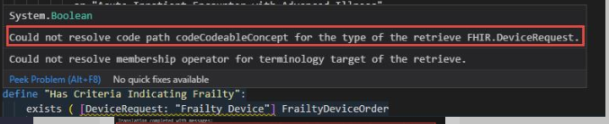

in the cql-to-elm compiler, it throws the same:

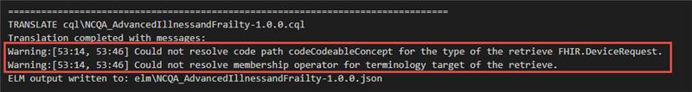

Updating [DeviceRequest: “Frailty Device”] to [DeviceRequest: code in “Frailty Device”]:

