* 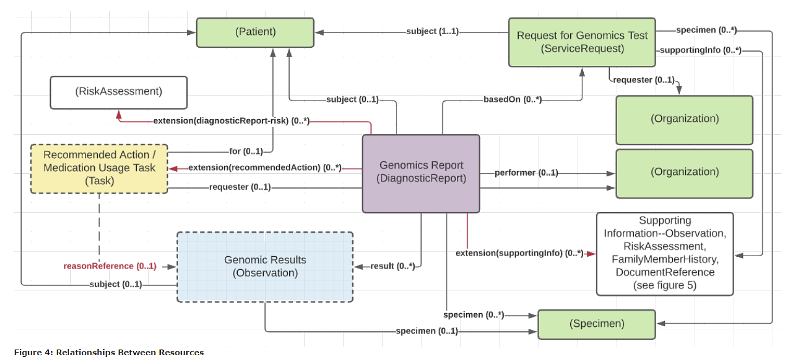[Request for Genomic Test](http://build.fhir.org/ig/HL7/genomics-reporting/branches/kp-task-category-changes/StructureDefinition-servicerequest.html) and the [reports resulting from them](http://build.fhir.org/ig/HL7/genomics-reporting/branches/kp-task-category-changes/StructureDefinition-genomics-report.html) can be associated to patients, to [specimens](http://build.fhir.org/ig/HL7/genomics-reporting/branches/kp-task-category-changes/StructureDefinition-specimen.html) or both.
  + The primary test to perform is captured in ServiceRequest.code. However, Qualifications on what variants, medications, diseases and other aspects to search on can be conveyed using the orderDetail element
  + The [Request for Genomic Test](http://build.fhir.org/ig/HL7/genomics-reporting/branches/kp-task-category-changes/StructureDefinition-servicerequest.html) typically represents a clinician order. However, it can also represent a lab-side filler order, a reflex order or even a plan or recommendation. These uses are distinguished via the intent element.
  + Family member history and tasks are always associated with a patient, not a specimen.
* All genomic observations are derived from a common abstract profile called [Genomic Base](http://build.fhir.org/ig/HL7/genomics-reporting/branches/kp-task-category-changes/StructureDefinition-genomics-base.html), that asserts they should have a category, effective date, issued date and status.
  + The effective date is the date the genomic specimen was collected and the issued date is when the observation was performed
  + Specimens may be linked to a specific subject, but they can also be stand-alone. For example, genomic testing of a sample swabbed from a counter-top
* Of the different types of observations, Genomic Findings all have exactly one specimen. The remainder might be associated with a specimen,but might not. Observations may also be associated with a particular BodyStructure, such as a fetus, tumor or lesion.
  + *Overall Genomic Interpretations* should be "derived from" *Genomic Findings*. For example, the report might want to be flagged as a 'Positive' report, and can reference the specific findings that lead to that interpretation.
  + *Genomic Implications should be "derived from" Genomic Findings. For example, in a genomic report, it's not acceptable to imply "patient is an increased metabolizer of drug X" without also indicating the variant, haplotype or genotype found that supports that implication.*
* *Recommended Actions* will (??? MUST???) have relationships. *Medication Recommendation* will have a reason relationship to a *Genomic Implication*. For example: a recommendation to increase the dosage of a medication might be tied to a genomic implication indicating that the patient is an increased metabolizer of that medication; *Followup Recommendation* might include suggestions for confirmatory testing, additional testing, and/or genomic counseling and can be tied to any of the observations in the report that support the recommendation.
* Genomic reports and observations can be tied to multiple "orders" - this is because each test requested is handled as a separate request. All tests ordered as part of a single requisition are linked by the requisition identifier.