

FHIR® Pilot Interoperability
Testbed (FHIR-PIT) and Ring of FHIR Training Guide

Basic Edition
FHIR Module

Version 1

® FHIR is the registered trademark of Health Level Seven International.

Copyright 2018
Michigan Health Information Network Shared Services
www.mihin.org

Table of Contents
Introduction 1
Fast Healthcare Interoperability Resources (FHIR®) 1
Why FHIR Is Important 1
How FHIR Works and Understanding FHIR Resources 1
FHIR Specification Segments 2
Other FHIR Initiatives 2
About the FHIR-PIT (FHIR Pilot Interoperability Testbed) 2
About This Guide 3
Training Goals 3
Training Prerequisites 3
Section 1. FHIR-PITs 4
Electronic Health Record (EHR) FHIR-PIT 4
Health Information Exchange (HIE) FHIR-PIT 4
Payer (Health Plan) FHIR-PIT 5
Active Care Relationship Service® FHIR-PIT 5
Health Directory FHIR-PIT 5
Quality FHIR-PIT 5
Section 2: Basic Find Capabilities 7
Log In at Your Base URL 7
Home Page 7
Organization Resource 8
Find an Organization Resource 9
Practitioner Resource 13
Find a Practitioner Resource 14
Patient Resource 17
Find Care Team Resource 22
Find Immunization Resource 27
Find Encounter Resource 34
Find Medication Resource 37
Section 2. Accessing FHIR Resources Through API Calls 40
Client Authentication 40
Creating a FHIR Client Application in Java 40
Step One. Software Requirements 41
Step Two. Environment Path for Java 41
Step Three. Download and Install Eclipse 44
Step Four. Create Maven Project 45
Step Five. Add FHIR Dependencies 49
Step Six. Create Packages 57
Step Seven. Create Classes 59
Section 3. Testing With the FHIR-PIT 67
Collecting a FHIR Resource 67
Retrieve Patient and Care Plan Data 68
Section 4. Testing with the Ring of FHIR 70
FHIR Station as Centralized Hub 70
How It Works 71
Example Scenario – Fighting Fire with FHIR 74
Meet Alice Vargas: 74
Additional Info, FAQs and Troubleshooting 75
Need More Assistance? 76
About the Michigan Health Information Network Shared Services 76

Table of Figures
Figure 1. Login Screen for FHIR-PIT Training 7
Figure 2. FHIR Server Home Page 8
Figure 3. Organization Resource Listing 9
Figure 4. Organization Search Parameter Example 10
Figure 5. Search Bar 10
Figure 6. Organization Entries Returned After Search – Read Selection 10
Figure 7. Practitioner Resource Listing 14
Figure 8. Practitioner Search Parameter Example 14
Figure 9. Practitioner Entries Returned After Search 15
Figure 10. Patient 18
Figure 11. Patient Search Parameter Example 19
Figure 12. Patient Entries Returned After Search 19
Figure 13. Care Team 22
Figure 14. Care Team Search Parameter Example 23
Figure 15. Care Team Results After Search 23
Figure 16. Immunization 28
Figure 17. Immunization Search Parameter Example 28
Figure 18. Immunization Results After Search 29
Figure 19. Encounter 35
Figure 20. Encounter Search Parameter Example 35
Figure 21. Encounter Results After Search 36
Figure 22. Medication 38
Figure 23. Medication Search Parameter Example 38
Figure 24. Medication Results After Search 38
Figure 25. Editing Environmental Variables in the Control Panel 42
Figure 26. System Properties 42
Figure 27. Environment Variables 43
Figure 28. Edit Environment Variable 44
Figure 29. Eclipse Launcher 45
Figure 30. Eclipse Workspace 46
Figure 31. New Maven Project 47
Figure 32. Project Tab Options 48
Figure 33. POM XML Screen 49
Figure 34. Maven Repository Website 52
Figure 35. Search Results for Spring-Web 53
Figure 36. Spring Web Options 53
Figure 37. Spring Web Dependency 54
Figure 38. Maven Clean 56
Figure 39. Maven Install 57
Figure 40. Create Package 58
Figure 41. New Java Package 58
Figure 42. Completed Packages 59
Figure 43. Retrieving Data Example 68
Figure 44. Results for Test 69
Figure 45. Ring of FHIR 70
Figure 46. Address 71
Figure 47. Results 72
Figure 48. Verifying Version of JDK 76

Introduction

Fast Healthcare Interoperability Resources (FHIR®)
FHIR is an interoperability standard for electronic exchange of healthcare information developed by Health Level Seven International (HL7), a not-for-profit organization that develops and provides frameworks and standards for the sharing, integration and retrieval of clinical health data and other electronic health information.

Why FHIR Is Important
FHIR is designed to help health information organizations more quickly and easily exchange and retrieve data from electronic health record (EHR) systems, and to help health IT developers more efficiently build applications to support this exchange of information.
While FHIR at first was a somewhat experimental project for HL7, it quickly acquired support from even fiercely competitive EHR vendors. The Argonaut Project, an HL7-backed consortium that includes EHR vendors and other major health IT vendors, moved FHIR forward to the point it became a full standard in February 2017.

How FHIR Works and Understanding FHIR Resources
FHIR frameworks are built around the concept of “resources” – these objects are basic, modular units of interoperability that can be assembled into working systems to try to resolve clinical, administrative and infrastructural problems in healthcare.
FHIR provides software development resources and tools for administrative concepts such as patients, providers, organizations and devices, as well as a variety of clinical concepts including problems, medications, diagnostics, care plans and financial issues, among others.
Unlike HL7's most widely-used formal standard (also called HL7), FHIR is designed specifically for the web and provides resources and foundations based on XML, JSON, HTTP, Atom and OAuth structures.
The FHIR specification is online, fully hyperlinked and can be linked from the resource of a property to the data type of that property. FHIR can be used in mobile phone applications, cloud communications, EHR-based data sharing and among institutional healthcare providers.
More information on FHIR can be found at: https://www.hl7.org/fhir/.

® FHIR is the registered trademark of Health Level Seven International.

FHIR Specification Segments
The FHIR specification is broken into three parts:
- General documentation
- Implementation
- Resource list
General documentation describes how resources are defined and gives background material including definitions of data types, codes and XML and JSON formats. Users can use resources with the RESTful architecture programming interface as clinical documents or in a service-based architecture.
FHIR defines a framework for extending and adapting resources, which can be read by any system, regardless of the way the extensions were developed. Extension definitions can be retrieved using the same framework as retrieving other resources. Each resource carries human-readable text representation using HTML.

Other FHIR Initiatives
SMART on FHIR has also gained broad industry support. The SMART on FHIR initiative is based at Boston Children’s Hospital and features a set of open specifications to integrate apps with EHRs, portals, health information exchanges and other health IT systems.
Another initiative is HAPI FHIR (“happy fire”), a new library for adding FHIR messaging to applications. It was developed at University Health Network in Ontario, Canada. HAPI FHIR is open source and free to use.

About the FHIR-PIT (FHIR Pilot Interoperability Testbed)
The FHIR-PIT is a cloud-based virtual environment that replicates low-cost instances of known, successful, interoperating web service modules in a “sandbox.” Health information organizations, health plans, health systems and other healthcare organizations can safely use this sandbox to learn, plan, design, develop, test and scale state-of-the-art information technology to springboard from “pilot” to “production” in a safe environment.
The FHIR-PIT mimics a live production environment with participating (simulated) health systems, health information organizations, health plans, and other healthcare organizations.
The testing environment is populated with synthetic patient data that looks like real, protected health information from a clinical setting, but is based on “artificial” people thus removing any legal or privacy risks.
The FHIR-PIT can be used to test and demonstrate FHIR to access clinical data through REST API calls from virtually any other system or service, including EHR systems.

About This Guide
The FHIR-PIT Basic Edition, Intro to FHIR Module offers a broad, basic introduction to FHIR, the FHIR Pilot Interoperability Testbed, and the Ring of FHIR. This module includes FHIR server(s) fully pre-populated with thousands of resources for testing purposes, and additionally includes tools for building your own FHIR client application. Future modules include support for quality measures that can perform Category 1 Quality Reporting Data Architecture (QRDA) file validation and conversion to Category 3 QRDA files.

Training Goals
FHIR-PIT training is designed to provide organizations with information necessary to learn, experiment, design, test, scale, and move from pilot to production in a safe “sandbox” environment.
With this basic edition, developers will first learn about FHIR and how to use FHIR capabilities to query data, including accessing data at the organization, practitioner, and patient level.
Once developers learn the basics of FHIR, we will move to the quality module which will allow developers to create populations and generate quality measure reports for quality care initiatives.

Training Prerequisites
To use the Pilot Interoperability Testbed, and to receive the most value from these training modules, you will need the following:
- Familiarity with JSON and some background in software development
- Ability to utilize RESTful web services
- Experience with Java (desirable)

Section 1. FHIR-PITs
There are six different types of FHIR-PITs available at the Connectathon. Each type of FHIR-PIT has resources related to its functions and features using Fast Healthcare Interoperability Resources (FHIR), so users and developers can experience how FHIR can improve their workflow and data-sharing processes.
The URLs for each FHIR-PIT are listed below. After registering and completing the online form, please visit the registration desk at the event or contact connectathon@mihin.org for the log-in credentials.

Electronic Health Record (EHR) FHIR-PIT
Specific resources available for you to find and use in this FHIR-PIT include:
- CarePlan
- Condition
- DiagnosticReport
- Encounter
- Immunization
- MedicationRequest
- Observation
- Procedure

URLs:
  - https://fire-pit.mihin.org/pit-ehr1/
  - https://fire-pit.mihin.org/pit-ehr2/
  - https://fire-pit.mihin.org/pit-ehr3/
  - https://fire-pit.mihin.org/pit-ehr3/

Health Information Exchange (HIE) FHIR-PIT
Specific resources available for you to find and use in this FHIR-PIT include:
- CarePlan
- Condition
- Encounter
- MedicationRequest
- Observation
- Procedure
URLs:
  - https://fire-pit.mihin.org/pit-hie1/
  - https://fire-pit.mihin.org/pit-hie2/
  - https://fire-pit.mihin.org/pit-hie3/
  - https://fire-pit.mihin.org/pit-hie4/

Payer (Health Plan) FHIR-PIT
Specific resources available for you to find and use in this FHIR-PIT include:
- Claims
- Coverage
URLs:
  - https://fire-pit.mihin.org/pit-bcbspayer/
  - https://fire-pit.mihin.org/pit-payer/

Active Care Relationship Service® FHIR-PIT
Specific resources available for you to find and use in this FHIR-PIT include:
- Care Team
- Patient
- Person
URLs:
  - https://fire-pit.mihin.org/pit-acrs/

Health Directory FHIR-PIT
Specific resources available for you to find and use in this FHIR-PIT include:
- Basic
- Contract
- Endpoint
- Location
- Organization
- Practitioner
- Practitioner Role
URLs:
  - https://fire-pit.mihin.org/pit-hd/

Quality FHIR-PIT
Specific resources available for you to find and use in this FHIR-PIT include:
- Observation
- Condition
- DiagnosticReport
- Encounter
- Immunization
- MedicationRequest
- Patient
- ValueSet
- Practioner
- Library
- CodeSystem
- CarePlan
- Measure
- Location
- Organization
- PlanDefinition
URLs:
  - https://fire-pit.mihin.org/cqf-ruler/tester/

Section 2: Basic Find Capabilities
We will start by accessing FHIR services to perform a basic “find.”

Log In at Your Base URL
- Open your internet browser and enter the Base URL for your FHIR-PIT FHIR server (NOTE: Base URL is available at end of “Training Prerequisites” section)
- Log in to your FHIR-PIT server
Figure 1 below shows the login screen you will see at your Base URL.
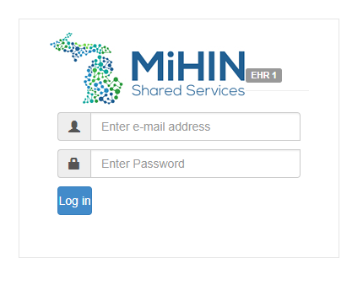
Figure 1. Login Screen for FHIR-PIT Training
Upon logging in you will be taken to your FHIR server home page.

Home Page
A screenshot of your initial FHIR server home page is shown in Figure 2, below.
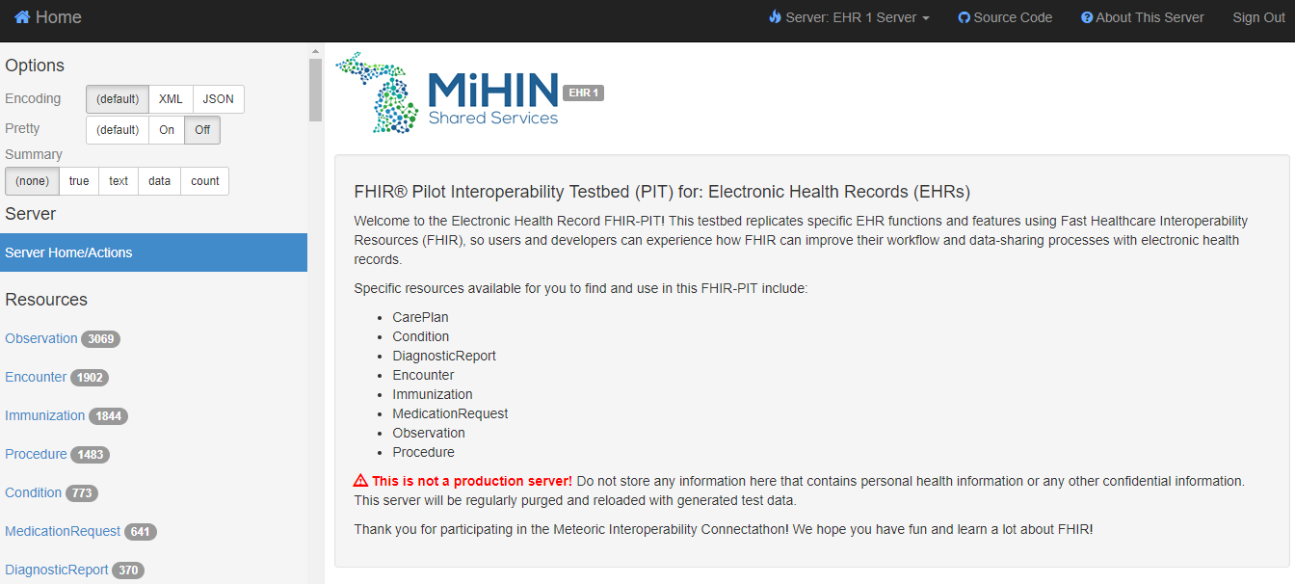
Figure 2. FHIR Server Home Page
Please note that your FHIR resources are displayed on the left side of your home page (Figure 2). The number next to the resource indicates the quantity of available entries for that resource. For example, if the number 7,000 is shown next to the PATIENT resource, there are currently 7,000 “patients” available for testing in your FHIR-PIT.
The center of the home page screen contains tools for retrieving a list of a given type of resource. For example, you can use these tools to display a list of all hospital resources available for testing in your FHIR-PIT.
We will start by learning how to “find” the resources you need on the FHIR server. Below are find examples around a series of options using the different resources available.
NOTE: The basic “find” capabilities are similar for each of these resources. We are including Find examples for all resources to address any specific interests of different trainees.
The main resources that will be used in the FHIR-PIT are organization,
practitioner, patient, encounter, medication, and immunization

Organization Resource
HL7 defines “Organization” in the following manner:
- HL7 Definition: “A formally or informally recognized grouping of people or organizations formed for the purpose of achieving some form of collective action. Includes companies, institutions, corporations, departments, community groups, healthcare practice groups, etc.”
“Organization” examples include hospitals, clinics, practices, health plans, etc.
Data Available in Organization Resource: The organization resource can include the following types of information:
- Identifier for organization across multiple systems
- Whether the organization is still in active use
- Kind of organization
- Organization name used
- Alternate or previous names for the organization.

- The resource should also include:
- Contact detail
- Organization address
- Organization of which this organization forms a part
- Contact for a certain purpose
- Type of contact
- Name associated with contact
- Contact details including telephone, email, etc.
- Visiting or postal addresses for contact
- Technical endpoint providing access to services operated for the organization.

Find an Organization Resource
Organization is one of the resources listed on the left side of the home page (Figure 3).
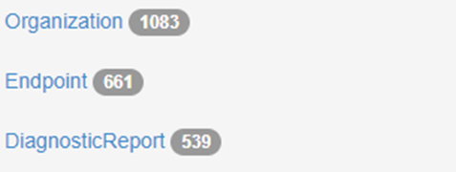
Figure 3. Organization Resource Listing
Begin by clicking on the Organization resource link.
The search parameters in the middle of the home page will update. You may now filter the entries for organization in your FHIR-PIT server. Choose a filter to limit the results of your search. An example filter is “Active”, as seen in Figure 4, below.
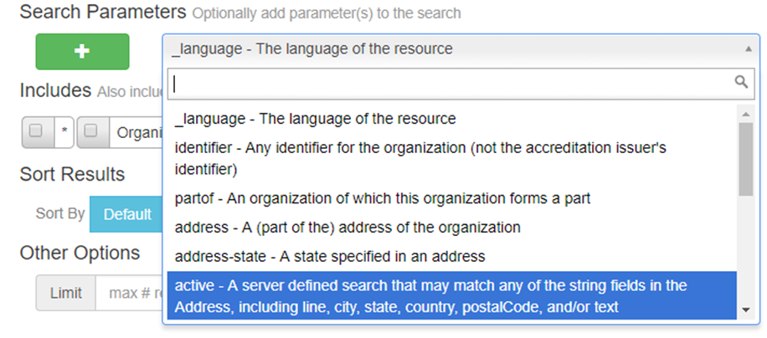
Figure 4. Organization Search Parameter Example
Perform the search by clicking on the “Search” bar (figure 5).

Figure 5. Search Bar
Results from your search are returned on your home page, as shown in Figure 6 below.
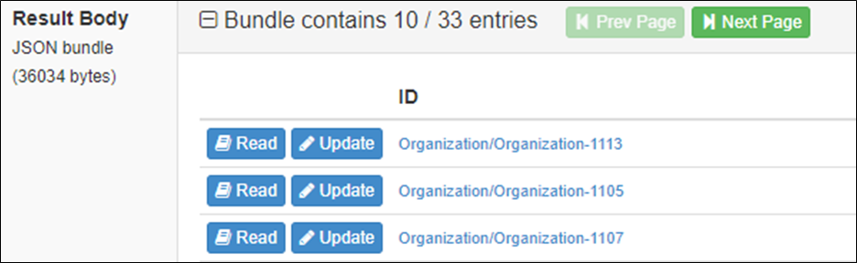
Figure 6. Organization Entries Returned After Search – Read Selection
You may select to “read” a selection, or to “update” a selection. In this section we are only learning how to find resources, so please start by choosing the “read” option.
The result will appear in a JSON format. An example JSON return is shown below:

{
"resourceType":"Organization",
"id":"Organization-1113",
"meta":{
"versionId":"2",
"lastUpdated":"2016-11-17T14:52:27.978-05:00"
},
"extension":[
{
"url":"http://org.mihin.fhir.extension.organization-license",
"valueIdentifier":{
"use":"official",
"system":"http://michigan.gov/fhir/organization/license",
"value":"LARA-ORG-1113",
"assigner":{
"display":"State of Michigan"
}
}
},
{
"url":"http://gov.onc.fhir.extension.taxonomy",
"valueCodeableConcept":{
"coding":[
{
"system":"http://org.nucc.taxonomy",
"code":"261Q00000X",
"display":"Clinic/Center"
}
]
}
},
{
"url":"http://org.mihin.fhir.extension.electronic-service",
"valueReference":{
"reference":"ElectronicService/ElectronicService-41",
"display":"Lake.Michigan.Medicial.Group@direct.test.mihin.org"
}
}
],
"identifier":[
{
"use":"official",
"system":"http://www.hl7.org/oid/",
"value":"1.2.3.4.5.9.99.999.9999.1113"
},
{
"use":"official",
"type":{
"coding":[
{
"system":"http://hl7.org/fhir/v2/0203",
"code":"PRN",
"display":"Provider number"
}
],
"text":"US National Provider Identifier"
},
"system":"http://hl7.org/fhir/sid/us-npi",
"value":"9999991113"
}
],
"active":true,
"type":{
"text":"Clinic/Center"
},
"name":"Lake Michigan Medicial Group",
"telecom":[
{
"system":"phone",
"value":"313-555-0953",
"use":"work"
}
],
"address":[
{
"line":[
"89 NE Missouri Avenue"
],
"city":"Dearborn",
"state":"MI",
"postalCode":"48126"
}
]
}

Practitioner Resource
HL7 defines “Practitioner” in the following manner:
- HL7 Definition: “A person who is directly or indirectly involved in the provisioning of healthcare.”

- Data Available in Practitioner Resource: The practitioner resource can include the following types of information:
- Identifier for the person as this agent
- Whether practitioner’s record is in active use
- Name(s) associated with the practitioner
- Contact detail for practitioner
- Address(es) of practitioner that are not role-specific (typically home address)
- Gender of practitioner
- Practitioner date of birth
- Image of practitioner

- The resource should also include:
- Qualifications obtained by training and certification
- Identifier for this qualification for practitioner
- Coded representation of the qualifications
- Period during which the qualification is valid
- Organization that regulates and issues the qualification
- Language the practitioner is able to use in patient communication.

Find a Practitioner Resource
Practitioner is one of the resources listed on the left side of the home page (Figure 7).

Figure 7. Practitioner Resource Listing
Begin by clicking on the Practitioner resource link
The search parameters in the middle of the home page will update. You may now filter the entries for Practitioner in your FHIR-PIT server. Choose a filter to limit the results of your search. An example filter is “Identifier”, as seen in Figure 8, below.
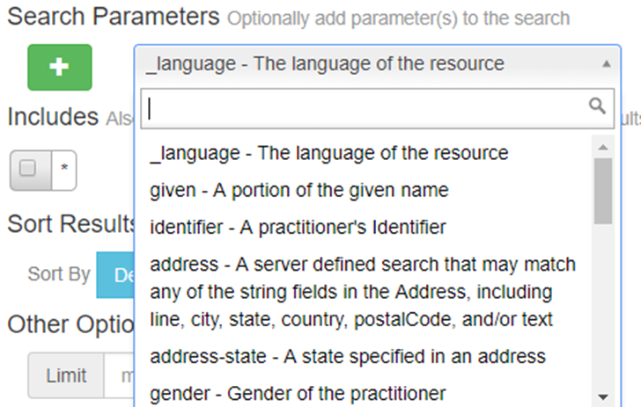
Figure 8. Practitioner Search Parameter Example
Perform the search by clicking on the “Search” bar (figure 5, above).
Results from your search are returned on your home page, shown in figure 9, below.
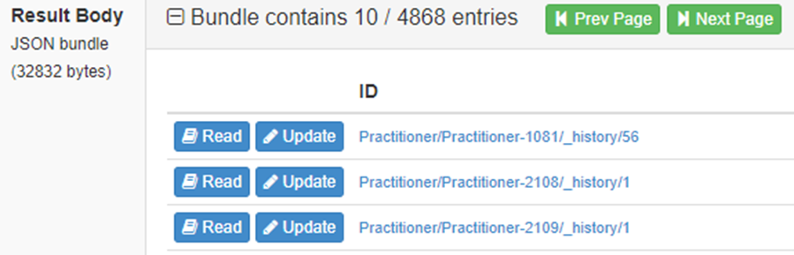
Figure 9. Practitioner Entries Returned After Search
You may select to “read” a selection, or to “update” a selection. In this section we are only learning how to find resources, so please start by choosing the “read” option.
The result will appear in JSON format. An example return is shown below:

"resourceType": "Practitioner",
"id": "Practitioner-1081",
"meta": {
"versionId": "56",
"lastUpdated": "2017-10-25T02:41:13.918-04:00"
},
"language": "en-GB",
"identifier": [
{
"use": "official",
"type": {
"coding": [
{
"system": "http://hl7.org/fhir/identifier-type",
"code": "SB",
"display": "Social Beneficiary Identifier"
}
],
"text": "US Social Security Number"
},
"system": "http://hl7.org/fhir/sid/us-ssn",
"value": "000001219"
},
{
"use": "official",
"type": {
"coding": [
{
"system": "http://hl7.org/fhir/identifier-type",
"code": "SB",
"display": "Social Beneficiary Identifier"
}
],
"text": "Michigan Common Key Service Identifier"
},
"system": "http://mihin.org/fhir/cks",
"value": "208D00000X"
}
],
"active": false,
"name": [
{
"family": "Taylor",
"given": [
"Katherine",
"Elaine"
],
"suffix": [
"MD"
]
}
],
"telecom": [
{
"system": "phone",
"value": "248-555-2330",
"use": "work"
},
{
"system": "phone",
"value": "248-555-9184",
"use": "mobile"
}
],
"address": [
{
"use": "work",
"type": "postal",
"line": [
"213 SE Hill Street"
],
"city": "Rochester",
"district": "Oakland County",
"state": "MI",
"postalCode": "48307"
}
],
"gender": "female",
"birthDate": "2017-10-25",
"qualification": [
{
"identifier": [
{
"use": "official",
"type": {
"coding": [
{
"system": "http://hl7.org/fhir/v2/0203",
"code": "MD",
"display": "Medical License number"
}
],
"text": "Michigan Medical License"
},
"system": "http://michigan.gov/fhir/medical-license",
"value": "LARA-1081",
"assigner": {
"display": "State of Michigan"
}
}
],
"code": {
"coding": [
{
"system": "http://michigan.gov/lara/license-type",
"code": "4305",
"display": "Medical Doctor"
}
]
}
}
]
}

Patient Resource
HL7 defines “Patient” in the following manner:
- HL7 Definition: “Demographics and other administrative information about an individual or animal receiving care or other health-related services.”
Data Available in Patient Resource: In this resource, you can find:
- An identifier for patient, if patient’s record is in active use
- Name associated with patient
- Contact detail for the individual
- Gender of patient
- Date of birth
- Indicator if individual is deceased or not
- Addresses for the individual
- Marital (civil) status of patient
- Whether patient is part of a multiple birth
- Image of patient

The resource should also include:
- Contact party (guardian, partner, friend) for patient
  - The kind of relationship
  - Name associated with the contact person
  - Contact detail
  - Address for the contact
  - Gender of contact
  - Organization associated with contact
- Period during which contact person or organization is valid to be contacted relating to this patient.

This resource should also include:
- List of languages to communicate with patient
  - Language preference indicator
- Patient’s nominated primary care provider
- Organization that is the custodian of patient record
- Link to another patient resource that concerns the same actual person
- Other patient or related person resource that link refers to.
Like Practitioner and Organization, “Patient” is one of the resources listed on the left-hand side of the home page (Figure 10, below).

Figure 10. Patient
In this example, there are 4902 entries available under Patient. You can do a find on that category by clicking on that option and then selecting the interested search parameter. As an example, in Figure 11 (below), “birthdate” is selected.
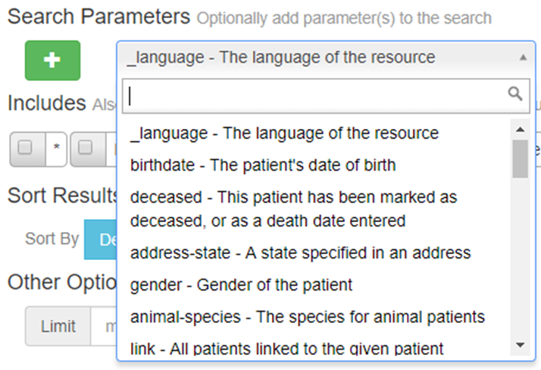
Figure 11. Patient Search Parameter Example
By clicking on the Search bar (Figure 5, above), the results of the parameter are shared. And, like with Practitioner and Organization, you can select which patient to view (Figure 12).
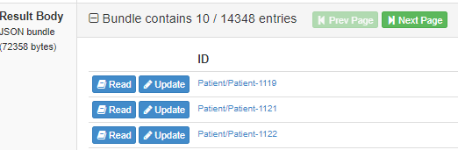
Figure 12. Patient Entries Returned After Search
The result may appear in a JSON format. You can see an example of one patient return in the text below:

{
"resourceType": "Patient",
"id": "Patient-1119",
"meta": {
"versionId": "60",
"lastUpdated": "2017-10-25T02:41:07.254-04:00"
},
"language": "es-AR",
"text": {
"status": "generated",
"div": "<div xmlns=\"http://www.w3.org/1999/xhtml\"> \n
<div class=\"hapiHeaderText\">Tricia Lynn \n
<b>FRANKLIN </b> \n
</div> \n
<table class=\"hapiPropertyTable\"> \n
<tbody> \n
<tr> \n
<td>Identifier</td> \n
<td>000000001</td> \n
</tr> \n
<tr> \n
<td>Address</td> \n
<td> \n
<span>770 SE Pecan Street </span> \n
<br/> \n
<span>Pontiac </span> \n
<span>MI </span> \n
</td> \n
</tr> \n
<tr> \n
<td>Date of birth</td> \n
<td> \n
<span>15 January 1987
</span> \n
</td> \n
</tr> \n
</tbody> \n
</table> \n
</div>"
},
"identifier": [
{
"use": "official",
"type": {
"coding": [
{
"system": "http://hl7.org/fhir/identifier-type",
"code": "SB",
"display": "Social Beneficiary Identifier"
}
],
"text": "US Social Security Number"
},
"system": "http://hl7.org/fhir/sid/us-ssn",
"value": "000000001"
},
{
"use": "official",
"type": {
"coding": [
{
"system": "http://hl7.org/fhir/identifier-type",
"code": "SB",
"display": "Social Beneficiary Identifier"
}
],
"text": "Michigan Common Key Service Identifier"
},
"system": "http://mihin.org/fhir/cks",
"value": "ah7xct5hfl4bdznumnupokdyn67ruuxusrdj4qgc"
}
],
"active": true,
"name": [
{
"family": "Franklin",
"given": [
"Tricia",
"Lynn"
]
}
],
"telecom": [
{
"system": "phone",
"value": "248-555-7818",
"use": "home"
},
{
"system": "phone",
"value": "248-555-0530",
"use": "mobile"
}
],
"gender": "male",
"birthDate": "2017-10-25",
"deceasedDateTime": "2017-10-25T02:41:07.233Z",
"address": [
{
"use": "home",
"type": "postal",
"line": [
"770 SE Pecan Street"
],
"city": "Pontiac",
"district": "Oakland County",
"state": "MI",
"postalCode": "48341"
}
],
"maritalStatus": {
"coding": [
{
"system": "http://hl7.org/fhir/v3/MaritalStatus",
"code": "S"
}
]
},
"multipleBirthBoolean": true
}

Find Care Team Resource
In HL7, a care team (written as “careteam” or “CareTeam”) is defined in the following manner:
- HL7 Definition: “The care team includes all the people and organizations who plan to participate in the coordination and delivery of care for a patient.”

Data Included in Resource: In this resource, you can find an identifier that includes:
- External IDs for this team
- Care team active status
- Type of care team
- Name of the team
- Who the care team is for
- Encounter or episode associated with care team
- Time period team covers
- Members of team
- Type of involvement
- Who is involved

This resource should also include:
- Organization of practitioner
- Time period of participant
- Why the care team exists
- Organization responsible for the care team
- Comments made about the care team
Care Team is listed as one of the resources on the left-hand side as “CareTeam,” as shown in Figure 13 below.
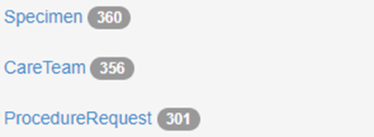
Figure 13. Care Team
Like with the other examples you do a search on the 356 (as in this example) entries in Care Team. After clicking on “CareTeam,” you will then select an entry in Search Parameters, like “Patient.” This is show in Figure 14.
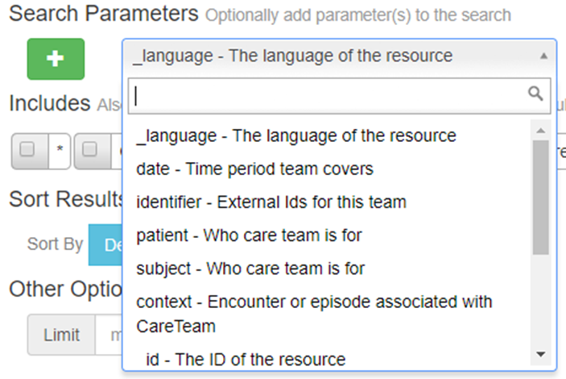
Figure 14. Care Team Search Parameter Example
After making a selection (like “Patient”) click on the Search bar (Figure 5, above), you can review the query results, as can be seen in Figure 15.
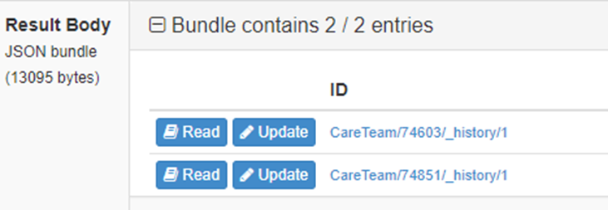
Figure 15. Care Team Results After Search
The result may appear in a JSON format. You can see an example of one care team return in the text below:

{
"resourceType": "CareTeam",
"id": "74851",
"meta": {
"versionId": "1",
"lastUpdated": "2017-10-25T02:39:52.844-04:00",
"tag": [
{
"system": "http://projectcrucible.org",
"code": "testdata"
}
]
},
"language": "bn",
"text": {
"status": "generated",
"div": "<div xmlns=\"http://www.w3.org/1999/xhtml\">CTJGNaYpRfY1cKdIwGQTMQ==</div>"
},
"identifier": [
{
"use": "temp",
"type": {
"coding": [
{
"system": "http://hl7.org/fhir/v2/0203",
"code": "PRN",
"display": "Provider number",
"userSelected": false
}
],
"text": "D58/l5Qk8meS0JzZRcSNRA=="
},
"system": "http://projectcrucible.org/0j3yQDKxBH2LjahiIpS/XA==",
"value": "wfys833QlzmRL38jehMkWQ==",
"period": {
"start": "2017-10-25T02:39:52.790Z",
"end": "2017-10-25T02:39:52.790Z"
},
"assigner": {
"identifier": {
"use": "temp",
"system": "http://projectcrucible.org/e0OuymUCtfvuyy5RunulIw==",
"value": "TEggTUZuoOlTkaZwBA8cUA=="
},
"display": "Organization UNwLILh/InRnKY/jSYBmFw=="
}
}
],
"status": "active",
"category": [
{
"coding": [
{
"system": "http://hl7.org/fhir/care-team-category",
"code": "event",
"display": "Event",
"userSelected": false
}
],
"text": "M3HSds9ggc5l20p5i6xeFA=="
}
],
"name": "FLGMsL6k+DKsSpmtA/hByQ==",
"subject": {
"identifier": {
"use": "secondary",
"type": {
"text": "Jk5Fc+DLE/oeGRHqDKxRjw=="
},
"system": "http://projectcrucible.org/2BZmkJOHP0iIV+4tatFLsg==",
"value": "WkRXYErRsCqg9H068rvzUw==",
"period": {
"start": "2017-10-25T02:39:52.792Z",
"end": "2017-10-25T02:39:52.792Z"
},
"assigner": {
"display": "Organization Nk620Jhwyr/xbNWW8d9lDA=="
}
},
"display": "Group MrZcZCsGZq+RdNUBtyct0A=="
},
"context": {
"identifier": {
"use": "temp",
"type": {
"text": "Did0xkN7uCMdmrrEaHwOOQ=="
},
"system": "http://projectcrucible.org/PGb8z6nYhPQ4lY6KOG7l3g==",
"value": "Y4aF8qB70V5a8ywX+qH25w==",
"period": {
"start": "2017-10-25T02:39:52.792Z",
"end": "2017-10-25T02:39:52.792Z"
},
"assigner": {
"display": "Organization 3fRDQvzPUyqaXkKfCrk1wA=="
}
},
"display": "Encounter wJKOfwGc84PFibmDztuMkA=="
},
"period": {
"start": "2017-10-25T02:39:52.793Z",
"end": "2017-10-25T02:39:52.793Z"
},
"participant": [
{
"role": {
"coding": [
{
"system": "http://snomed.info/sct",
"code": "444199001",
"display": "Friend of subject",
"userSelected": false
}
],
"text": "bXvTUublR2g+De9+vS3jjw=="
},
"member": {
"identifier": {
"use": "secondary",
"system": "http://projectcrucible.org/pSvq58cPJERDzugbV/Y9sQ==",
"value": "O/3WTPy/fZ8bLlfY3qiqQg=="
},
"display": "RelatedPerson PIakzI7EE7N0mVbiFEPCrQ=="
},
"period": {
"start": "2017-10-25T02:39:52.818Z",
"end": "2017-10-25T02:39:52.818Z"
}
}
],
"reasonCode": [
{
"coding": [
{
"system": "http://snomed.info/sct",
"code": "320003",
"display": "Cervical dilatation, 1cm",
"userSelected": false
}
],
"text": "joWS7/AILha1v0irqtMDQw=="
}
],
"reasonReference": [
{
"identifier": {
"use": "secondary",
"type": {
"text": "/5CRMUlCuWf1YAYFEF0LYQ=="
},
"system": "http://projectcrucible.org/c9xFHiF1gfswU4lhzeE5tQ==",
"value": "dwBD6EPWubW2gXa4C5qGGw==",
"period": {
"start": "2017-10-25T02:39:52.822Z",
"end": "2017-10-25T02:39:52.822Z"
},
"assigner": {
"display": "Organization Mit9K4FqBdSpJTtN7lMY3Q=="
}
},
"display": "Condition 6uAm0d50U8pV25EuOUTLSA=="
}
],
"managingOrganization": [
{
"identifier": {
"use": "temp",
"type": {
"text": "LbsiAIXUHUHK+OuQh/+1kw=="
},
"system": "http://projectcrucible.org/n0OANi+KMoulVTWA8T/BRg==",
"value": "ptSZVu489wWk9Rn9xgnHmA==",
"period": {
"start": "2017-10-25T02:39:52.822Z",
"end": "2017-10-25T02:39:52.822Z"
},
"assigner": {
"display": "Organization yjHRlgvk9zqSoyJcYNCJQA=="
}
},
"display": "Organization EaT2iahIS8OUMhWW3oFCrg=="
}
],
"note": [
{
"authorReference": {
"identifier": {
"use": "temp",
"system": "http://projectcrucible.org/e8U2SE+QiAYtCsoNyGkhFQ==",
"value": "XuBQNxURnpFevuez2rSf4g=="
},
"display": "Patient jGradeQ5zDUGhlrRY2u/pQ=="
},
"time": "2017-10-25T02:39:52.823Z",
"text": "SdtkCTXPAlIQEwJ6bTnNuQ=="
}
]
}

Find Immunization Resource
Immunization information is also available in your FHIR-PIT. It can be searched for in the same way as other searches. To begin with, in HL7, immunization is defined in the following manner:
- HL7 Definition: “Describes the event of a patient being administered a vaccination or a record of a vaccination as reported by a patient, a clinician or another party and may include vaccine reaction information and what vaccination protocol was followed.”
Data Included in Resource: In this resource, you can find:
- Business identifier
- Status of immunization
- Flag for if immunization was given
- Vaccine product administered
- Who was immunized
- Encounter administered as part of
- Date vaccination was administered
- Indication of context the data was recorded in
- Source of secondary reported record
- Location where vaccination occurred
- Vaccine manufacturer
- Vaccine lot number
- Vaccine expiration date
- Body site vaccine was administered
- How vaccine entered body
- Amount of vaccine administered
- Who performed event
- What type of performance was done
- Individual who performed the event
This resource should also include:
- Vaccination notes
- Reasons for administration/non-administration
- Details of reaction that follows immunization
- When reaction started
- Additional information on reaction
- Vaccination protocol followed
Like the other resources, Immunizations are also listed on the left-side of the home page as “Immunization.” Figure 16 showcases an example with 110 entries listed.
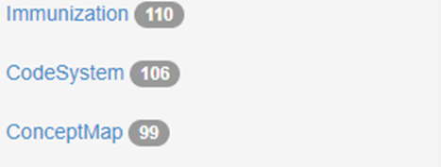
Figure 16. Immunization
There are different search parameters available for Immunization. In Figure 17, “Reason” is selected as an example of a search.
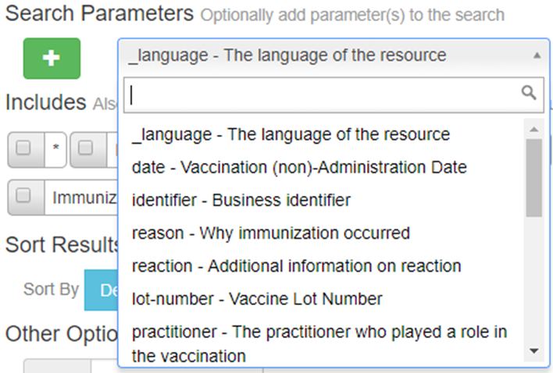
Figure 17. Immunization Search Parameter Example
After a parameter is elected, the Search button (Figure 5) can be used to bring up the selected entries. An example of selected entries can be seen in Figure 18.
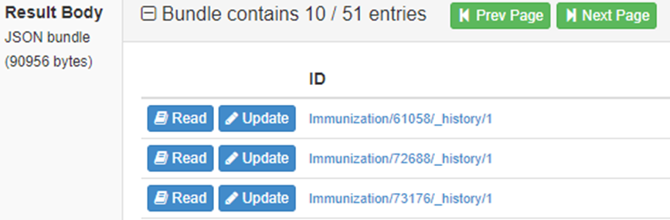
Figure 18. Immunization Results After Search
The result may appear in a JSON format. You can see an example of one immunization return in the text below:

{
"resourceType": "Immunization",
"id": "61058",
"meta": {
"versionId": "1",
"lastUpdated": "2017-06-07T01:13:09.646-04:00",
"tag": [
{
"system": "http://projectcrucible.org",
"code": "testdata"
}
]
},
"language": "de-CH",
"text": {
"status": "generated",
"div": "<div xmlns=\"http://www.w3.org/1999/xhtml\">E6OU4+CRaArWGZnBg3+Sjw==</div>"
},
"identifier": [
{
"use": "official",
"type": {
"coding": [
{
"system": "http://hl7.org/fhir/identifier-type",
"code": "SB",
"display": "Social Beneficiary Identifier",
"userSelected": false
}
],
"text": "6OiCu02yLlISKCpEkAUbQg=="
},
"system": "http://projectcrucible.org/HEpxQmMAIEIAhOaibEGWNA==",
"value": "+h7LoMdvoFIS5tUBVoUSug==",
"period": {
"start": "2017-06-07T01:13:09.488Z",
"end": "2017-06-07T01:13:09.488Z"
},
"assigner": {
"identifier": {
"use": "official",
"system": "http://projectcrucible.org//vDgjhRcLTCoiKlcO+O8VQ==",
"value": "PT9QMlqRaq9HJPevbG0oSQ=="
},
"display": "Organization 9vbpzn1sZfohnbRH+k9czQ=="
}
}
],
"status": "completed",
"notGiven": false,
"vaccineCode": {
"coding": [
{
"system": "http://hl7.org/fhir/sid/cvx",
"code": "130",
"display": "DTaP-IPV",
"userSelected": true
}
],
"text": "w5EkFojvOqOJ3lh51t3Hdw=="
},
"patient": {
"identifier": {
"use": "secondary",
"type": {
"text": "qUC/gqJwExLicV/phvT6Ag=="
},
"system": "http://projectcrucible.org/kRtAV43Lnw+g/ZRpZrPqLQ==",
"value": "Nr6GWTI+N16rDENHKoOGAQ==",
"period": {
"start": "2017-06-07T01:13:09.490Z",
"end": "2017-06-07T01:13:09.490Z"
},
"assigner": {
"display": "Organization KC6npFTfzqed1x2xKLmlxg=="
}
},
"display": "Patient jo+p8atUq7FtFtPSfl5KwA=="
},
"encounter": {
"identifier": {
"use": "temp",
"type": {
"text": "k4cG9NyZGRX+sflhe0yZfg=="
},
"system": "http://projectcrucible.org/o6EG+6QvxIU0+MrtaW2N2Q==",
"value": "SDF9EB6+OA2sNdX/xD3kmg==",
"period": {
"start": "2017-06-07T01:13:09.490Z",
"end": "2017-06-07T01:13:09.490Z"
},
"assigner": {
"display": "Organization FGEeB3InBcQCp+dK1d3NsQ=="
}
},
"display": "Encounter HdEa2jgTQGHIWuKUjx2+BQ=="
},
"date": "2017-06-07T01:13:09.490Z",
"primarySource": false,
"reportOrigin": {
"coding": [
{
"system": "http://hl7.org/fhir/immunization-origin",
"code": "recall",
"display": "Parent/Guardian/Patient Recall",
"userSelected": true
}
],
"text": "MpPeCHsRqmeoaKtKg6PWJw=="
},
"location": {
"identifier": {
"use": "secondary",
"type": {
"text": "6QjjBpXGZCDizZb+UoLfRQ=="
},
"system": "http://projectcrucible.org/U741XPG8VW2Ha3o0sWowzw==",
"value": "SeR6DtBbUZJ0SI84Hzy70Q==",
"period": {
"start": "2017-06-07T01:13:09.492Z",
"end": "2017-06-07T01:13:09.492Z"
},
"assigner": {
"display": "Organization Q8P5VdBGpDfgtZ1YJneA8w=="
}
},
"display": "Location BY8UzbQJ+IoNEuDVIBK5Aw=="
},
"manufacturer": {
"identifier": {
"use": "official",
"type": {
"text": "hX5ioaL5/Dl5htGx7SuyGg=="
},
"system": "http://projectcrucible.org/+pGmmlVxlLcAl5jJfEfkfA==",
"value": "N4wxd5Ff9MiPOSMH6domLQ==",
"period": {
"start": "2017-06-07T01:13:09.492Z",
"end": "2017-06-07T01:13:09.492Z"
},
"assigner": {
"display": "Organization ITp8Y6eCYhI/gTxF8rkuPQ=="
}
},
"display": "Organization g9tVXIcjVYabnjwdSnL6jg=="
},
"lotNumber": "q/KxuaCL6ltiuXJimdfsfQ==",
"expirationDate": "2017-06-07",
"site": {
"coding": [
{
"system": "http://hl7.org/fhir/v3/ActSite",
"code": "LA",
"display": "Left arm",
"userSelected": true
}
],
"text": "osYKvrLI7PQGH7hrmqh1tQ=="
},
"route": {
"coding": [
{
"system": "http://hl7.org/fhir/v3/RouteOfAdministration",
"code": "NASINHL",
"display": "Inhalation, nasal",
"userSelected": false
}
],
"text": "7THdqbO6d+BDFCZksnAUiw=="
},
"doseQuantity": {
"value": 0.301330407426758,
"unit": "PVUyqOIzstAxeKioK1gbMw==",
"system": "http://projectcrucible.org/idb+Isvq+skCENaZqgVkGQ==",
"code": "TOBS0zthwW3nmUrnkgvCgg=="
},
"practitioner": [
{
"role": {
"coding": [
{
"system": "http://hl7.org/fhir/v2/0443",
"code": "OP",
"display": "Ordering Provider",
"userSelected": false
}
],
"text": "swGF61rqCDDV5JVEzJ1d2Q=="
},
"actor": {
"identifier": {
"use": "secondary",
"system": "http://projectcrucible.org/v4VxG3KsPfVmmZM2NHGOug==",
"value": "bdyIYYhmQogBNdszjkk2WQ=="
},
"display": "Practitioner 89Biv95YJhkHS5ByytdGyA=="
}
}
],
"note": [
{
"authorString": "OatGUt0sMhL+JzDWdpyT9Q==",
"time": "2017-06-07T01:13:09.507Z",
"text": "6VUGiiOtPM+XPiOTcPz8qw=="
}
],
"explanation": {
"reason": [
{
"text": "reason p8OhqMeFrj/u9fc4jUqfqA=="
}
]
},
"reaction": [
{
"date": "2017-06-07T01:13:09.563Z",
"detail": {
"identifier": {
"use": "usual",
"system": "http://projectcrucible.org/Nv0SJ5f8zhOgUubx/2NzAw==",
"value": "oWxlNMWlmauAQSdyO4+NAw=="
},
"display": "Observation 8pb8SmfqwTmls0mUtKX2Tw=="
},
"reported": false
}
],
"vaccinationProtocol": [
{
"doseSequence": 83,
"description": "Xus8yCS539+oUzCVi8FPJg==",
"authority": {
"identifier": {
"use": "secondary",
"system": "http://projectcrucible.org/qL1jowTBpfgWDIvz7IR5bw==",
"value": "MUKiUjk6ezXRf+dvgZ6HDg=="
},
"display": "Organization TGl585lbJzBuHSiDl4QEKw=="
},
"series": "MSSalZk28EH/gstc/MqyvA==",
"seriesDoses": 100,
"targetDisease": [
{
"coding": [
{
"system": "http://snomed.info/sct",
"code": "36989005",
"display": "Mumps",
"userSelected": false
}
],
"text": "5nw6q0sV8P16mpMN1qb4cA=="
}
],
"doseStatus": {
"coding": [
{
"system": "http://hl7.org/fhir/vaccination-protocol-dose-status",
"code": "count",
"display": "Counts",
"userSelected": false
}
],
"text": "bzXlZg5O7g1E04UStJ7ROQ=="
},
"doseStatusReason": {
"coding": [
{
"system": "http://hl7.org/fhir/vaccination-protocol-dose-status-reason",
"code": "outsidesched",
"display": "Administered outside recommended schedule",
"userSelected": false
}
],
"text": "4jqy9ww3TZyduMNrZG5dnw=="
}
}
]
}

Find Encounter Resource
It is also possible to review “Encounter” entries in a FHIR-PIT. Like with the previous discussion, HL7 defines and describes an “Encounter” entry in the follow manner:

- HL7 Definition: “An interaction between a patient and healthcare provider(s) for the purpose of providing healthcare service(s) or assessing the health status of a patient.”
Data Included in Resource: In this resource, you can find an identifier for which:
- Encounter in known
- Status of encounter
- Class of encounter
- List of past encounter classes
- Specific type of encounter
- Priority indicator for urgency of encounter
- Patient or group present at encounter
- Episode(s) of care that this encounter should be recorded against
- Referral request that initiated encounter
- List of participants
- Appointment that scheduled this encounter
- Start and end time of this encounter
- Quantity of time the encounter lasted
- Reason the encounter takes place
This resource should also include:
- List of diagnosis relevant to encounter
- Set of accounts that may be used for billing
- Details about admission to a healthcare service
- List of locations where the patient has been
- Custodian organization of this encounter record
- Another encounter this encounter is a part of
“Encounter” is also a resource option on the left-side of the home page. In this example, there are 7565 entries available in this category (Figure 19, below).

Figure 19. Encounter
Like the previous discussions, you can select different search parameters under “Encounter” In this example, you can select “Date,” Figure 20.
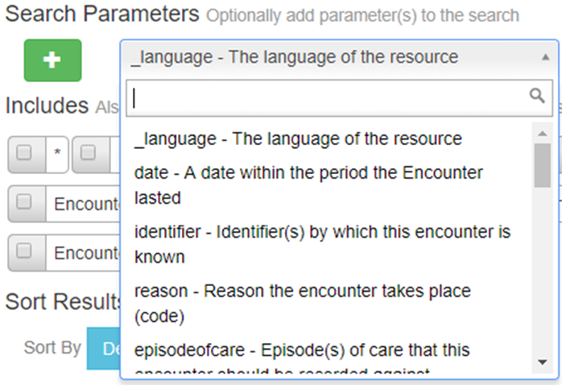
Figure 20. Encounter Search Parameter Example
Once choosing a search parameter (like “Date”), you can perform a search by clicking on the Search bar (Figure 5). Figure 21 shows an example of results.
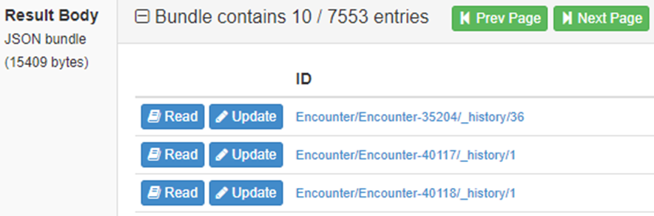
Figure 21. Encounter Results After Search
The result may appear in a JSON format. You can see an example of one encounter return in the text below:

{
"resourceType": "Encounter",
"id": "Encounter-40118",
"meta": {
"versionId": "1",
"lastUpdated": "2017-04-17T07:48:36.895-04:00"
},
"status": "finished",
"class": {
"system": "http://hl7.org/fhir/encounter-class",
"code": "other",
"display": "Other"
},
"subject": {
"reference": "Patient/Patient-7104",
"display": "Lydia Rocha Glenn"
},
"participant": [
{
"period": {
"start": "2020-01-01T14:00:00-05:00",
"end": "2020-01-01T14:00:00-05:00"
},
"individual": {
"reference": "Practitioner/Practitioner-5875",
"display": "Denise Katie Santiago MD"
}
}
],
"period": {
"start": "2020-01-01T14:00:00-05:00",
"end": "2020-01-01T14:00:00-05:00"
},
"location": [
{
"location": {
"reference": "Location/Location-26",
"display": "Novi Hospital Emergency Room"
}
}
],
"serviceProvider": {
"reference": "Organization/Organization-1322",
"display": "Novi Hospital Emergency Room"
}
}

Find Medication Resource
Medication information is another resource available in FHIR-PITs. It can be searched for in the same way as other searches. To begin with, in HL7, Medication is defined in the following manner:
- HL7 Definition: “This resource is primarily used for the identification and definition of a medication. It covers the ingredients and the packaging for a medication.”
Data Included in This Resource: In this resource, you can find codes that identify:
- Medication
- Medication status
- Manufacturer of the item
- Form of medication
- Active or inactive ingredient
- Product contained
- Active ingredient indicator
- Quantity of ingredient present
- Details about packaged medications
- What is in package
- Batch that identifies a single production run
- Picture of the medication
Medication information is another resource on the left-side of the home page. In this example, there are 179 entries available in this category (Figure 22).
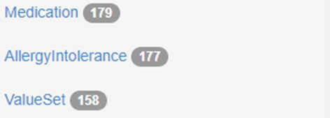
Figure 22. Medication
There are also search parameters available under Medication. As in the other examples you can review the options under search options (Figure 23).
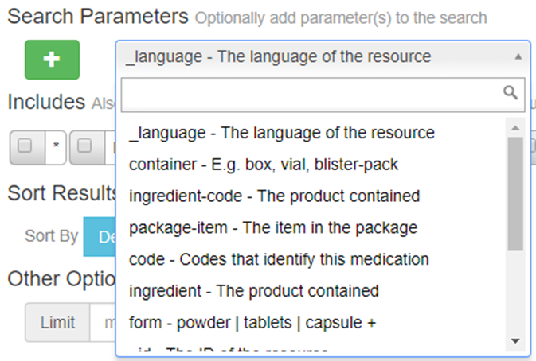
Figure 23. Medication Search Parameter Example
For the sake of this example, “code” is selected and the Search bar (Figure 5 above) is clicked. Entry options are then available (Figure 24).
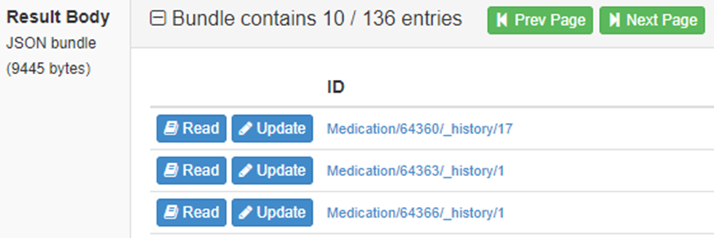
Figure 24. Medication Results After Search
In this example, the section option was selected by Read. The results are presented in JSON:

{
"resourceType": "Medication",
"id": "64363",
"meta": {
"versionId": "1",
"lastUpdated": "2017-07-17T08:07:38.606-04:00"
},
"text": {
"status": "generated",
"div": "<div xmlns=\"http://www.w3.org/1999/xhtml\"><div class=\"hapiHeaderText\">Enalapril Maleate 10 MG / Hydrochlorothiazide 25 MG Oral Tablet</div></div>"
},
"code": {
"coding": [
{
"system": "http://www.nlm.nih.gov/research/umls/rxnorm",
"code": "858828",
"display": "Enalapril Maleate 10 MG / Hydrochlorothiazide 25 MG Oral Tablet"
}
],
"text": "Enalapril Maleate 10 MG / Hydrochlorothiazide 25 MG Oral Tablet"
}
}

Section 2. Accessing FHIR Resources Through API Calls
In Section One we reviewed accessing FHIR Resources through the FHIR-PIT web user interface.
In this section, we will review how to access FHIR resources through RESTful Application Programming Interface (API) calls, so you don’t need to visit the FHIR-PIT portal to find FHIR resources, but can instead acquire the same information programmatically.
For example: You can use a FHIR client application to retrieve all patient resources that are in your FHIR server, search for a specific practitioner to find all patients for that practitioner, and then find immunization information for a specific patient so you can follow up with any patient due for immunization, all programmatically from your native system.

Client Authentication
Any API calls made to the FHIR-PIT must include client authentication. All FHIR-PIT APIs utilize HTTP basic authentication. HTTP basic authentication is a simple challenge and response mechanism with which a server can request authentication information (a user ID and password) from a client. The client passes the authentication information to the server in an Authorization header.
For more details about HTTP basic authentication please refer to the following link:
https://www.ibm.com/support/knowledgecenter/en/SSGMCP_5.1.0/com.ibm.cics.ts.internet.doc/topics/dfhtl2a.html

Creating a FHIR Client Application in Java
In this section, we will walk through steps to create a FHIR client. We will begin by downloading all necessary prerequisites and making sure you have everything you need to create the FHIR client application.
If you are experienced with programming in Java you can skip to Step Four - Create Maven Project. NOTE: You must already have Eclipse and JAVA installed on your machine to jump to Step Four.
This tutorial will guide you step-by-step on how to create a FHIR client in JAVA.
By the end of this tutorial you will be able to use test cases that will return FHIR resources from the FHIR server. You will be able to modify the IDs for the resources in the code to fetch specific resources.

Step One. Software Requirements
Your first step is to download the software required to write code in Java. Before downloading the software, you will need to verify the correct program in Java that you will need for your computer. You can find this information by reviewing “properties” in your computer. For a Windows-based operating system, this information can be found by right-clicking on the local drive, selecting properties and then choosing “check system type.” You may also find this information by selecting System in the Start menu and choosing Device Specification. This should inform you if you have a 32- or 64-bit system (for example).
For this example, we recommend downloading and installing Java Development Kit (JDK) 1.8. You can find it online via the following link: http://www.oracle.com/technetwork/pt/java/javase/downloads/jdk8-downloads-2133151.html.
Once you know the right program for your system configuration, download it from the site.

Step Two. Environment Path for Java
Once the JDK has downloaded to your computer, you will set the environment path for it. An environment path is a “set of directories where executable programs are located.” In other words this will allow the program to work in your system and allow it to complete the tasks you want for it.
An example of how to set an environment path is shown below, but PLEASE NOTE: Different operating systems have different ways to set environment paths so you will need to determine the correct method for your operating system. The example given below should work for Windows 8.
To begin the process, open the control panel on your computer. Windows users can find it by searching for “control panel” in your Windows Explorer search bar, or by choosing “Settings” in the Start menu.
Enter “system” in the control panel search bar. Depending on your operating system, your screen should look similar to Figure 25 below. You may need to first click on the “System” icon to see the menu items displayed below.
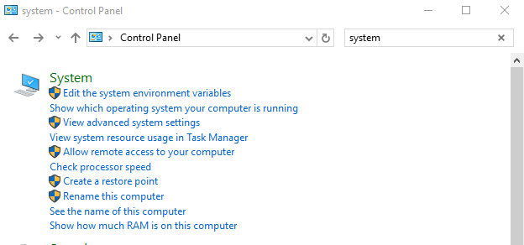
Figure 25. Editing Environmental Variables in the Control Panel
Choose the option under “System” to “Edit the system environmental variables.” This will bring up a “System Properties” screen; Figure 26, below.
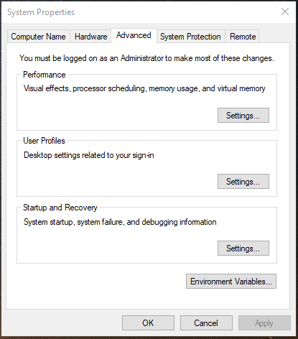
Figure 26. System Properties
Click the button on the bottom of the System Properties screen labeled “Environment Variables…”. This will bring up a screen similar to Figure 27, below.
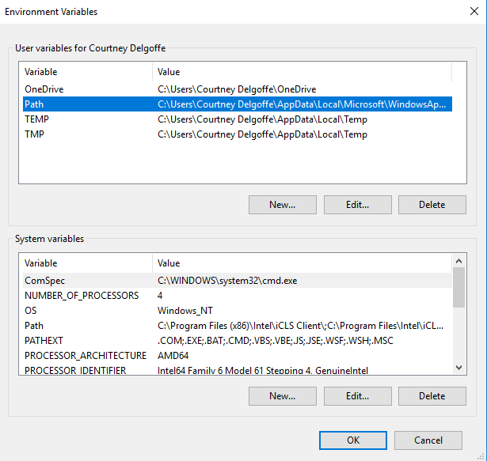
Figure 27. Environment Variables
Click on the “Path” row as shown in Figure 27, above, and select edit. It will bring up the window shown in Figure 28, below.

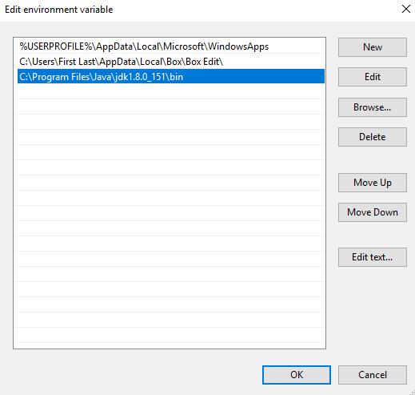
Figure 28. Edit Environment Variable
On this screen select “New,” which will give you the option to add the path for your Java Development Kit. This means you will be replacing the path the current path and changing it to the correct path of the JDK. Typically, the path will be something like C:\Program Files\Java\jdk1.8.0_151\bin.
With the pathway now edited to the new path, click “OK” to close the window.

Step Three. Download and Install Eclipse
Eclipse is a popular program for using Java. It is an integrated development environment (IDE), which means it gives the user a workspace and in that workspace, the user can develop and customizing Java.
At the time of this writing, Eclipse can be found online at http://www.eclipse.org/downloads/.
You need to look for a specific version of Eclipse that aligns with the Java installed on your computer. For this example, we used the Oxygen package which is at this address: http://www.eclipse.org/downloads/packages/eclipse-ide-java-ee-developers/oxygen1a.
Once Eclipse is downloaded, you will need to open it in your computer, this is usually accomplished via a double click (it is typically a zip file and information needs to be extracted in the installation process). After opening, the following screen (Figure 29), appears on your screen.

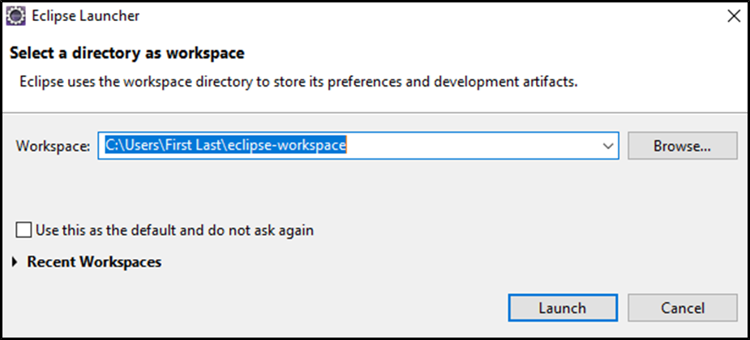
Figure 29. Eclipse Launcher
From this screen, you will begin the process of creating a workspace. If you are happy with the workspace location, you may click “Launch.” However, if you want to have a new location, click on “Browse” and select a different location on your computer.
After clicking on “Launch,” the next step begins.

Step Four. Create Maven Project
Now you have everything you need to create a FHIR client application in JAVA. Next we will create and configure a project in JAVA to support your FHIR client application.
Via Eclipse, we will be creating a maven project.
A Maven Project is a build tool that simplifies building Java projects.
This new Maven Project will simplify the Java work for you. The process begins after clicking on “Launch” (Step Three above), bringing up the Eclipse Workspace. You will first need to create the Maven Project you will be working in. This is accomplished by selecting “New” under “File.” This is shown in Figure 30, below.
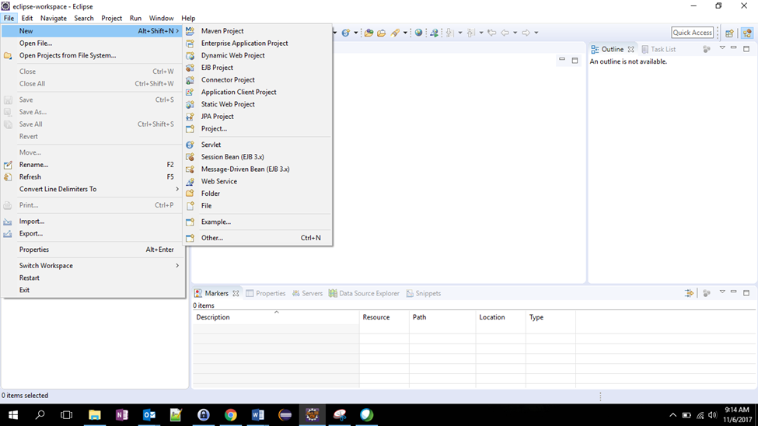
Figure 30. Eclipse Workspace
After selecting Maven Project, you have the option to select a simple project. This will be done by clicking on the box by “Create a simple project (skip archetype selection)” and then selecting “Next.” This brings up a window for a new Maven Project; this is presented in Figure 31, below.
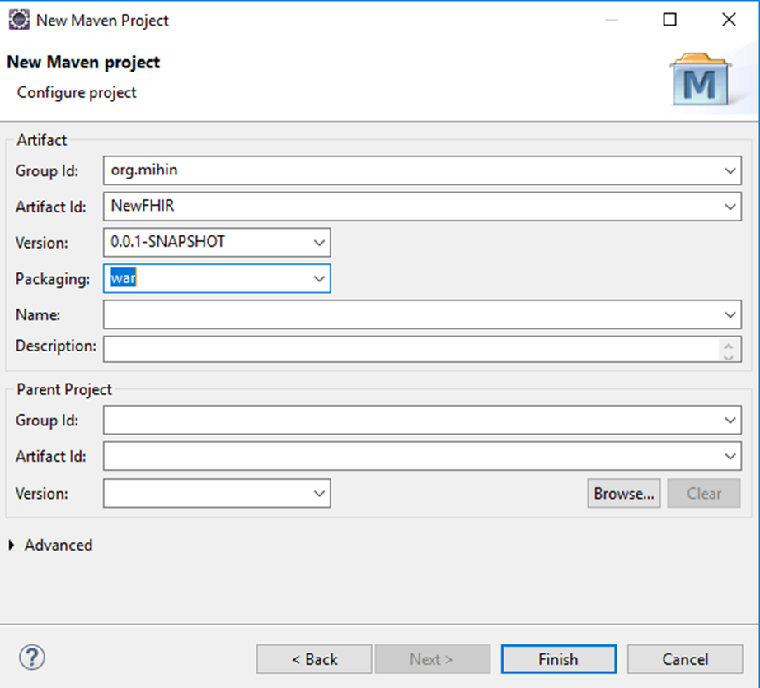
Figure 31. New Maven Project
To move onto the next step, we need to fill in the first four lines on this screen. By accomplishing this step, this app can be extended to web services. Above in Figure 31, you can see what MiHIN would supply for the answers. For example in Group Org ID we used “org.mihin.” This can be anything, but it might be best to select something based on your organization’s name.
The second option (Artifact ID) is the name of the project. For this example, we used “NewFHIR.”
The third option is the Maven version you are using – for this example we used 0.0.1-SNAPSHOT.
The fourth row (“Packaging”) is to choose the correct packaging type needed for Java web application. For this task you need to select “war.”
You can now select “Finish.”
You have now been returned to the main page for the project (Figure 30). On the tabs at the top of the page you have a selection of different choices, from “File” to “Help.” You will need to select “Project.” This will bring up a directory, similar to Figure 32.
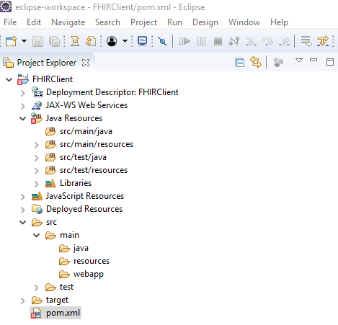
Figure 32. Project Tab Options
From this list of options, select the bottom option “pom.xml” (it is highlighted in Figure 32). “POM” stands for “project object model.”
Project Object Model (POM) contains project configuration and information about the project. It is the basic unit that Maven utilizes to build the project.
You are then transported to a different screen. An example of it is presented in Figure 33, below.
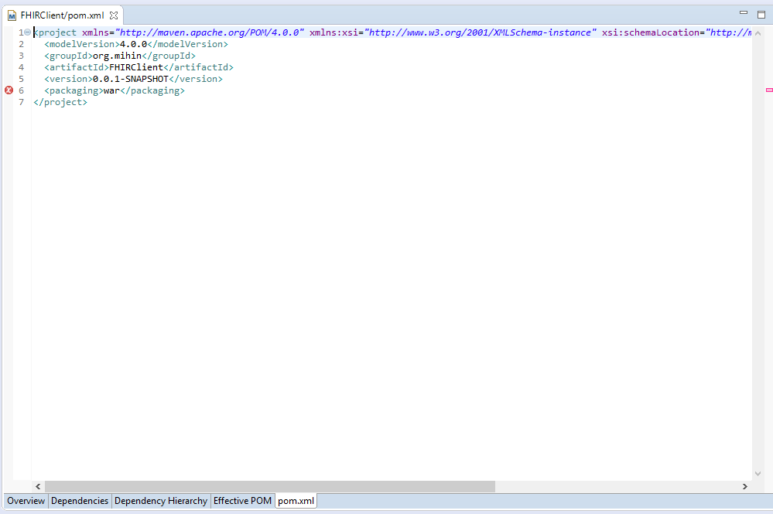
Figure 33. POM XML Screen
From this screen, there are a series of tabs on the bottom. The next step is to click on the “pom.xml” tab (the sixth one over from the left or the last one on the right). This will bring you to Step Five.

Step Five. Add FHIR Dependencies
The next aim in the process is to add FHIR dependencies to the pom.xml screen.
FHIR dependencies are external libraries that are required to translate responses that you will give from the FHIR-PIT server.
You will need to add the following external libraries (dependencies) in Java. There are multiple ways that this can be accomplished. The easiest step to adding the dependencies is to copy and paste this example below.
In your version, be sure to change the groupId, artifact Id, finalName and FHIRClient to match your work.
Note: tjc 2018-02-21 I changed the following POM in this doc to reflect Spring 5.
<project xmlns="http://maven.apache.org/POM/4.0.0" xmlns:xsi="http://www.w3.org/2001/XMLSchema-instance"
xsi:schemaLocation="http://maven.apache.org/POM/4.0.0 http://maven.apache.org/xsd/maven-4.0.0.xsd">
<modelVersion>4.0.0</modelVersion>
<groupId>org.mihin</groupId>
<artifactId>FHIRClient</artifactId>
<version>0.0.1-SNAPSHOT</version>
<packaging>war</packaging>
<properties>
<spring.version>5.0.3..RELEASE</spring.version>
<java.version>1.8</java.version>
<junit.version>4.12</junit.version>
<hapi-fhir-structures-dstu3.version>3.0.0</hapi-fhir-structures-dstu3.version>
<javax.servlet-api.version>3.0.1</javax.servlet-api.version>
<spring-test.version>5.0.3.RELEASE</spring-test.version>
<project.build.sourceEncoding>UTF-8</project.build.sourceEncoding>
</properties>
<dependencies>
<dependency>
<groupId>org.springframework</groupId>
<artifactId>spring-web</artifactId>
<version>${spring.version}</version>
</dependency>
<dependency>
<groupId>org.springframework</groupId>
<artifactId>spring-webmvc</artifactId>
<version>${spring.version}</version>
</dependency>

<!-- https://mvnrepository.com/artifact/org.apache.commons/commons-lang3 -->
<dependency>
<groupId>org.apache.commons</groupId>
<artifactId>commons-lang3</artifactId>
<version>3.7</version>
</dependency>

<!-- https://mvnrepository.com/artifact/org.springframework/spring-test -->
<dependency>
<groupId>org.springframework</groupId>
<artifactId>spring-test</artifactId>
<version>${spring-test.version}</version>
<scope>test</scope>
<exclusions>
<exclusion>
<groupId>org.hamcrest</groupId>
<artifactId>hamcrest-core</artifactId>
</exclusion>
</exclusions>
</dependency>
<dependency>
<groupId>org.hamcrest</groupId>
<artifactId>hamcrest-library</artifactId>
<version>1.3</version>
<scope>test</scope>
</dependency>

<!-- https://mvnrepository.com/artifact/ca.uhn.hapi.fhir/hapi-fhir-structures-dstu3 -->
<dependency>
<groupId>ca.uhn.hapi.fhir</groupId>
<artifactId>hapi-fhir-structures-dstu3</artifactId>
<version>${hapi-fhir-structures-dstu3.version}</version>
</dependency>

<!-- https://mvnrepository.com/artifact/ca.uhn.hapi.fhir/hapi-fhir-client -->
<dependency>
<groupId>ca.uhn.hapi.fhir</groupId>
<artifactId>hapi-fhir-client</artifactId>
<version>${hapi-fhir-structures-dstu3.version}</version>
</dependency>

<dependency>
<groupId>javax.servlet</groupId>
<artifactId>javax.servlet-api</artifactId>
<version>${javax.servlet-api.version}</version>
</dependency>
<!-- https://mvnrepository.com/artifact/junit/junit -->
<dependency>
<groupId>junit</groupId>
<artifactId>junit</artifactId>
<version>${junit.version}</version>
<scope>test</scope>
</dependency>

</dependencies>
<build>
<plugins>
<plugin>
<groupId>org.apache.maven.plugins</groupId>
<artifactId>maven-compiler-plugin</artifactId>
<version>3.3</version>
<configuration>
<source>1.8</source>
<target>1.8</target>
</configuration>
</plugin>
<plugin>
<groupId>org.apache.maven.plugins</groupId>
<artifactId>maven-war-plugin</artifactId>
<version>2.4</version>
<configuration>
<warSourceDirectory>src/main/webapp</warSourceDirectory>
<warName>fireclient</warName>
<failOnMissingWebXml>false</failOnMissingWebXml>
</configuration>
</plugin>
</plugins>
<finalName>FHIRClient</finalName>
</build>
</project>

Another option for creating dependencies is to directly copy and paste the information from Maven Repository. This assures you that you have the most current versions available. You will need to collect the following external libraries from Maven:
- spring-web
- spring-webmvc
- spring-test
- commons-lang3
- hamcrest-core
- hamcrest-library
- hapi-fhir-structures-dstu3
- hapi-fhir-client
- javax.servlet-api
- junit
At the time of this writing, all these dependencies can directly be downloaded from Maven at https://mvnrepository.com/. An example of the current web page for Maven is included as Figure 34.
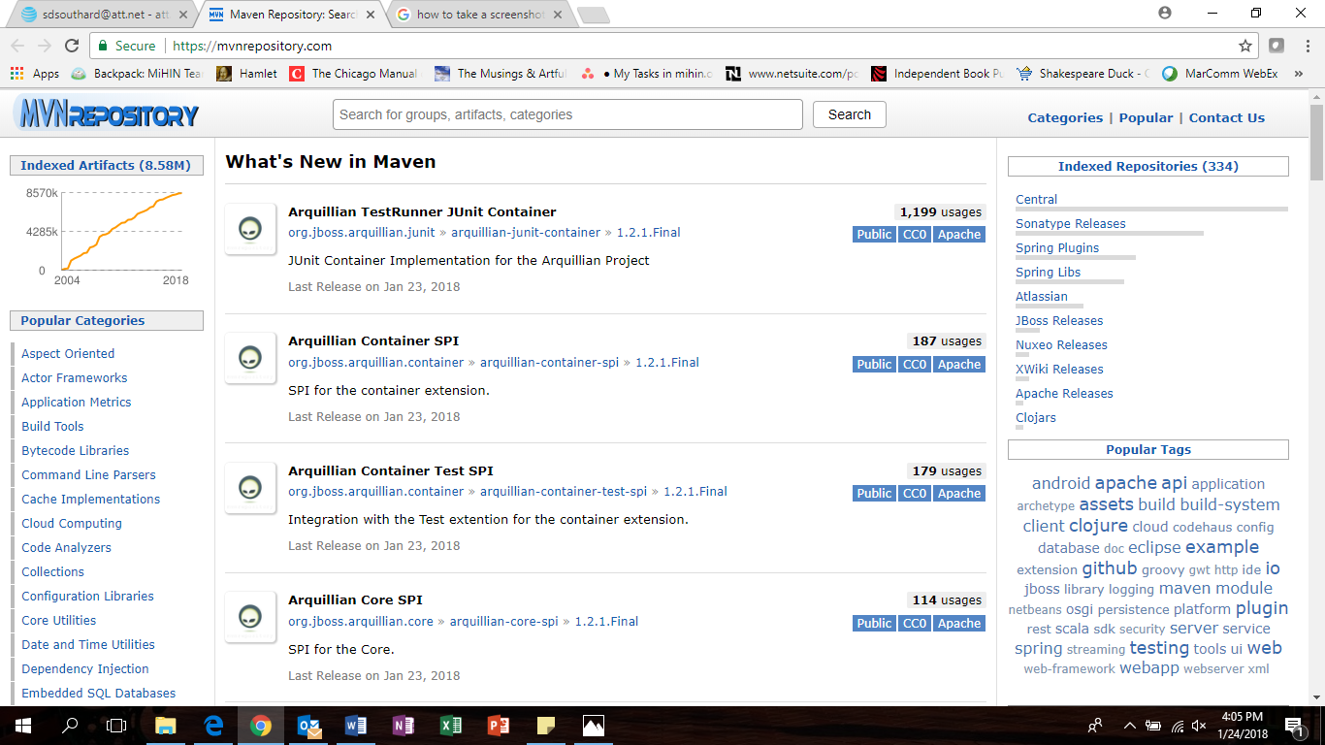
Figure 34. Maven Repository Website
Please visit the web page link. From this page you can do a simple search in the search bar (middle, top of the page) for each of the libraries mentioned in the list. Once the search result appears on the screen, click on the relevant result. For this example, let’s do a search for the first option in the list, “spring-web.”
We begin by typing “spring-web” in the search bad and hit enter. It will bring up a list of options. Our results from the time of this writing are showcased in Figure 35, below.
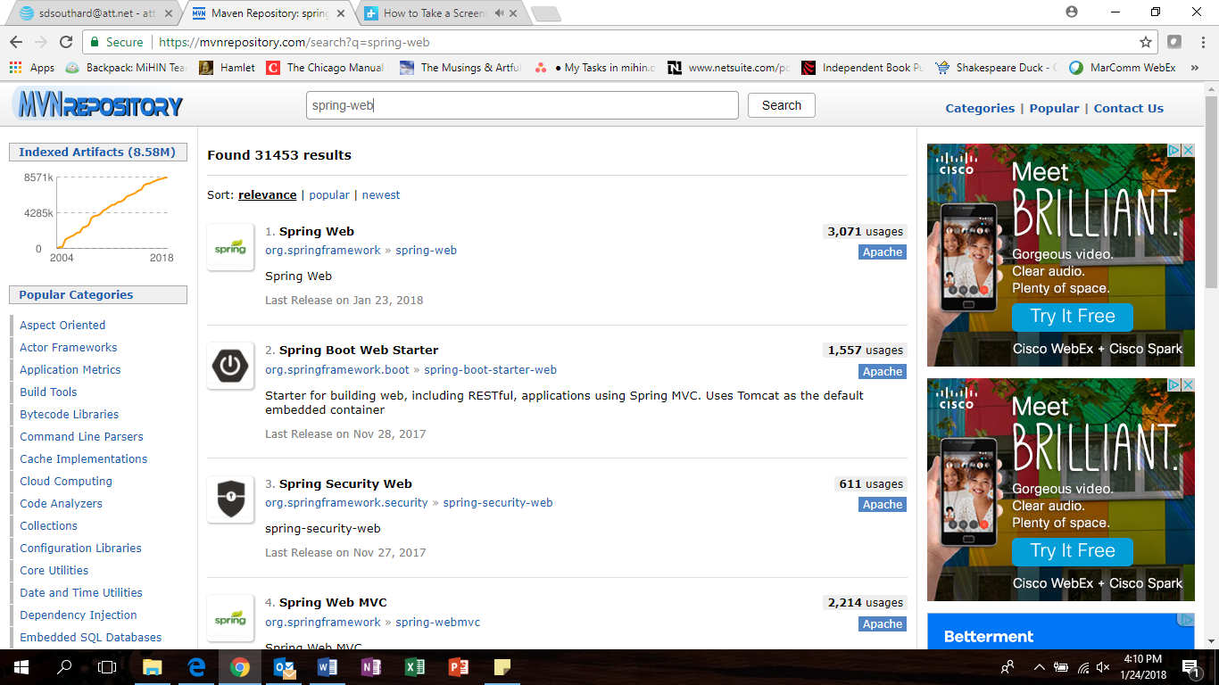
Figure 35. Search Results for Spring-Web
Now click on the relevant search result. This will bring up a series of different versions of the dependency. An example of the choices is presented in Figure 36 below.
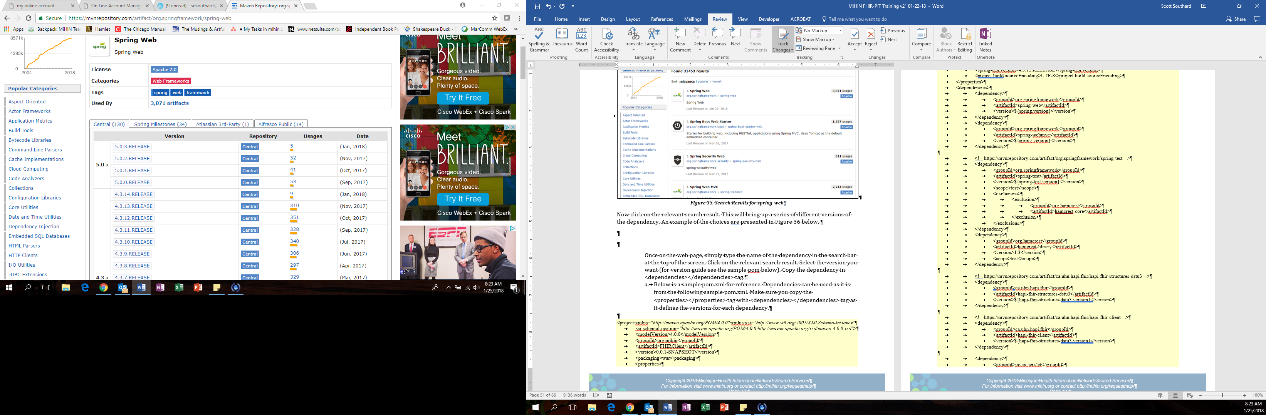
Figure 36. Spring Web Options
After clicking on the most recent version (for this example, 5.0.3. from January 23, 2018), the next screen displays the dependency numbers. An example of the screen is presented in Figure 37.
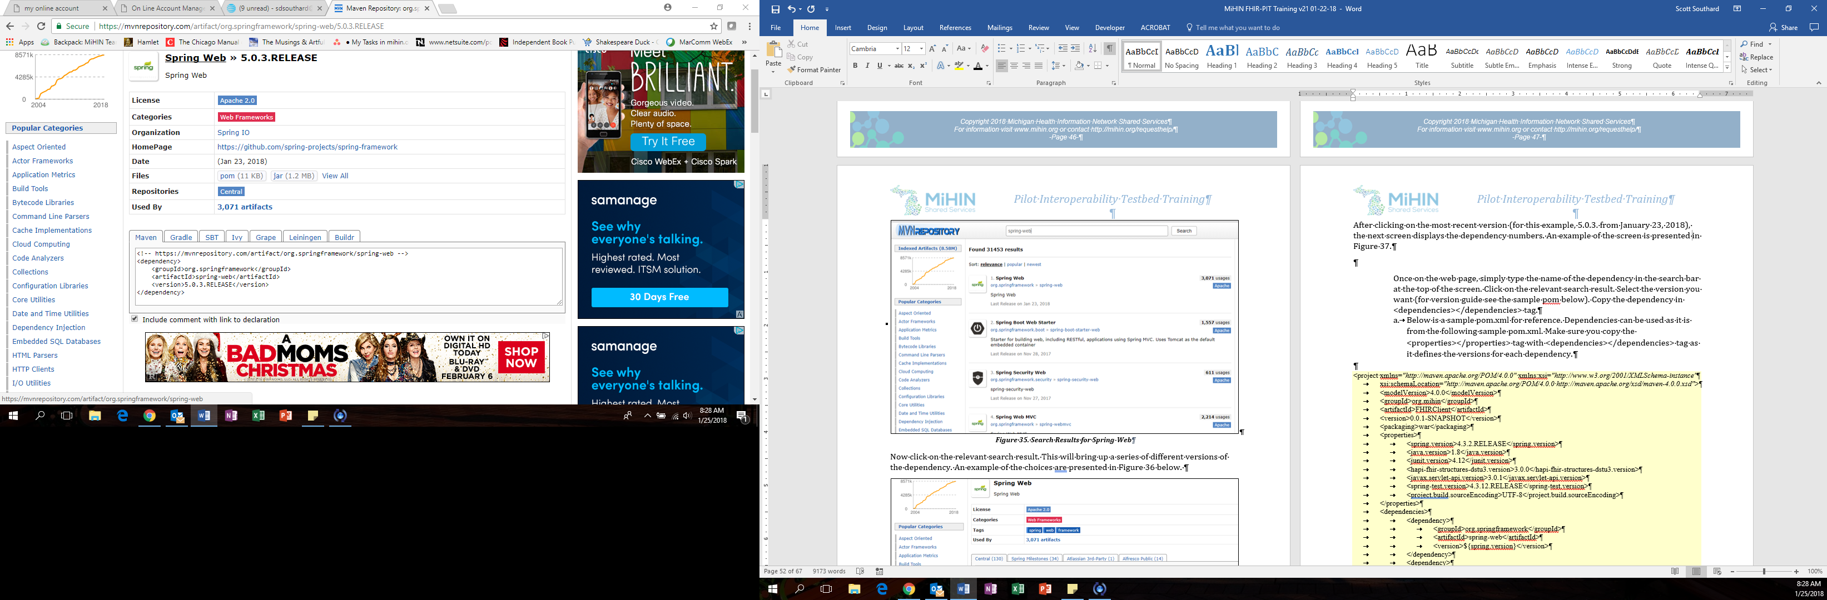
Figure 37. Spring Web Dependency
You have found the dependency for Spring Web, the first one on the list needed for pom. By clicking in the box, you can copy the necessary code. For this example, it is:
<!-- https://mvnrepository.com/artifact/org.springframework/spring-web -->
<dependency>
<groupId>org.springframework</groupId>
<artifactId>spring-web</artifactId>
<version>5.0.3.RELEASE</version>
</dependency>
After copying the code, return to the pom screen in Maven. On the bottom of the screen is a tab for “dependencies,” you can directly paste your script there.
Another option is you can add it to the pom tab, but you will need to tell FHIR that they are dependencies by using proper tags.
<dependencies>

<dependency>
COPIED CODE
</dependency>

<dependency>
COPIED CODE
</dependency>

<dependency>
COPIED CODE
</dependency>

</dependencies>

Now you will have to accomplish this for each of the dependencies. To help in the task, please feel free to use the following checklist:
- Spring Web
- Spring Webmvc
- Spring Test
- Commons Lang3
- Hamcrest Core
- Hamcrest Library
- Hapi Fhir Structures Dstu3
- Hapi Fhir Client
- Javax.servlet Api
- Junit

After adding all of the dependencies, you will need to “clean the project.”
This is accomplished by right clicking in the project on the screen, as seen in Figure 38 (below). Select “Screen Editor.” From there select “Run as” and then “maven clean.”

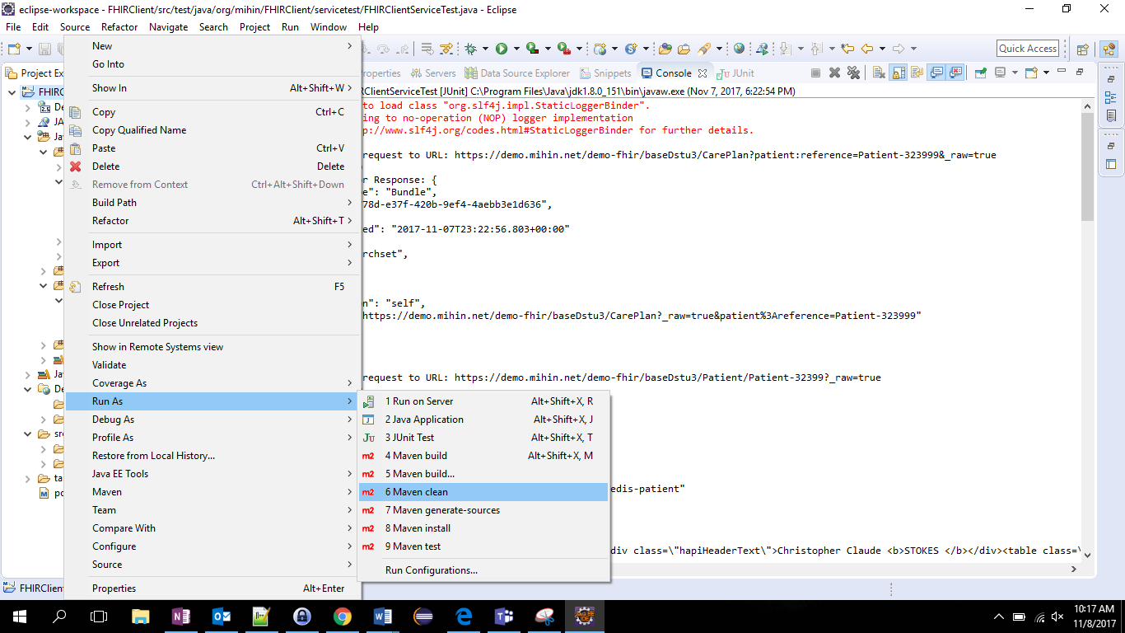
Figure 38. Maven Clean
We are finally up to the final step relating to FHIR dependencies! We will be installing them into Maven.
Like with the Maven Clean, right click on the screen, select “Run As,” and then select “Maven Install.” This is shown as an example in Figure 39, below. This step will download all the dependencies mentioned in the pom.xml.

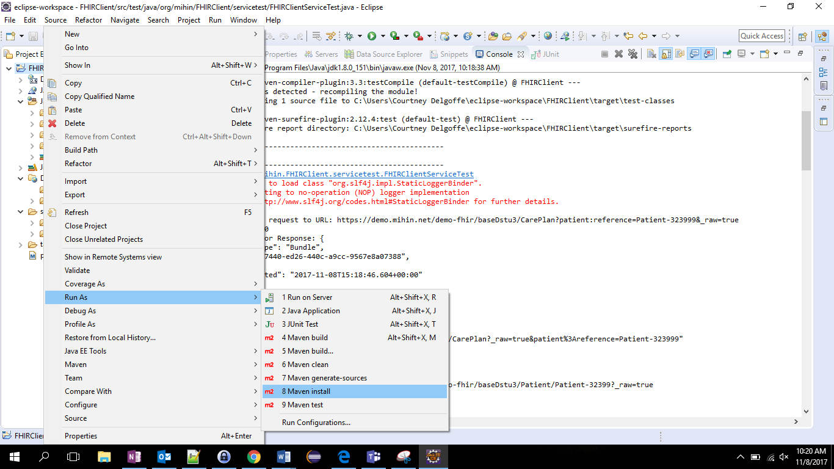
Figure 39. Maven Install

Step Six. Create Packages
In this next step we will be creating packages in the project. Packages will be used to organize the coding files.
Packages are folders that contain files just like any folder on your computer.
The following packages will be created under src/main/java:
- config
- constant
- controller
- service
- servicelmpl
The following steps are showcased in Figure 40, below. On the left side of the screen (under Project Explorer), select “Java Resources.” In the list under Java Resources, should appear the option “src/main/java.” Right click on that option.
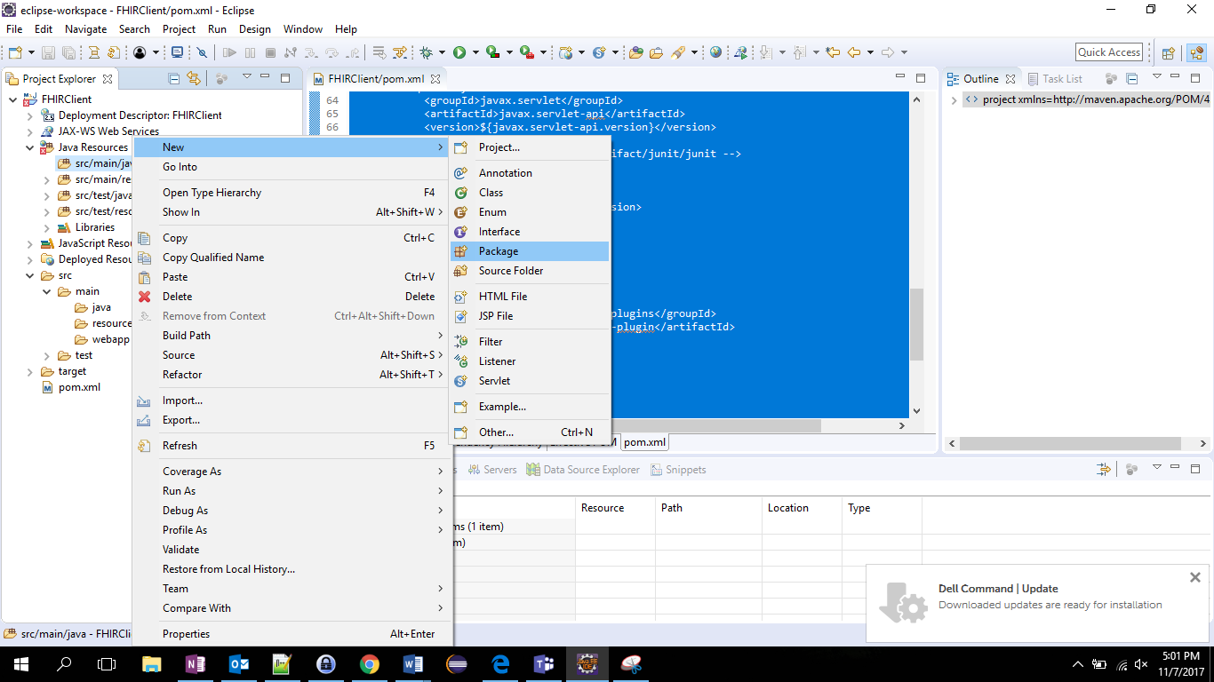
Figure 40. Create Package
After right clicking on src/main/java, select the option “New” and then “Package” (as shown in Figure 40). This will open the “New Java Package” window, Figure 41 (below).
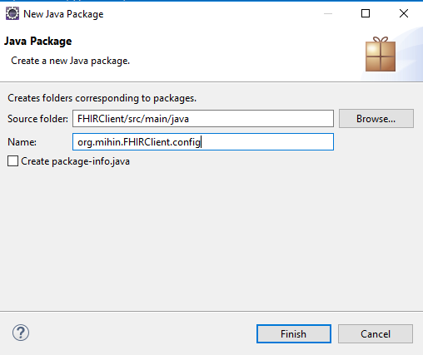
Figure 41. New Java Package
In the “Name” row, you will be saving each of the packages. In the example in Figure 41, we saved a “Config” file. You will be using the same name format for it as well. For our saves, it created a list of:
- Org.mihin.FHIRClien.config
- Org.mihin.FHIRClien.constant
- Org.mihin.FHIRClien.controller
- Org.mihin.FHIRClien.service
- Org.mihin.FHIRClien.servicelmpl
After completing the name, click “Finish,” Now repeat this task for each of the other needed project. When completed, it should like Figure 42 on your screen under Java Resource in Project Explorer.
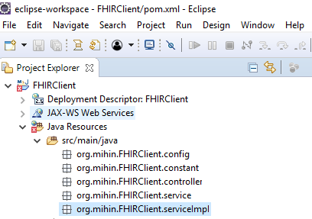
Figure 42. Completed Packages

Step Seven. Create Classes
The seventh step will be to create project configuration classes.
A class is a template that holds information and code snippets that define specific behavior. In java every class has .java extension, so classes can be recognized by java compiler (Compiler is a program that converts your code into byte code that is zeros and ones).
Below are presented a collection of “Classes” that can be copied as they appear here. Each has the correct package name declared at the top on where you are creating your class. For each, begin in the src/main/java folder (as seen in Figure 42), and right click on the right line, for example “org.main.FHIRClient.config.” After right clicking, click on “New” and then “Class.”
Please note: Make sure class name inside the code (like public class WebMvcConfig) is same as the class file name.

Config Classes
First, we will be adding classes under the config package.
Config classes hold the information on how your program will start up.
For that package, you will need to create “WebMvcConfig.java” and “CustomWebAppInitializer.java.”
Note: this version of WebMvcConfig is for Spring v5.x, not for 4.x.
The same is true for the CustomWebAppInitializer class, illustrated further down this document.
WebMvcConfig.java
package org.mihin.FHIRClient.config; // Make sure the package name is correct where you are //creating your class

import org.springframework.context.annotation.ComponentScan;
import org.springframework.context.annotation.Configuration;
import org.springframework.web.servlet.config.annotation.EnableWebMvc;

@Configuration //Represents a configuration class. Config classes contain @Bean annotated methods
@EnableWebMvc
@ComponentScan(basePackages = {"org.mihin.FHIRClient"}) //Scan base packages for annotated components to be handled by Spring container
public class WebMvcConfig {
//There are no @Bean annotated methods here. Spring will look up for annotated classes in the //base packages. Below are the common annotated types that make beans auto-detectable by //spring:
//@Repository Mark a bean as DAO component that defines the persistence layer
//@Service Mark a bean as Service component that defines the business logic layer
//@Controller Mark a bean as Controller component that defines the presentation layer that //define views and request mappings
//@Configuration Represents a configuration component
//@Component A generic annotation. Can be used for any layer of the program
//Note: You can replace all above mentioned annotations by @Component everywhere. But to //keep a consistent and clean design it is recommended to use the annotation based on the //purpose of the class.
}
CustomWebAppInitializer.java
//Replaces traditional web.xml(config file for web based applications). Loads your basic config class and define servlet mappings
package org.mihin.FHIRClient.config; //This is the name of the package you are creating the class //in

import javax.servlet.ServletContext;
import javax.servlet.ServletException;
import javax.servlet.ServletRegistration;

import org.springframework.web.WebApplicationInitializer;
import org.springframework.web.context.ContextLoaderListener;
import org.springframework.web.context.support.AnnotationConfigWebApplicationContext;
import org.springframework.web.servlet.DispatcherServlet;

public class CustomWebAppInitializer implements WebApplicationInitializer {

@Override
public void onStartup(ServletContext container) throws ServletException {
AnnotationConfigWebApplicationContext context = new AnnotationConfigWebApplicationContext();
context.setConfigLocation("org.mihin.FHIRClient.config");

container.addListener(new ContextLoaderListener(context));

ServletRegistration.Dynamic dispatcher = container.addServlet("dispatcher", new DispatcherServlet(context));

dispatcher.setLoadOnStartup(1);
dispatcher.addMapping("/");
}

}

Constant Classes
Next we will be adding classes under Constant. Like with Config., you will find this option by right clicking on the constant package (Figure 42), and then selecting “New” and then “Class.”
A Constant class defines all of the state constant variables required by the program to run.
For this class, you will need to add “NAME” and “NAME.” The text that needs to be copied in, is included below.

//A class defining all the static constant variables required by the program to run. Make //sure you update the server base URL to the FHIR server’s URL with which you are //trying to communicate

package org.mihin.FHIRClient.constant;

import ca.uhn.fhir.context.FhirContext;

public class FHIRClientConstant {
//FHIRContext is required to parse resources or create generic client. This class is //expensive to create as it scans all the resource classes required to be parsed or //encode, so should be created only once and shared among threads.
public static FhirContext ctx = FhirContext.forDstu3();
public static String base = "${Server Base URL}"; //Server base url
public String contentType = "application/json; charset=utf-8";
public static boolean useClientIds = true;
public static boolean appendAsJson = true;
public static String version = "";
}

Service Classes
The next classes to add will be “Service” classes. These classes include method definitions.
Methods are small blocks of code that are responsible for some functionality
For Service classes, we will need to add two options (included below). They are “FHIRClientService.java” and “HttpMethodService.java.” This direction is different than the previous ones, for here you will need to select “Interface” and then “Create.”
An interface in JAVA defines structure of a class. It contains method definitions.
The information to copy in are below.

FHIRClientService.java
//FHIRClientService.java is the entry point for FHIRClientService. It will act as a middle //man between your requests to the FHIR server.
//An interface that defines the methods for FHIRClientService
package org.mihin.FHIRClient.service;

import org.hl7.fhir.dstu3.model.Reference;
import org.hl7.fhir.dstu3.model.Resource;

public interface FHIRClientService {
public Resource read(Reference reference) throws Exception;

public Resource read(String type, String query) throws Exception;

public Resource create(Resource resource) throws Exception;
}

HttpMethodService.java
//Contains http methods to send the requests over the internet to communicate with //FHIR server
//An interface that define http request methods
package org.mihin.FHIRClient.service;

import java.net.HttpURLConnection;

public interface HttpMethodService {
public HttpURLConnection sendGet(String base, String query, StringBuffer response) throws Exception;

public HttpURLConnection sendPost(String base, String query, String data, StringBuffer response) throws Exception;

public HttpURLConnection sendPut(String base, String query, String data, StringBuffer response) throws Exception;

public HttpURLConnection sendDelete(String base, String query, String data, StringBuffer response) throws Exception;
}

Servicelmpl Classes
The final series of classes we will be including are servicelmpl packages. For this one we will be copying in two scripts. They are “FHIRClientServicelmpl.java” and “HttpMethodServicelmpl.java.”
Like with the other examples, click on servicelmpl” and select “Class.” Then copy in the material below.

FHIRClientServicelmpl.java
//Actual implementation of the FHIRClientService
package org.mihin.FHIRClient.serviceImpl;

import java.net.HttpURLConnection;

import org.hl7.fhir.dstu3.model.IdType;
import org.hl7.fhir.dstu3.model.Reference;
import org.hl7.fhir.dstu3.model.Resource;
import org.mihin.FHIRClient.constant.FHIRClientConstant;
import org.mihin.FHIRClient.service.FHIRClientService;
import org.mihin.FHIRClient.service.HttpMethodService;
import org.springframework.beans.factory.annotation.Autowired;
import org.springframework.stereotype.Service;

@Service("fhirClientService")
public class FHIRClientServiceImpl implements FHIRClientService {

@Autowired //Injecting HttpMethodService
private HttpMethodService httpMethodService;

/*Read a resource by reference*/
@Override
public Resource read(Reference reference) throws Exception {
String ref = reference.getReference();
StringBuffer response = new StringBuffer();
String query = FHIRClientConstant.appendAsJson ? "_raw=true" : "";
HttpURLConnection con = httpMethodService.sendGet(FHIRClientConstant.base + FHIRClientConstant.version + ref, query, response);
if (con.getResponseCode() != 200) {
// System.out.println("e" + con.getResponseCode() + " " + con.getResponseMessage());
throw new RuntimeException("FHIR Read error " + con.getResponseCode());
}
Resource resource = (Resource) FHIRClientConstant.ctx.newJsonParser().parseResource(response.toString());
return resource;
}

/*Read a resource by type and conditional query*/
@Override
public Resource read(String type, String query) throws Exception {
StringBuffer response = new StringBuffer();
query = FHIRClientConstant.appendAsJson ? query + "&_raw=true" : query;
HttpURLConnection con = httpMethodService.sendGet(FHIRClientConstant.base + "/" + type, query, response);
if (con.getResponseCode() != 200) {
System.out.println("e" + con.getResponseCode() + " " + con.getResponseMessage());
throw new RuntimeException("FHIR Read error " + con.getResponseCode());
}
Resource resource = (Resource) FHIRClientConstant.ctx.newJsonParser().parseResource(response.toString());
return resource;
}

@Override
/*Create a resource on FHIR server*/
public Resource create(Resource resource) throws Exception {
if (FHIRClientConstant.base != null)
if (FHIRClientConstant.useClientIds) {
String json = FHIRClientConstant.ctx.newJsonParser().setPrettyPrint(true)
.encodeResourceToString(resource);
StringBuffer response = new StringBuffer();
String base2 = FHIRClientConstant.base + "/" + resource.getResourceType().toString() + "/"
+ resource.getId();
HttpURLConnection con = httpMethodService.sendPut(base2, null, json, response);
if (con.getResponseCode() != 201) {
// System.out.println("e" + con.getResponseCode() + " " + con.getResponseMessage());
throw new RuntimeException("FHIR Create error " + con.getResponseCode());
}
} else {
resource.setId((IdType) null);
String json = FHIRClientConstant.ctx.newJsonParser().setPrettyPrint(true)
.encodeResourceToString(resource);
StringBuffer response = new StringBuffer();
HttpURLConnection con = httpMethodService
.sendPost(FHIRClientConstant.base + "/" + resource.getResourceType(), null, json, response);
if (con.getResponseCode() != 201) {
// System.out.println("e" + con.getResponseCode() + " " + con.getResponseMessage());
throw new RuntimeException("FHIR Create error " + con.getResponseCode());
}
setResourceId(resource, con);
}
return resource;
}

/*Set id for new resource. This will be used only when clientIds in the contants class is set to false*/
public void setResourceId(Resource resource, HttpURLConnection con) {
String location = con.getHeaderField("Location");
String[] parts = location.split("/");
resource.setId(parts[6]);
}

}

HttpMethodServicelmpl.java
//Actual implementation of the HttpMethodService
/*Http request methods.*/
package org.mihin.FHIRClient.serviceImpl;

import java.io.BufferedReader;
import java.io.DataOutputStream;
import java.io.InputStreamReader;
import java.net.HttpURLConnection;
import java.net.URL;

import org.mihin.FHIRClient.service.HttpMethodService;
import org.springframework.stereotype.Service;

@Service("httpMethodService")
public class HttpMethodServiceImpl implements HttpMethodService {
final static String USER_AGENT = "Mozilla/5.0";

@Override
public HttpURLConnection sendGet(String base, String query, StringBuffer response) throws Exception {
URL url = query == null || query.isEmpty() ? new URL(base) : new URL(base + "?" + query);
HttpURLConnection con = (HttpURLConnection) url.openConnection();

con.setRequestMethod("GET");
con.setRequestProperty("User-Agent", USER_AGENT);
con.setRequestProperty("Accept", "application/fhir+json;charset=UTF-8");
// setAuthorization(con);
System.out.println("\nSending 'GET' request to URL: " + url);
send(null, response, con);
// System.out.println(response.toString());
return con;
}

@Override
public HttpURLConnection sendPost(String base, String query, String data, StringBuffer response) throws Exception {
return null;
}

@Override
public HttpURLConnection sendPut(String base, String query, String data, StringBuffer response) throws Exception {
return null;
}

@Override
public HttpURLConnection sendDelete(String base, String query, String data, StringBuffer response)
throws Exception {
return null;
}

private void send(String data, StringBuffer response, HttpURLConnection con) {
try {
String encoding =
Base64.getEncoder().encodeToString(("fhir@tester.org:Sandbox2@").getBytes());
con.setRequestProperty("BasicAuth", "Basic " + encoding);
if (data != null) {
System.out.println(data);
con.setDoOutput(true);
DataOutputStream wr = new DataOutputStream(con.getOutputStream());
wr.writeBytes(data);
wr.flush();
wr.close();
} else {
con.setDoOutput(false);
}
BufferedReader in = new BufferedReader(new InputStreamReader(con.getInputStream()));
String inputLine;
while ((inputLine = in.readLine()) != null)
response.append(inputLine);
in.close();
System.out.println("Response = " + con.getResponseCode());
} catch (Exception e) {
}
}

}

With the completion of these sections, you are ready to test the FHIR-PIT!

Section 3. Testing With the FHIR-PIT
With the completion of the previous two sections, you now have the capability to test the FHIR-PIT. Below are two options for tests that you can accomplish in the FHIR-PIT.
- Collecting a FHIR resource
- Retrieving patient and care plan data

Collecting a FHIR Resource
The first option you should consider is your ability to collect a FHIR resource. In other words, information that is available in FHIR now. To begin this test, return to the Eclipse Workspace (Figure 30).
To begin, create a package under src/test/java, using the same techniques as were discussed above. These tests will be using the FHIR codes we just wrote, “call” the FHIR-PIT and return a FHIR resource. A sample test could be getting resources from the FHIR server ids, and they can be modified to fetch different resources.

package org.mihin.FHIRClient.servicetest;

import static org.junit.Assert.assertNotNull;
import org.hl7.fhir.dstu3.model.Bundle;
import org.hl7.fhir.dstu3.model.Patient;
import org.hl7.fhir.dstu3.model.Reference;
import org.junit.Test;
import org.junit.runner.RunWith;
import org.mihin.FHIRClient.config.WebMvcConfig;
import org.mihin.FHIRClient.constant.FHIRClientConstant;
import org.mihin.FHIRClient.service.FHIRClientService;
import org.springframework.beans.factory.annotation.Autowired;
import org.springframework.test.context.ContextConfiguration;
import org.springframework.test.context.junit4.SpringJUnit4ClassRunner;
import org.springframework.test.context.web.WebAppConfiguration;

@RunWith(SpringJUnit4ClassRunner.class)
@WebAppConfiguration
@ContextConfiguration(classes = {WebMvcConfig.class})
public class FHIRClientServiceTest {
@Autowired
private FHIRClientService fhirClientService;

@Test
public void getPatientByIdTest() throws Exception {
Patient pat = (Patient) fhirClientService.read(new Reference().setReference("/Patient/Patient-32399"));
String json = FHIRClientConstant.ctx.newJsonParser().setPrettyPrint(true).encodeResourceToString(pat);
assertNotNull(pat);
System.out.println("getPatientByIdTest Response: "+json);
}

@Test
public void getCarePlansFor() throws Exception {
Bundle bundle = (Bundle) fhirClientService.read("CarePlan", "patient:reference=Patient-323999");
assertNotNull(bundle);
String json = FHIRClientConstant.ctx.newJsonParser().setPrettyPrint(true).encodeResourceToString(bundle);
System.out.println("getCarePlansFor Response: "+json);
}
}

Retrieve Patient and Care Plan Data
Another important function of the FHIR-PIT is to retrieve patient and care plan data. There are three steps to complete this process.
            - You can retrieve this data for a different patient by changing their ID or their care plan. (You can see the patient number highlighted in the code above.)
            - Then you will need to run the program to bring up the new information. This is illustrated by Figure 43.
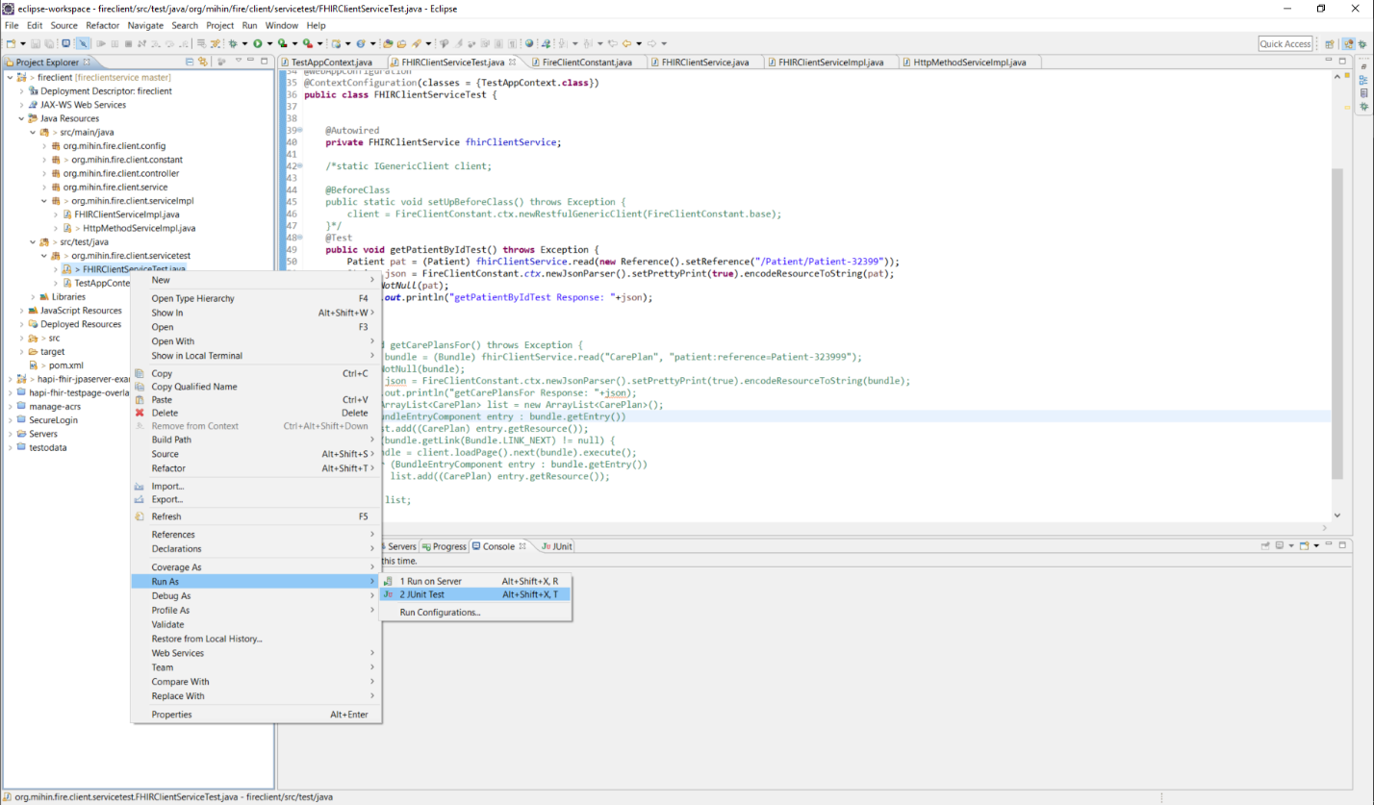
Figure 43. Retrieving Data Example

            - After completing your program, you can right click on the unit tests and select run as junit that you created in FHIRClientServiceTest and see the result in console. The results are presented for this example in Figure 44, below.

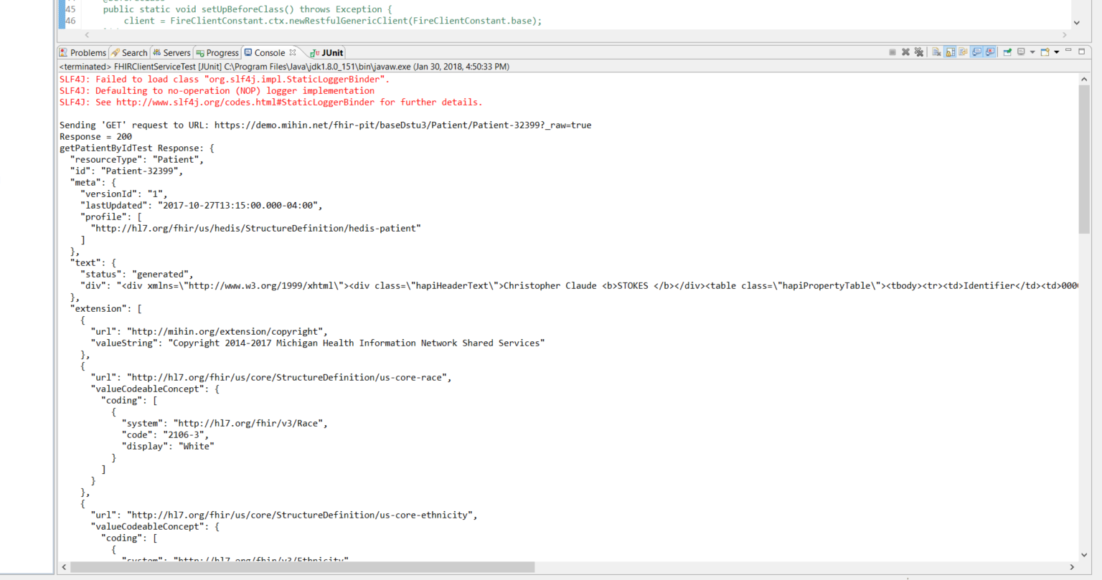
Figure 44. Results for Test

Section 4. Testing with the Ring of FHIR
People travel for many reasons, and at times they need to visit a healthcare professional or organization. Patient treatment data can, as a result, be spread among many organizations across a city, region, state, the U.S., and even across the planet.
Ideally, a healthcare practitioner, to keep their patient records complete, would be copied on updates from other healthcare professionals about their patients, or they could query individual systems to gain knowledge of their patient’s visits elsewhere: assuming of course, that they know whose system to query.
Better interoperability between statewide and national networks is starting to make this vision a reality, and the introduction of FHIR for access to granular patient information is transforming healthcare IT from sharing cumbersome, multi-page patient documents that must be analyzed and parsed into an efficient, highly-targeted enterprise that can produce exactly the desired information in exactly the right format.
The “Ring of FHIR” was created to simulate more granular interoperability using FHIR between organizations (e.g. hospital, clinic, HIE, health plan, government agency, etc.). The Ring of FHIR allows an environment in which authorized providers use a REST API application to enter a Patient_ID and the category of data desired (Medications, Immunizations, Observations, etc.) and receive back those records in JSON format for the patient, wherever the patient may have traveled, assuming there is a local FHIR-PIT holding that data.
The MiHIN Active Care Relationship Service (ACRS®) acts (among other things) as an index of where patients have received healthcare, so that local or regional FHIR-PITS can then be queried to obtain information on that patient’s treatment and report it back to the querying healthcare professional.

FHIR Station as Centralized Hub
The Ring of FHIR includes several FHIR-PITs interconnected by a FHIR client application, the MiHIN “FHIR Station”, which serves as a hub for these simulated “edge” organizations to produce and consume stored test data (e.g. FHIR resources).
Figure 45. Ring of FHIR

How It Works
- End user requests Document Reference (e.g. CCD) for Patient ID from MiHIN FHIR Station
- MiHIN FHIR Station sends query with Patient ID as a parameter to FHIR-PIT A, B, C, D, E
- FHIR-PIT A, B, C, D, and E query for Patient Resource (Demographics) for Patient ID
- FHIR-PIT A, B, C, D, and E return Patient Resource to MiHIN FHIR Station
- MiHIN FHIR Station queries Active Care Relationship Service (ACRS) for End Points of Patient Resource relationships
- ACRS returns End Points (FHIR-PIT B, C, D, and E)
- MiHIN FHIR Station queries End Points for Document Reference
- FHIR-PITs B, C, D, and E return Document Reference Resources
- MiHIN FHIR Station bundles Document References and sends to End User

MiHIN FHIR Station
The FHIR Station will query FHIR-PITs that have clinical information for patients by using the Patient ID, entered as a string of characters; e.g., “Patient-1123”, without the quotes. You can use different Patient IDs, but you can only enter one at a time for a given browser tab.
The MiHIN FHIR Station allows the entry of a query in the browser web address box:

Figure 46. Entry of Query

Address of MiHIN FHIR Station for Connectathon:
http://<hostname>/fhirstation/<resource-to-query/Patient-n
As shown above, to query the MiHIN FHIR Station, you will need to enter Hostname, the FHIR Station Name, the resource you’re looking for (ex. Observation; Immunization; Medications, etc) and Patient ID into the URL.
After you press enter, the application will work for a few seconds, and if data is found, it will show:
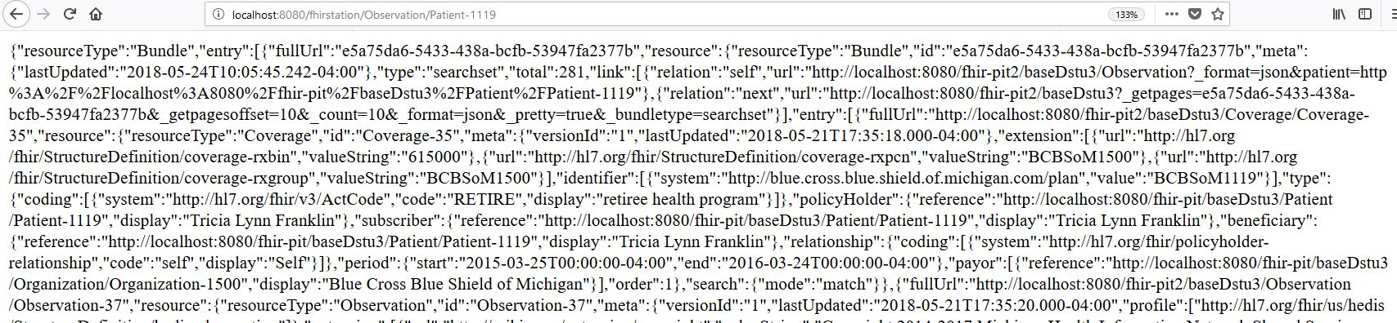
Figure 47. Results
This text can then be selected, copied, and converted to JSON format by a site like:
https://jsonformatter.curiousconcept.com/
which will give you:
{
"resourceType":"Bundle",
"entry":[
{
"fullUrl":"http://localhost:8080/fhir-pit/baseDstu3/Observation/Observation-17878278/_history/1",
"resource":{
"resourceType":"Observation",
"id":"Observation-17878278",
"meta":{
"versionId":"1",
"lastUpdated":"2017-10-27T14:55:44.000-04:00",
"profile":[
"http://hl7.org/fhir/us/hedis/StructureDefinition/hedis-observation"
]
},
"extension":[
{
"url":"http://mihin.org/extension/copyright",
"valueString":"Copyright 2014-2017 Michigan Health Information Network Shared Services"
}
],
"identifier":[
{
"system":"mihin.org/fhir/sid/elementId",
"value":"a7f9fc29-22d9-4a04-bcd4-c5737646d0b7"
}
],
"status":"final",
"code":{
"coding":[
{
"system":"http://loinc.org",
"code":"6206-7",
"display":"Peanut IgE Ab in Serum"
}
]
},
"subject":{
"reference":"Patient/Patient-43836",
"display":"Leon Webster Tanner"
},
"context":{
"reference":"Encounter/Encounter-658759",
"display":"Allergist_Initial_Visit"
},
"effectiveDateTime":"2020-01-02T00:29:00-05:00",
"performer":[
{
"reference":"Practitioner/Practitioner-4972",
"display":"Wilma Crystal Travis MD"
}
(rest of JSON omitted)
This type of lookup can be performed for Immunizations, MedicationRequests, Encounters, and other FHIR resources contained in FHIR-pits.

Addresses of FHIR-PITs that are queried by Ring of FHIR:
EHRs
  - https://fire-pit.mihin.org/pit-ehr1/
  - https://fire-pit.mihin.org/pit-ehr2/
  - https://fire-pit.mihin.org/pit-ehr3/
  - https://fire-pit.mihin.org/pit-ehr3/
HIEs
  - https://fire-pit.mihin.org/pit-hie1/
  - https://fire-pit.mihin.org/pit-hie2/
  - https://fire-pit.mihin.org/pit-hie3/
  - https://fire-pit.mihin.org/pit-hie4/
Payers
  - https://fire-pit.mihin.org/pit-bcbspayer/
  - https://fire-pit.mihin.org/pit-payer/
ACRS®
  - https://fire-pit.mihin.org/pit-acrs/
Health Directory
  - https://fire-pit.mihin.org/pit-hd/
Quality
  - https://fire-pit.mihin.org/cqf-ruler/tester/

Example Scenario – Fighting Fire with FHIR


Meet Alice Vargas:
- Alice Vargas’s life after returning from a tour in Afghanistan has not been easy. While there, she was caught in an explosion which cost her half of her right leg. Alice is suffering from post-traumatic stress disorder (PTSD). She copes by smoking more than a pack a day and drinking more than she used to. She is also drawn to drugs
- Alice sees her primary care provider at the local Veteran Affairs hospital for an annual check-up. Her doctor would like to view Alice’s most recent medication list
Steps:
- Primary care physician (PCP) uses EHR to find Alice’s medications
- MiHIN’s FHIR Station uses Active Care Relationship Service to find Alice’s Care Team
- FHIR Station finds medications from Care Team members’ EHRs
- EHRs respond with Alice’s medications
- FHIR Station sends medication list back to Alice’s primary care physician

Additional Info, FAQs and Troubleshooting
Scalable health information exchange can be accomplished by focusing on interoperability through enforcing rigorous data and technical standards. The testbed enables machine-validated conformance and normalization.

Confidential Information
The FHIR Pilot Interoperability Testbed (FHIR-PIT) is provided exclusively as a service to the healthcare software development community for testing purposes.
Information that contains protected health information (PHI) or any other confidential information are not permissible in the FHIR-PIT.

Not for Use for Clinical Care
This testbed should not be used in the provision of clinical care.

Common Problem: Java Development Kit
Please be sure you download the correct version of the Java Development Kit. At the of this writing, the correct version of JDK is JDK1.7+. To verify you have the correct version, click on “projects” then select “properties.” From there visit “java build path” then “libraries.” The screen will display the current JDK installed. This is illustrated in Figure 45, below.
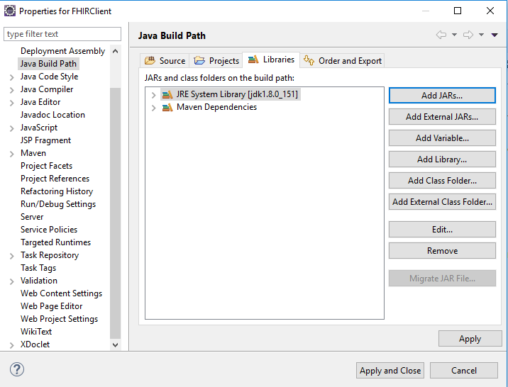
Figure 48. Verifying Version of JDK

Need More Assistance?
If you are experiencing difficulties, have questions or simply would like to learn more about the FHIR-PIT, please contact Tom Clifford
- Thomas.clifford@mihin.org
- Tom will be available via WebEx on Monday, June 4 from 10am-2pm and Tuesday, June 5 from 9:00am-12pm

For WebEx information, please contact lauren.kosowski@mihin.org.

Many thanks to HL7 for agreeing to let MiHIN host this
Meteoric Interoperability Connectathon!

About the Michigan Health Information Network Shared Services
The Michigan Health Information Network Shared Services (MiHIN) is Michigan’s state-designated entity to improve health care quality, efficiency, and patient safety by sharing electronic health information statewide, helping reduce costs for patients, providers, and payers. MiHIN is a non-profit, public-private collaboration that includes stakeholders from the State of Michigan, health information exchanges that serve Michigan, health systems and providers, health plans/payers, pharmacies, and the Governor’s Health Information Technology Commission. For more information on MiHIN, please visit mihin.org.

Margaret Rouse, “FHIR (Fast Healthcare Interoperability Resources),” Techtarget, accessed January 15, 2018, http://searchhealthit.techtarget.com/definition/FHIR-Fast-Healthcare-Interoperability-Resources
Ibid.
Ibid.
Ibid.
Ibid.
“8.6.8 Resource Organization – Detailed Descriptions,” FHIR Release 3 (STU), accessed November 1, 2017, https://www.hl7.org/fhir/organization-definitions.html
Ibid.
“8.4.8 Resource Practitioner – Detailed Descriptions,” FHIR Release 3 (STU), accessed November 1, 2017, https://www.hl7.org/fhir/practitioner-definitions.html
Ibid.
“8.1.13 Resource Patient – Detailed Descriptions,” FHIR Release 3 (STU), accessed November 1, 2017, https://www.hl7.org/fhir/patient-definitions.html
Ibid.
“9.7.6 Resource CareTeam – Detailed Descriptions,” FHIR Release 3 (STU), accessed November 1, 2017, https://www.hl7.org/fhir/careteam-definitions.html
Ibid.
“11.6.6 Resource Immunization – Detailed Descriptions,” FHIR Release 3 (STU), accessed November 1, 2017, https://www.hl7.org/fhir/immunization-definitions.html
Ibid.
“8.11.8 Resource Encounter,” FHIR Release 3 (STU), accessed November 1, 2017, https://www.hl7.org/fhir/encounter-definitions.html
Ibid.
“11.5.6 Resource Medication – Detailed Descriptions,” FHIR Release 3 (STU), accessed November 1, 2017, https://www.hl7.org/fhir/medication-definitions.html
Ibid.
“HTTP basic authentication,” IBM Knowledge Center, accessed January 19, 2018, https://www.ibm.com/support/knowledgecenter/en/SSGMCP_5.1.0/com.ibm.cics.ts.internet.doc/topics/dfhtl2a.html
At the time of this writing (January 19, 2018), the current JAVA SE Development kit is 8u152.
“PATH (variable),” Wikipedia, accessed January 19, 2018, https://en.wikipedia.org/wiki/PATH_(variable)
Please note, this address is based on the version available as of this writing, it might be different for you.
“Eclipse (software),” Wikipedia, accessed January 22, 2018, https://en.wikipedia.org/wiki/Eclipse_(software)
January 22, 2018
January 29, 2018

