Clinicians on FHIR

Emergency Care

How do we represent ED specific data in FHIR? Chief Complaint? Coded CC?

Screening tasks

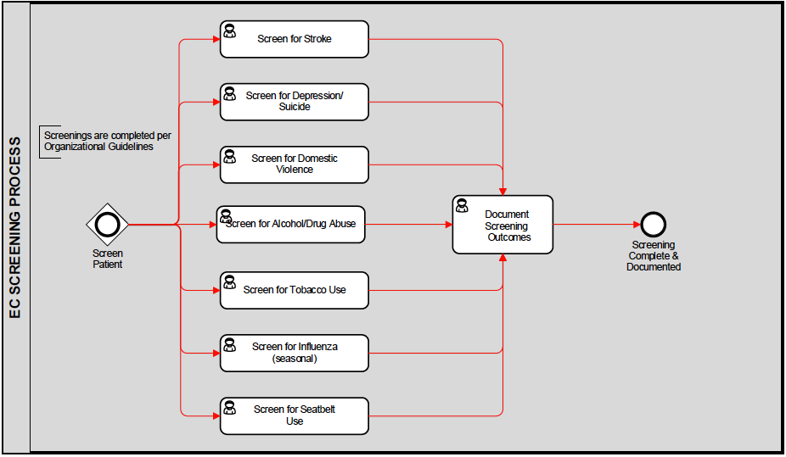

Stroke

**FAST** is an [acronym](https://en.wikipedia.org/wiki/Acronym) used as a [mnemonic](https://en.wikipedia.org/wiki/Mnemonic) to help detect and enhance responsiveness to [stroke](https://en.wikipedia.org/wiki/Stroke) victim needs. The acronym stands for **F**acial drooping, **A**rm weakness, **S**peech difficulties and **T**ime to call emergency services.[[1]](https://en.wikipedia.org/wiki/FAST_%28stroke%29#cite_note-autogenerated1-1)

* Facial drooping: A section of the face, usually only on one side, that is [drooping and hard to move](https://en.wikipedia.org/wiki/Central_facial_palsy). This can be recognized by a crooked smile.
* Arm weakness: The inability to [raise one's arm fully](https://en.wikipedia.org/wiki/Paresis)
* Speech difficulties: An [inability or difficulty to understand or produce speech](https://en.wikipedia.org/wiki/Aphasia)
* Time: If any of the symptoms above are showing, time is of the essence; call the [emergency services](https://en.wikipedia.org/wiki/Emergency_services) or go to the hospital.[[1]](https://en.wikipedia.org/wiki/FAST_%28stroke%29#cite_note-autogenerated1-1)

1. *Facial droop:* Have the person smile or show his or her teeth. If one side doesn't move as well as the other so it seems to droop, that could be sign of a stroke.
   * Normal: Both sides of face move equally
   * Abnormal: One side of face does not move as well as the other (or at all)
2. *Arm drift:* Have the person close his or her eyes and hold his or her arms straight out in front for about 10 seconds. If one arm does not move, or one arm winds up drifting down more than the other, that could be a sign of a stroke.
   * Normal: Both arms move equally or not at all
   * Abnormal: One arm does not move, or one arm drifts down compared with the other side
3. *Speech:* Have the person say, "You can't teach an old dog new tricks," or some other simple, familiar saying. If the person slurs the words, gets some words wrong, or is unable to speak, that could be sign of stroke.
   * Normal: Patient uses correct words with no slurring
   * Abnormal: Slurred or inappropriate words or mute

LAPSS

**Screening Criteria**

* Over 45 years old
* No history of seizures
* Neurologic symptoms started to present within the last 24 hours
* Patient is not hospitalized
* Blood sugar is 60 - 400 mg/dL
* Unilateral (and not bilateral) exhibition of Facial Droop, Grip weakness, Arm weakness or other observable motor asymmetries

If **all** of these criteria are met (or not ascertainable) the LAPSS is positive for stroke. Patients may still be experiencing a stroke even if LAPSS criteria are not met.[[2]](https://en.wikipedia.org/wiki/Los_Angeles_Prehospital_Stroke_Screen_%28LAPSS%29#cite_note-2)

Depression/Suicide

PHQ-9

Domestic Violence

SAFE Questions (oral, add sequentially as needed)  
Ashur M. Asking About Domestic Violence: SAFE Questions. JAMA.1993;269(18):2367

**Stress/safety**

1. What stresses do you experience in your relationships?
2. Do you feel safe in your relationship?

**Afraid/abused**

1. People in relationships sometimes fight.  What happens when you and your partner disagree?
2. Have there been situations in your relationship where you have felt afraid?
3. Have you been physically hurt or threatened by your partner?
4. Has your partner forced you to engage in sexual activities that you didn’t want?

**Friends/family**

1. Are your friends and family aware of what is going on?

**Emergency**

8. Do you have a safe place to go in an emergency?

Alcohol Drug Abuse

SBIRT – pull out example from the PDF document.

DAST – pull out example from the PDF document – page 10.

Tobacco Use

Do you use tobacco? Y/N

What form (cigarettes, pipe, cigar, chew, …. – anything in the value set authority?

How much? How many packs per day?

How long have you been using tobacco? < 1 year, ….. 10 years or more,

How old were you when you first started using tobacco? *age

Screen for Influenza

When was your last flu shot? (expected answer – a date, or number of months or years ago, refused immunization)

Screen for Seatbelt Use

Do you use your seatbelt? Y/N, always, sometimes, never…

Fall?

Have you fallen in the last year? Y/N

How many times (number)

When was the last fall? (date, or number of weeks/months ago)