**Mock EDC System for Clinical Research Track Home Page:**

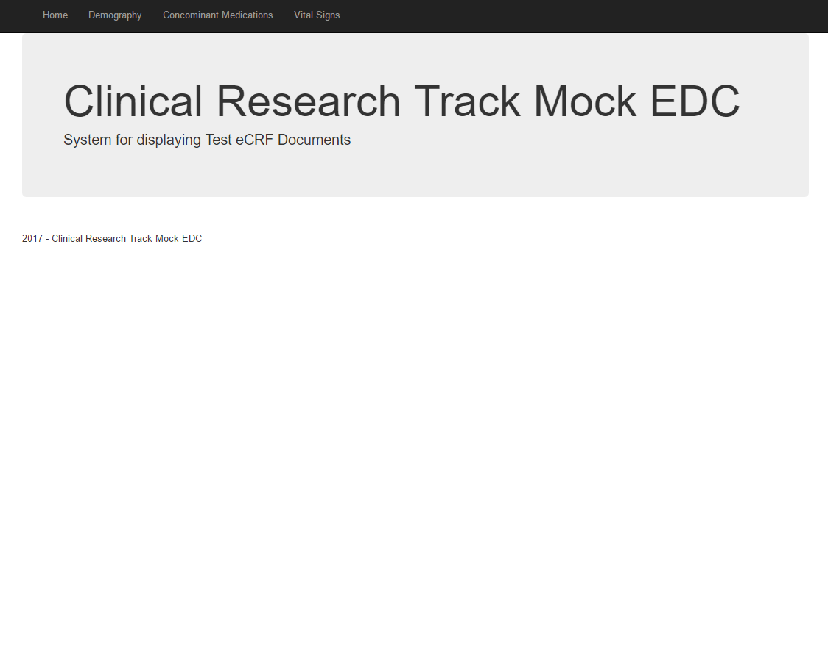

**Subject Demography eCRF:**

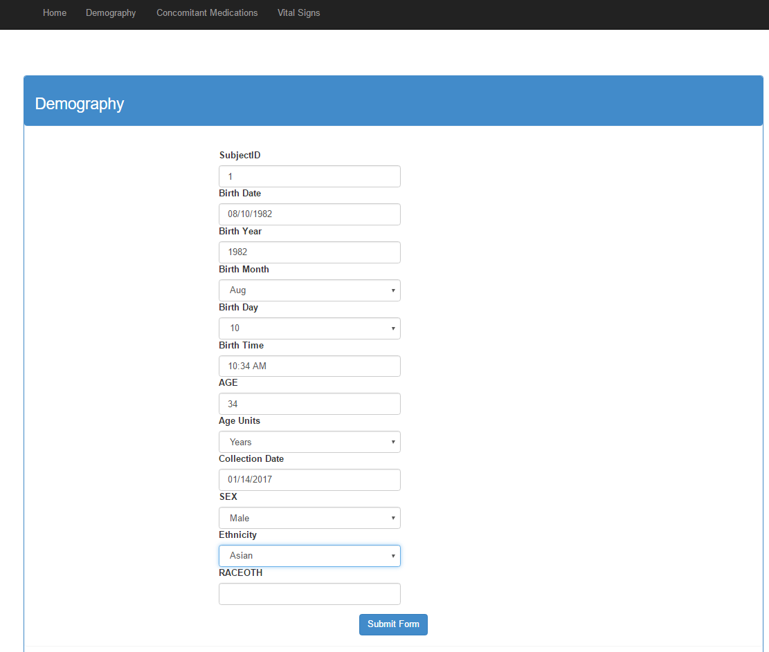

**CRF Demography Service**

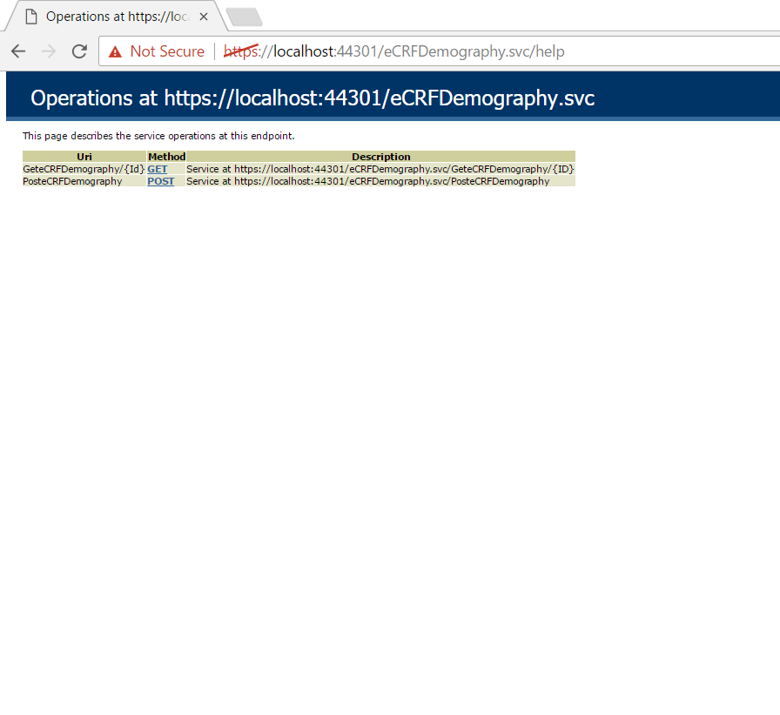

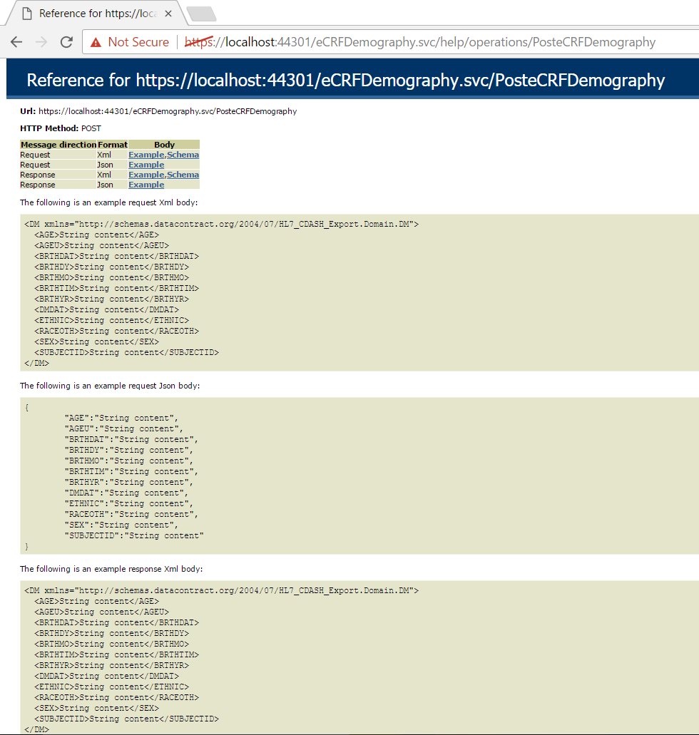

**Sample eCRF Object Serialized (CDASH Specification)**

{

"AGE": "34",

"AGEU": "MU.YEARS_2011-10-24",

"BRTHDAT": "1982-08-10",

"BRTHDY": "10",

"BRTHMO": "8",

"BRTHTIM": "10:34",

"BRTHYR": "1982",

"DMDAT": "2017-01-14",

"ETHNIC": "RACE.ASIAN",

"RACEOTH": null,

"SEX": "M",

"SUBJECTID": "1"

}