

**DME Order Details API**

**Release: 2020 – Q1**

**Version: 1.3**

|  |  |  |  |
| --- | --- | --- | --- |
|  |  | |  |
|  |  | |  |
| **Table of Contents** | |  | |
|  | |  | |

1 Introduction 4

1.1 Document Purpose 4

1.2 Data Type Descriptions 4

1.3 Technical Overview 5

2 Authentication 6

2.1 Tokens 6

2.2 Creating a Client 6

2.3 Creating a Token 7

2.4 Creating a Token 8

3 DME Order API 10

3.1 Get: Order List - All 10

3.2 Get: Order List – From Date/Time (to Now) 10

3.3 Get: Order – by Record Locator 10

3.4 Get: Document – by Order Document ID 12

4 Order Data Layout 13

4.1 Hierarchy 13

5 Base objects – JSON Data 15

5.1 OrderList 15

5.2 OrderListRecord 16

5.3 Name 18

5.4 Address 18

5.5 Contact 18

6 Order & dependent objects – JSON Data 20

6.1 Order 20

6.2 Item 25

6.3 Document 25

6.4 Note 26

6.5 Patient 27

6.5.1 Demographics 28

6.5.2 Coverage 28

6.5.2.1 Guarantor 30

6.5.2.2 Payor 31

6.5.3 ClinicalEncounter 32

6.5.3.1 Observations 32

6.5.3.2 Diagnoses 33

6.5.3.2.1 Diagnosis 33

6.5.3.1 Medications 33

6.5.3.1.1 Medication 33

6.5.3.2 Procedures 34

6.5.3.2.1 Procedure 34

6.6 Provider 35

6.6.1 ProviderOrganization 36

6.6.2 ProviderLocation 37

6.6.3 Prescriber 38

6.7 Supplier 39

6.7.1 SupplierOrganization 39

6.7.2 SupplierBranch 41

6.8 SupplierContract 41

6.8.1 SupplierContractOrganization 42

6.8.2 SupplierContractBranch 43

7 Future API Considerations 45

7.1 Publish API - Postman Documentation 45

7.2 Order Lifecycle Journal 45

7.3 ClinicalEncounter 46

7.4 ClinicalEpisode 46

8 Copyright Notice 46

8.1 Trademarks 46

8.2 Version 46

8.3 Corrections 47

9 Revision History 48

# Introduction

DMEhub provides for secure access to Order information so that medical equipment suppliers (“Suppliers”) and healthcare providers (“Providers”) can retrieve Order data for use within their workflows.

For Providers, use cases include…

* Medical Record - Documents  
  Retrieving relevant documents for inclusion into a patient’s encounter medical record; Documents – DWO (Detailed Written Order), CMN (Certificate of Medical Necessity), WOPD (Written Order Prior to Delivery), Delivery Ticket/Confirmation, Patient Assessments, etc.
* SLA – Service Level Reporting  
  Retrieve service level key performance indicators to determine – how long for; order status - acceptance / rejection / delivery / abandonment / cancellation,  
  Prescriber to sign order, etc.

For Suppliers, use cases include…

* Order Qualification / Processing  
  Retrieve all Order information for automating qualification and processing of an order.
* SLA – Service Level Reporting  
  Retrieve service level key performance indicators to determine – how long for; order status - acceptance / rejection / delivery / abandonment / cancellation,  
  Prescriber to sign order, etc.

## Document Purpose

This document outlines how to securely connect electronically with DMEhub and how to retrieve Order related data via configuration within the DMEhub web-app (establish secure identity) and how to interact with the API (calls, returned data, etc.).

## Data Type Descriptions

The DMEhub Order Details API is a REST (JSON) based API secured using OAuth2.

* Note: Future version of API will convert from using integer based ID to UUID as listed below…

DMEhub UUID  
<https://en.wikipedia.org/wiki/Universally_unique_identifier>

* + DMEhub supports version 1.

Example of valid value.

* + F523E801-DB84-42D6-A796-93DBEF2CF37C
  + 263D1757-4B93-3665-3DA9-F8F121CEEA5A
* dateTime  
  <https://en.wikipedia.org/wiki/ISO_8601>

* date  
  <https://en.wikipedia.org/wiki/ISO_8601>

## Technical Overview

The DMEhub Order Details API is a REST (JSON) based API secured using OAuth2.

* OAuth2 information can be found here:  
  <https://oauth.net/2/>

# Authentication

## Tokens

For authentication with the DMEhub – Order Details API, partners should must use a **Client ID** and **Client Secret** created within the DMEhub application to create a token which can then be used in subsequent requests.

Partners are responsible for the management of the token during its lifetime.

## Creating a Client

Using OAuth 2 with authorization codes is how most developers are familiar with OAuth 2. When using authorization codes, a client application will redirect a system user to the DMEhub server where DMEhub will either approve or deny the request to issue an access token to the client.

First, developers building applications that need to interact with the DMEhub – Order Details API will need to register their application with DMEhub by creating a **Client ID**. Typically, this consists of providing the name of the client application and a URL that the client application can redirect to after approval for the request for authorization.

To do that, system users will need to login to DMEhub and go to their Settings and click on the API tab:

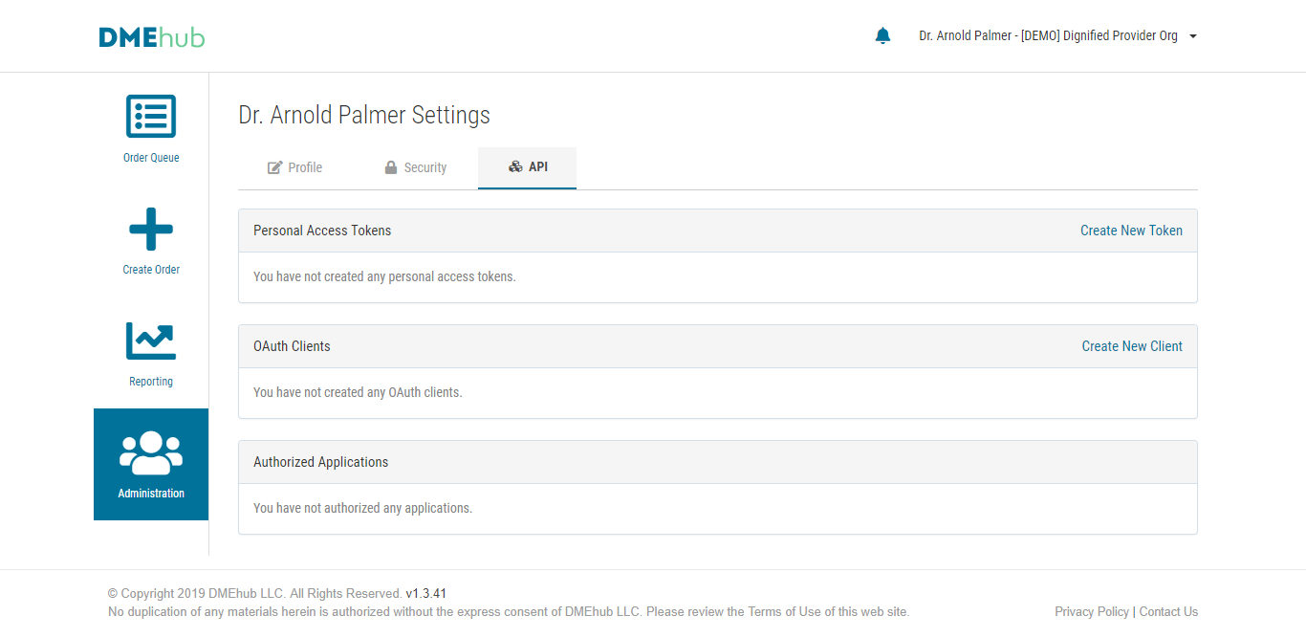

From here, click on the “Create New Client” link and enter the client information:

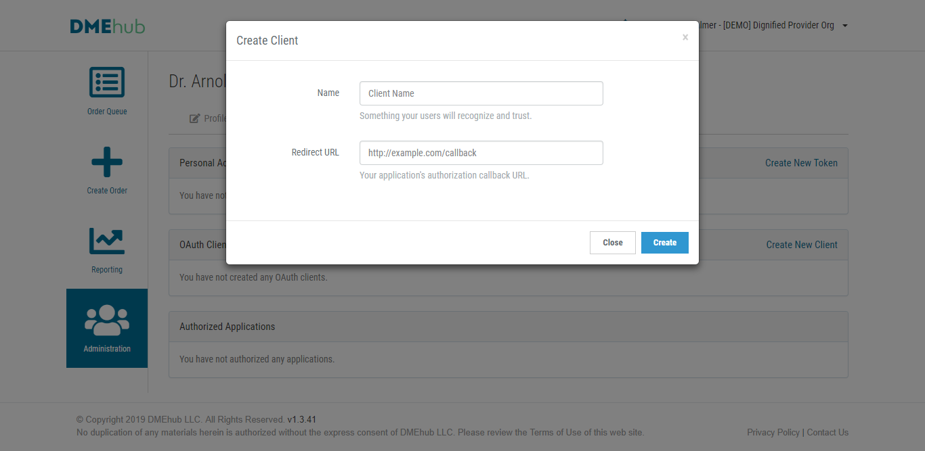

## Creating a Token

Once a system user access client has been created, an access token can be created by clicking the “Create New Token” link:

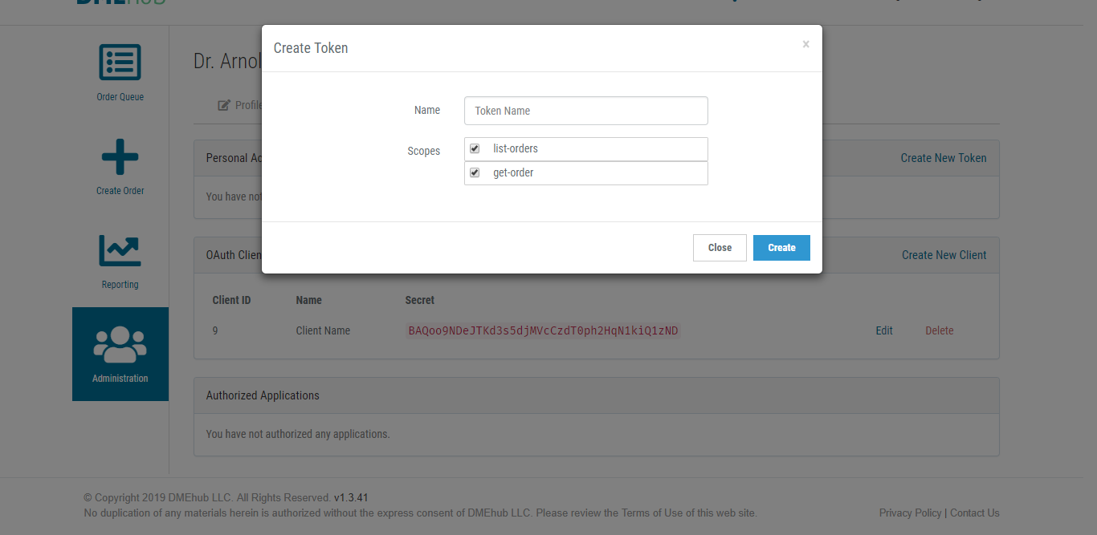

Once an access token is created, it can be used along with the **Client ID** and **Client Secret** to make requests to the DMEhub – Order Details API.

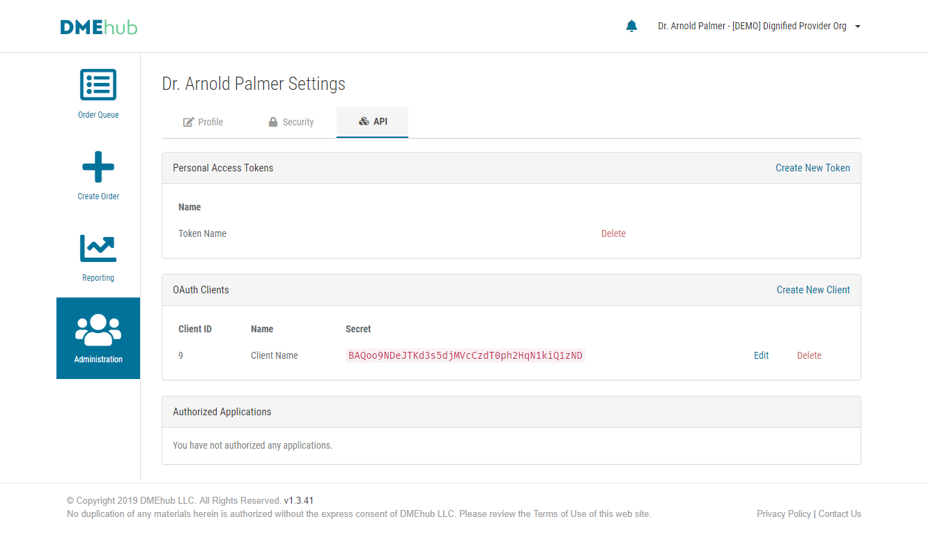

## 2.4 Creating a Token

The ClientID and Client Secret are only needed to authenticate a user using the

/oauth/token end point. The request format is:

|  |  |
| --- | --- |
| cURL |  |
| curl | **"https://orders.dmehub.com/oauth/token"** \ |
| -X | "POST" \ |
| -H | "client_id: XXXXX" \ |
| -H  -H  --data | "client_secret: XXXXX"\  "Content-Type: application/json"  ‘{“username”: [testuser@dmehub.com](mailto:healthdr1@dmehub.com), “password”:“testpassword”, “client_id”:”xxxxx”,”client_secret”:”xxxxx”,”grant_type”:”password”,”scope”:” get-order list-orders"} |

**Returns:**

JSON object - OrderList

# DME Order API

## Get: Order List - All

**Get a list of all orders:**

|  |  |
| --- | --- |
| cURL |  |
| curl | **"https://orders.dmehub.com/api/v1.2/orders"** \ |
| -X | "GET" \ |
| -H | "authorization:Bearer XXXXX" |
|  |  |

**Returns:**

JSON object - OrderList

## Get: Order List – From Date/Time (to Now)

**Get a list of orders from a specific date/time until today (now):**

|  |  |
| --- | --- |
| cURL |  |
| curl | **"https://orders.dmehub.com/api/v1.2/orders?from={Orders From Date/Time}"** \ |
| -X | "GET" \ |
| -H | "authorization: Bearer XXXXX" |
|  |  |

**URL Query String(s):**

{Orders From Date/Time}

Note: Need to URL encode query string

Examples of valid values…  
(Date/Time ISO 8601 based: https://en.wikipedia.org/wiki/ISO_8601)

**Returns:**

JSON object - OrderList

## Get: Order – by Record Locator

**Get an order based on its record locator:**

|  |  |
| --- | --- |
| cURL |  |
| curl | **"https://orders.dmehub.com/api/v1.2/order/{Order Record Locator}"** \ |
| -X | "GET" \ |
| -H | "authorization: Bearer XXXXX" |
|  |  |

**URL Query String(s):**

{Orders Record Locator} – ‘orderID_DMEhubRecordLocator’ of the Order / OrderListRecord JSON objects.

Examples of valid values…

* A1B2C3
* X7Y8Z9

**Returns:**

JSON object - Order

## Get: Document – by Order Document ID

**Get a document for an order:**

|  |  |
| --- | --- |
| cURL |  |
| curl | **"https://orders.dmehub.com/api/v1.2/document/{Order Document ID}"** \ |
| -X | "GET" \ |
| -H | "authorization: Bearer XXXXX" |
|  |  |

**URL Query String(s):**

{Order Document ID} – ‘documentID_DMEhub’ of the Document JSON object.

Examples of valid values…

* F523E801-DB84-42D6-A796-93DBEF2CF37C
* 263D1757-4B93-3665-3DA9-F8F121CEEA5A

**Returns:**

Supported - MIME / Content-Type …

* pdf application/pdf

Note: Future version will only use PDF and no longer support the types listed below.  
In a future release, the following types will be converted to PDF.

* doc application/msword
* docx application/vnd.openxmlformats-officedocument.wordprocessingml.document
* txt text/plain
* tif image/tiff
* tiff image/tiff
* png image/png
* jpeg image/jpeg
* jpg image/jpeg
* bmp image/bmp

**Future:**

UUID will replace use integer ID for…  
{Order Document ID} – ‘documentID_DMEhub’ of the Document JSON object.

Examples of valid values…

* F523E801-DB84-42D6-A796-93DBEF2CF37C
* 263D1757-4B93-3665-3DA9-F8F121CEEA5A

# Order Data Layout

## Hierarchy

Order  
  
Order.Items [1...*]  
  
Order.Documents [0...*]  
  
Order.Notes [0…*]  
  
Order.Patient  
Order.Patient.Name  
Order.Patient.Demographics  
Order.Patient.AddressBilling  
Order.Patient.AddressDelivery  
Order.Patient.Coverage  
Order.Patient.Coverage.Guarantor  
Order.Patient.Coverage.Guarantor.Address  
Order.Patient.Coverage.PayorPrimary  
Order.Patient.Coverage.PayorSecondary  
Order.Patient.Coverage.PayorTertiary  
Order.Patient.ClinicalEpisode  
Order.Patient.ClinicalEpisode.Observations  
Order.Patient.ClinicalEpisode.Diagnoses  
Order.Patient.ClinicalEpisode.Diagnoses.Diagnosis [1…25]  
  
Order.Provider  
Order.Provider.OrderOwner  
Order.Provider.Organization  
Order.Provider.Organization.Address  
Order.Provider.Organization.PrimaryContact  
Order.Provider.Location  
Order.Provider.Location.Address  
Order.Provider.Location.PrimaryContact  
Order.Provider.Prescriber  
Order.Provider.Prescriber.Name

Order.Supplier  
Order.Supplier.OrderOwner  
Order.Supplier.OrderAcceptor  
Order.Supplier.OrderDeliverer  
Order.Supplier.Organization  
Order.Supplier.Organization.Address  
Order.Supplier.Organization.PrimaryContact  
Order.Supplier.Branch  
Order.Supplier.Branch.Address  
Order.Supplier.Branch.PrimaryContact  
  
Order.SupplierContract  
Order.SupplierContract.OrderOwner  
Order.SupplierContract.OrderAcceptor  
Order.SupplierContract.OrderDeliverer  
Order.SupplierContract.Organization  
Order.SupplierContract.Organization.Address  
Order.SupplierContract.Organization.PrimaryContact  
Order.SupplierContract.Branch  
Order.SupplierContract.Branch.Address  
Order.SupplierContract.Branch.PrimaryContact

# Base objects – JSON Data

## OrderList

|  |  |  |  |
| --- | --- | --- | --- |
| **Key / Field Name** | **Optionality** | **Data Type** | **Description / Notes** |
| ordersTotal | Required | number |  |
| ordersPerPage | Required | number |  |
| currentPage | Required | number |  |
| lastPage | Required | number |  |
| nextPage_URL | Optional | string |  |
| previousPage_URL | Optional | string |  |
| pageDataFrom | Optional | number |  |
| pageDataTo | Optional | number |  |
| orderListRecords [ ] | Optional | object 🡪 | Object: OrderListRecord  Cardinality [ ]: 0..* |

## OrderListRecord

Response

|  |  |  |  |
| --- | --- | --- | --- |
| **Key / Field Name** | **Optionality** | **Data Type** | **Description / Notes** |
| orderID_DMEhub | Required | string | DMEhub Order ID  *Future: UUID will replace integer ID* |
| orderID_DMEhubRecordLocator | Required | string | DMEhub Order Record Locator: 6 alphanumeric characters (e.g. ‘A1B2C3’) |
| order_URL | Required | string |  |
| status | Required | string | Value list…  ● "In Progress", "Rejected", "Cancelled", "Expired", "Accepted", "Scheduled", "Delivered", "Picked Up" |
| eventActionLast | Required | string | Value list…  ● "Incomplete", "Submitted to Provider (Incomplete)", "Sent for Signature", "Signed", "Submitted to Supplier (Complete)", "Referred to Contract Supplier", "Rejected", "Cancelled", "Accepted", "Delivered"  *Reserved - Future Use*  ● "Created (Incomplete)", "Saved (Incomplete)", "Sent for Approval", "Approved", "Patient Portion Paid", "Recalled to Provider", "Recalled to Supplier", "Expired", "Scheduled", "Picked Up" |
| dateTimeCreated | Required | string |  |
| dateTimeSignedLast | Preferred | string |  |
| dateTimeSubmittedLast | Preferred | string |  |
| dateTimeRecalledLast | Conditional | string | *Reserved - Future Use*  Condition: If status ‘Recalled …’; |
| dateTimeRejectedLast | Conditional | string | Condition: If status ‘Rejected’; |
| dateTimeAccepted | Preferred | string |  |
| dateTimeDeliveryRequested | Preferred | string | *Reserved - Future Use* |
| dateTimeDeliveryScheduled | Preferred | string | *Reserved - Future Use* |
| dateTimeDelivered | Preferred | string |  |
| dateTimePickedUp | Preferred | string | *Reserved - Future Use* |
| dateTimeCanceled | Preferred | string |  |
| dateOrdered | Preferred | string | Provider assigned – Date ordered |
| dateStartDelivery | Preferred | string | Provider assigned – Order Start / Delivery date |

## Name

|  |  |  |  |
| --- | --- | --- | --- |
| **Key / Field Name** | **Optionality** | **Data Type** | **Description / Notes** |
| full | Optional | string |  |
| prefixTitle | Optional | string |  |
| givenFirst | Preferred | string |  |
| givenMiddle | Preferred | string |  |
| familyLast | Required | string |  |
| suffixQualifications | Optional | string |  |

## Address

|  |  |  |  |
| --- | --- | --- | --- |
| **Key / Field Name** | **Optionality** | **Data Type** | **Description / Notes** |
| line1 | Required | string |  |
| line2 | Optional | string |  |
| city | Required | string |  |
| state | Required | string |  |
| postalCode | Required | string |  |
| country | Optional | string | *Reserved - Future Use*  ISO 3 letter  LINK: <https://en.wikipedia.org/wiki/ISO_3166-1> |

## Contact

|  |  |  |  |
| --- | --- | --- | --- |
| **Key / Field Name** | **Optionality** | **Data Type** | **Description / Notes** |
| nameFull | Optional | string |  |
| eMail | Optional | string |  |
| phoneWork | Optional | string |  |
| phoneWorkExt | Optional | string |  |
| phoneFAX | Optional | string |  |
| eMailHISPDirect | Optional | string | *Reserved - Future Use*  Information Link:  <https://www.directtrust.org/directtrust-101/> |

# Order & dependent objects – JSON Data

## Order

Note: ‘Optionality’ based on ‘Accepted’ or later order statuses; otherwise, most ‘Required’ optionality values become ‘Preferred’.

|  |  |  |  |
| --- | --- | --- | --- |
| **Key / Field Name** | **Optionality** | **Data Type** | **Description / Notes** |
| orderID_DMEhub | Required | string | DMEhub Order ID  *Future: UUID will replace integer ID* |
| orderID_DMEhubRecordLocator | Required | string | DMEhub Order Record Locator: 6 alphanumeric characters (e.g. ‘A1B2C3’) |
| transactionID_DMEhub | Optional | string | DMEhub Order interface transaction ID |
| orderID_ProviderOrg | Optional | string | Order ID as known by the Provider organization |
| orderID_ProviderEHR | Optional | string | Order ID within the Provider EHR |
| transactionID_ProviderEHR | Optional | string | Transaction ID of an order within Provider EHR |
| orderID_SupplierOrg | Optional | string | Order ID as known by the Supplier organization |
| orderID_SupplierERP | Optional | string | Order ID within the Supplier ERP |
| transactionID_SupplierERP | Optional | string | Transaction ID of an order within Supplier (contract) ERP |
| orderID_SupplierContractOrg | Optional | string | Order ID as known by the Supplier (contract) organization |
| orderID_SupplierContractERP | Optional | string | Order ID within the Supplier (contract) ERP |
| transactionID_SupplierContractERP | Optional | string | Transaction ID of an order within Supplier ERP |
| type | Required | string | Value list…  ● “Product” / “Service” |
| condition | Required | string | Value list…  ● “Trial”, “Initial”, “Supply”, “Recertification”  *Reserved - Future Use*  ● “Revised”, “Repair”, |
| group | Preferred | string | Provided when applicable. Value list…  ● "Diabetics", "General Home Equipment", "Infusion Pumps", "Lifts", "Mobility", "Nutrients", "Orthotics", "Prostheses", "Respiratory", "Speech", "Stimulators", "Suction Pumps", "Therapy", "Toileting", "Wound Care" |
| categoryProductDMEhub | Conditional | string | Condition: If ‘Product’ selected;  Selected from Product Category drop-down selector.  Value list…  ● "Bathroom Aids", "Breast Pump - Lactation", "Diabetes - Glucose Monitors", "Enteral", "Hospital Bed", "Mobility", "Mobility: PMD - Power Mobility Device", "Nebulizer", "NIV - Non-Invasive Ventilation", "Negative Pressure Wound Therapy", "Orthotics: Knee/Ankle/Foot", "Orthotics: Spinal", "Oxygen", "Patient Lifts", "Respiratory: Assist Devices", "PAP/PAP Supplies", "Respiratory: Suction Pump", "Seat Lift Mechanisms", "Support Surfaces", "TENS", "Tracheostomy", "Traction", "Urological - Catheters", "UV Light Therapy", "General / Miscellaneous" |
| categoryServiceDMEhub | Conditional | string | Condition: If ‘Service’ selected;  Selected from Service Category drop-down selector.  Value list…  ● “Oximetry” |
| categoryProductCMS | Preferred | string | Derived from CMS-855s & LCD Titles  Value list…  ● "Automatic External Defibrillators (AEDs) and/or Supplies", "Blood Glucose Monitors and/or Supplies (mail order)", "Blood Glucose Monitors and/or Supplies (non-mail order)", "Breast Prostheses and/or Accessories", "Canes and/or Crutches", "Cochlear Implants", "Commodes/Urinals/Bedpans", "Continuous Passive Motion (CPM) Devices", "Continuous Positive Airway Pressure (CPAP) Devices and/or Supplies", "Contracture Treatment Devices: Dynamic Splint", "Diabetic Shoes/Inserts", "Diabetic Shoes/Inserts—Custom", "Enteral Equipment and/or Supplies", "Enteral Nutrients", "External Infusion Pumps and/or Supplies", "Facial Prostheses", "Gastric Suction Pumps", "Heat & Cold Applications", "Hemodialysis Equipment and/or Supplies", "High Frequency Chest Wall Oscillation (HFCWO) Devices and/or Supplies", "Home Dialysis Equipment and/or Supplies", "Hospital Beds—Electric", "Hospital Beds—Manual", "Implanted Infusion Pumps and/or Supplies", "Infrared Heating Pad Systems and/or Supplies", "Insulin Infusion Pumps and/or Supplies", "Intermittent Positive Pressure Breathing (IPPB) Devices", "Intrapulmonary Percussive Ventilation Devices", "Invasive Mechanical Ventilation Devices", "Limb Prostheses", "Mechanical In-Exsufflation Devices", "Nebulizer Equipment and/or Supplies", "Negative Pressure Wound Therapy Pumps and/or Supplies", "Neuromuscular Electrical Stimulators (NMES) and/or Supplies", "Neurostimulators and/or Supplies", "Ocular Prostheses", "Orthoses: Custom Fabricated", "Orthoses: Off-the-Shelf", "Orthoses: Prefabricated (non-custom fabricated)", "Osteogenesis Stimulators", "Ostomy Supplies", "Oxygen Equipment and/or Supplies", "Parenteral Equipment and/or Supplies", "Parenteral Nutrients", "Patient Lifts", "Penile Pumps", "Pneumatic Compression Devices and/or Supplies", "Power Operated Vehicles (Scooters)", "Prosthetic Lenses: Conventional Contact Lenses", "Prosthetic Lenses: Conventional Eyeglasses", "Prosthetic Lenses: Prosthetic Cataract Lenses", "Respiratory Assist Devices", "Respiratory Suction Pumps", "Seat Lift Mechanisms", "Somatic Prostheses", "Speech Generating Devices", "Support Surfaces: Pressure Reducing Beds/Mattresses/Overlays/Pads", "Surgical Dressings", "Tracheostomy Supplies", "Traction Equipment", "Transcutaneous Electrical Nerve Stimulators (TENS) and/or Supplies", "Ultraviolet Light Devices and/or Supplies", "Urological Supplies", "Ventilators: All Types–Not CPAP or RAD", "Voice Prosthetics", "Walkers", "Wheelchair Seating/Cushions", "Wheelchairs—Complex Rehabilitative Manual Wheelchair Related Accessories", "Wheelchairs—Complex Rehabilitative Manual Wheelchairs", "Wheelchairs—Complex Rehabilitative Power Wheelchair Related Accessories", "Wheelchairs—Complex Rehabilitative Power Wheelchairs", "Wheelchairs—Standard Manual", "Wheelchairs—Standard Manual Related Accessories", "Wheelchairs—Standard Power", "Wheelchairs—Standard Power Related Accessories", "[LCD] Ankle-Foot/Knee-Ankle-Foot Orthosis", "[LCD] Bowel Management Devices", "[LCD] Immunosuppressive Drugs", "[LCD] Intravenous Immune Globulin", "[LCD] Knee Orthoses", "[LCD] Oral Anticancer Drugs", "[LCD] Oral Antiemetic Drugs (Replacement for Intravenous Antiemetics)", "[LCD] Oral Appliances for Obstructive Sleep Apnea", "[LCD] Spinal Orthoses: TLSO and LSO", "[LCD] Transcutaneous Electrical Joint Stimulation Devices (TEJSD)", "[LCD] Tumor Treatment Field Therapy (TTFT)", "[ACA] Breast Pumps" |
| status | Required | string | Value list…  ● "In Progress", "Rejected", "Cancelled", "Expired", "Accepted", "Scheduled", "Delivered", "Picked Up" |
| eventActionLast | Required | string | Value list…  ● "Incomplete", "Submitted to Provider (Incomplete)", "Sent for Signature", "Signed", "Submitted to Supplier (Complete)", "Referred to Contract Supplier", "Rejected", "Cancelled", "Accepted", "Delivered"  *Reserved - Future Use*  ● "Created (Incomplete)", "Saved (Incomplete)", "Sent for Approval", "Approved", "Patient Portion Paid", "Recalled to Provider", "Recalled to Supplier", "Expired", "Scheduled", "Picked Up" |
| dateTimeCreated | Required | string |  |
| dateTimeSignedLast | Preferred | string |  |
| dateTimeSubmittedLast | Preferred | string |  |
| dateTimeRecalledLast | Conditional | string | *Reserved - Future Use*  Condition: If status ‘Recalled …’; |
| dateTimeRejectedLast | Conditional | string | Condition: If status ‘Rejected’; |
| dateTimeAccepted | Preferred | string |  |
| dateTimeDeliveryRequested | Preferred | string | *Reserved - Future Use* |
| dateTimeDeliveryScheduled | Preferred | string | *Reserved - Future Use* |
| dateTimeDelivered | Preferred | string |  |
| dateTimePickedUp | Preferred | string | *Reserved - Future Use* |
| dateTimeCanceled | Preferred | string |  |
| dateOrdered | Required | string | Provider assigned – Date ordered |
| dateStartDelivery | Required | string | Provider assigned – Order Start / Delivery date |
| adultOrPediatric | Optional | string | Value list…  ● “Adult” / “Pediatric” |
| rentalOrPurchase | Optional | string | Value list…  ● “Rental” / “Purchase” |
| items [ ] | Required | object 🡪 | Object: Item  Cardinality [ ]: 1..* |
| documents [ ] | Preferred | object 🡪 | Object: Document  Cardinality [ ]: 0..* |
| notes [ ] | Optional | object 🡪 | Object: Note  Cardinality [ ]: 0..* |
| patient | Required | object 🡪 | Object: Patient |
| provider | Required | object 🡪 | Object: Provider |
| supplier | Required | object 🡪 | Object: Supplier |
| supplierContract | Required | object 🡪 | Object: SupplierContract |

## Item

|  |  |  |  |
| --- | --- | --- | --- |
| **Key / Field Name** | **Optionality** | **Data Type** | **Description / Notes** |
| sequence | Required | number | [1...*] |
| lengthOfNeed | Optional | number | Number of Months  “99” = Lifetime  Value range: 1…99 |
| quantity | Required | number |  |
| codeHCPCS | Optional | string | Link: <https://www.cms.gov/Medicare/Coding/MedHCPCSGenInfo/index.html> |
| codeCPT | Optional | string | Link:  <https://www.ama-assn.org/amaone/cpt-current-procedural-terminology> |
| codeNDC | Optional | string | Link: <https://www.fda.gov/drugs/drug-approvals-and-databases/national-drug-code-directory> |
| codeUPC | Optional | string | Link: <https://en.wikipedia.org/wiki/Universal_Product_Code> |
| codeEPI | Optional | string | *Reserved - Future Use* |
| item | Optional | string |  |
| description | Required | string |  |
| frequencyOrIntervalOfUse | Optional | string |  |
| dosageOrConcentration | Optional | string |  |
| routeOfAdministration | Optional | string |  |
| durationOfInfusion | Optional | string |  |
| additionalDispensingInstructions | Optional | string | Device settings, etc. |
| refillsNumberOf | Optional | number |  |
| refillUtilization | Optional | string | e.g. “1 / 3 months”, “30 / month” |

## Document

|  |  |  |  |
| --- | --- | --- | --- |
| **Key / Field Name** | **Optionality** | **Data Type** | **Description / Notes** |
| documentID_DMEhub | Required | string | DMEhub Document ID  *Future: UUID will replace integer ID* |
| url | Required | string |  |
| fileName | Optional | string |  |
| fileExtensionType | Optional | string | Value list…  ● "pdf" Note: The following are used but will be deprecated in the future… "doc", "docx", "jpg", "pdf", "png", "tiff" |
| fileSizeBytes | Optional | number |  |
| origin | Required | string | Value list…  ● “Uploaded by User”, “System Generated”, |
| creator | Optional | string | Value list…  ● “Provider”, “Supplier” |
| creatorContact | Optional | object 🡪 | Object: Contact |
| title | Optional | string |  |
| taxonomyCategory | Optional | string | *Reserved - Future Use* |
| taxonomyClass | Optional | string | *Reserved - Future Use* |
| taxonomySubClass | Optional | string | *Reserved - Future Use* |
| dateTimeUpdated | Required | string |  |

## Note

|  |  |  |  |
| --- | --- | --- | --- |
| **Key / Field Name** | **Optionality** | **Data Type** | **Description / Notes** |
| noteID_DMEhub | Required | string | DMEhub Note ID  *Future: UUID will replace integer ID* |
| type | Required | string | Value list…  ● “system”, “standard”, “reject”, “cancel” |
| recipient | Required | string | Value list…  ● “all”, “provider”, “supplier” |
| creator | Optional | string | *Reserved - Future Use*  Value list…  ● “system”, “provider”, “supplier” |
| creatorContact | Optional | object 🡪 | Object: Contact |
| title | Optional | string |  |
| body | Required | string |  |
| dateTimeUpdated | Required | string |  |

## Patient

|  |  |  |  |
| --- | --- | --- | --- |
| **Key / Field Name** | **Optionality** | **Data Type** | **Description / Notes** |
| patientID_ProviderOrg | Optional | string | Commonly PID or MRN |
| patientID_ProviderEHR | Optional | string |  |
| patientID_DMEhub | Required | string | DMEhub Patient ID  *Future: UUID will replace integer ID* |
| patientID_SSN | Optional | string | Note: Could be full or redacted. |
| patientID_SupplierOrg | Optional | string |  |
| patientID_SupplierERP | Optional | string |  |
| patientID_SupplierContractOrg | Optional | string |  |
| patientID_SupplierContractERP | Optional | string |  |
| name | Required | object 🡪 | Object: Name |
| demographics | Required | object 🡪 | Object: Demographics |
| addressBilling | Required | object 🡪 | Object: Address |
| addressDelivery | Required | object 🡪 | Object: Address |
| coverage | Preferred | object 🡪 | Object: Coverage |
| clinicalEncounter | Optional | object 🡪 | Object: ClinicalEncounter |

### Demographics

|  |  |  |  |
| --- | --- | --- | --- |
| **Key / Field Name** | **Optionality** | **Data Type** | **Description / Notes** |
| sex | Required | string | Value list…  ● “Male”, “Female”, “Other” |
| dateBirth | Required | string |  |
| dateTimeDeath | Optional | string |  |
| phoneHome | Optional | string |  |
| phoneMobile | Optional | string |  |
| phoneWork | Optional | string |  |
| phoneWorkExt | Optional | string |  |
| eMailPrimary | Optional | string |  |
| langaugePrimary | Optional | string |  |
| race | Optional | string |  |
| ethnicGroup | Optional | string |  |

### Coverage

|  |  |  |  |
| --- | --- | --- | --- |
| **Key / Field Name** | **Optionality** | **Data Type** | **Description / Notes** |
| patientIsGuarantor | Preferred | boolean | *Reserved - Future Use* |
| guarantor | Conditional | object 🡪 | *Reserved - Future Use*  Object: Guarantor  Condition: If ‘patientIsGuarantor’ is ‘false’; |
| primaryCoverageType | Preferred | string | Value list…  ● “Patient Pay”, “Commercial”, “Medicaid”, “Medicare”  *Reserved - Future Use*  ● “Guarantor Pay”, “Automobile Medical”, “Blue Cross / Blue Shield”, “Dental”, “Tricare (Military)”, “Worker's Compensation” |
| payorPrimary | Optional | object 🡪 | Object: Payor |
| payorSecondary | Optional | object 🡪 | Object: Payor |
| payorTertiary | Optional | object 🡪 | Object: Payor |

#### Guarantor

|  |  |  |  |
| --- | --- | --- | --- |
| **Key / Field Name** | **Optionality** | **Data Type** | **Description / Notes** |
| nameFull | Required | string |  |
| nameSpouseFull | Optional | string |  |
| relationshipToPatient | Preferred | string |  |
| phonePrimary | Preferred | string |  |
| phoneWork | Optional | string |  |
| phoneWorkExt | Optional | string |  |
| address | Optional | object 🡪 | Object: Address |

#### Payor

|  |  |  |  |
| --- | --- | --- | --- |
| **Key / Field Name** | **Optionality** | **Data Type** | **Description / Notes** |
| payorID_ProviderOrg | Optional | string |  |
| payorID_ProviderEHR | Optional | string |  |
| payorID_ProviderClearinghouse | Optional | string |  |
| payorID_DMEhub | Optional | string | DMEhub Payor ID  *Future: UUID will replace integer ID* |
| payorID_SupplierOrg | Optional | string |  |
| payorID_SupplierERP | Optional | string |  |
| payorID_SupplierClearinghouse | Optional | string |  |
| payorID_SupplierContractOrg | Optional | string |  |
| payorID_SupplierContractERP | Optional | string |  |
| payorID_SupplierContractClearinghouse | Optional | string |  |
| payorID_HPID | Optional | string | U.S. HHS – Health Plan Identifier <https://www.cms.gov/Regulations-and-Guidance/Administrative-Simplification/Unique-Identifier/HPID.html> |
| payorCompanyName | Optional | string |  |
| phonePayor | Optional | string |  |
| planType | Optional | string |  |
| planName | Optional | string |  |
| policyNumber | Optional | string |  |
| groupName | Optional | string |  |
| groupNumber | Optional | string |  |
| datePolicyStart | Optional | string |  |
| datePolicyExpiration | Optional | string |  |

### ClinicalEncounter

|  |  |  |  |
| --- | --- | --- | --- |
| **Key / Field Name** | **Optionality** | **Data Type** | **Description / Notes** |
| encounterVisit_ID_ProviderOrg | Optional | string |  |
| encounterVisit_ID_ProviderEHR | Optional | string |  |
| encounterVisit_ID_DMEhub | Optional | string | DMEhub Patient Encounter/Visit ID  *Future: UUID will replace integer ID* |
| dateAdmit | Optional | string |  |
| dateEncounter | Optional | string |  |
| dateDischargePlanned | Optional | string |  |
| dateDischarge | Optional | string |  |
| observations | Optional | object 🡪 | Object: Observations |
| diagnoses | Optional | object 🡪 | Object: Diagnoses |
| medications | Optional | object 🡪 | Object: Medications |
| procedures | Optional | object 🡪 | Object: Procedures |

#### Observations

|  |  |  |  |
| --- | --- | --- | --- |
| **Key / Field Name** | **Optionality** | **Data Type** | **Description / Notes** |
| bodyWeight | Optional | number |  |
| bodyWeightUOM | Optional | string | Value list…  ● “kg”, “lb”  <https://www.hl7.org/fhir/valueset-ucum-bodyweight.html>  <http://unitsofmeasure.org/ucum.html> |
| bodyHeightLength | Optional | number |  |
| bodyHeightLengthUOM | Optional | string | Value list…  ● “cm”, “in”  <https://www.hl7.org/fhir/valueset-ucum-bodylength.html>  <http://unitsofmeasure.org/ucum.html> |

#### Diagnoses

|  |  |  |  |
| --- | --- | --- | --- |
| **Key / Field Name** | **Optionality** | **Data Type** | **Description / Notes** |
| DRG_Working | Optional | string |  |
| DRG_Aspirational | Optional | string |  |
| DRG_Final | Optional | string |  |
| diagnosis [ ] | Optional | object 🡪 | Object: Diagnosis  Cardinality [ ]: 1..25 |

##### Diagnosis

|  |  |  |  |
| --- | --- | --- | --- |
| **Key / Field Name** | **Optionality** | **Data Type** | **Description / Notes** |
| sequence | Required | number | Value Cardinality [ ]: 1..25 |
| ICD10CM | Required | string | Link: <https://www.cms.gov/Medicare/Coding/ICD10/index> |

#### Medications

|  |  |  |  |
| --- | --- | --- | --- |
| **Key / Field Name** | **Optionality** | **Data Type** | **Description / Notes** |
| codeableConcept | Required | string | Value list…  ● “RxNorm”, “NDC”  Links:  <https://www.hl7.org/fhir/rxnorm.html>  <https://www.hl7.org/fhir/ndc.html> |
| medication [ ] | Optional | object 🡪 | Object: Medication  Cardinality [ ]: 1..25 |

##### Medication

|  |  |  |  |
| --- | --- | --- | --- |
| **Key / Field Name** | **Optionality** | **Data Type** | **Description / Notes** |
| sequence | Required | number | Value Cardinality [ ]: 1..25 |
| identifier | Optional | string | Business identifier for this medication |
| code | Required | string | Links:  RxNorm - <https://www.nlm.nih.gov/research/umls/rxnorm/docs/techdoc.html>  NDC - <https://www.fda.gov/drugs/drug-approvals-and-databases/national-drug-code-directory> |
| description | Optional | string |  |
| status | Optional | string | Value list…  ● "Active", "Completed", "Entered-in-Error", "Intended", "Stopped", "On-hold", "Unknown", "Not-taken" |
| dateTimeEffective | Optional | string | The date/time when the medication is/was taken |
| dateTimePeriodEffectiveStart | Optional | string | The period when the medication is/was taken – Start date/time |
| dateTimePeriodEffectiveEnd | Optional | string | The period when the medication is/was taken – End date/time |
| frequencyOrIntervalOfUse | Optional | string |  |
| dosageOrConcentration | Optional | string |  |
| routeOfAdministration | Optional | string |  |
| additionalDispensingInstructions | Optional | string |  |
| refillsNumberOf | Optional | number |  |
| refillUtilization | Optional | string |  |

#### Procedures

|  |  |  |  |
| --- | --- | --- | --- |
| **Key / Field Name** | **Optionality** | **Data Type** | **Description / Notes** |
| codeableConcept | Required | string | Value list…  ● “SNOMEDCT”, “CPT”  Links:  <https://www.hl7.org/fhir/valueset-procedure-code.html>  <https://www.hl7.org/fhir/cpt.html> |
| procedure [ ] | Optional | object 🡪 | Object: Procedure  Cardinality [ ]: 1..25 |

##### Procedure

|  |  |  |  |
| --- | --- | --- | --- |
| **Key / Field Name** | **Optionality** | **Data Type** | **Description / Notes** |
| sequence | Required | number | Value Cardinality [ ]: 1..25 |
| identifier | Optional | string | Business identifier for this medication |
| code | Required | string | Links:  SNOMEDCT - <http://snomed.info/sct>  CPT - [www.ama-assn.org/go/cpt](http://www.ama-assn.org/go/cpt) |
| description | Optional | string |  |
| modifiers | Optional | string | Quoted & comma separated list |
| status | Optional | string | Value list…  ● "Preparation", "In-progress", "Not-done", "On-hold", "Stopped", "Completed", "Entered-in-Error", "Unknown" |
| dateTimePerformed | Optional | string | The date/time when the procedure was performed |
| dateTimePeriodPerformedStart | Optional | string | The period when the procedure was performed – Start date/time |
| dateTimePeriodPerformedEnd | Optional | string | The period when the procedure was performed – End date/time |
| agePerformed | Optional | string | Age when procedure was performed |
| PerformedTiming | Optional | string | Narative when the procedure was performed |
| bodySite | Optional | string | Narative of detailed and structured anatomical location information. Multiple locations are allowed. |
| outcome | Optional | string | Narative of the outcome of the procedure. |
| note | Optional | string | Narative of other notes and comments about the procedure. |

## Provider

|  |  |  |  |
| --- | --- | --- | --- |
| **Key / Field Name** | **Optionality** | **Data Type** | **Description / Notes** |
| organization | Required | object 🡪 | Object: ProviderOrganization |
| location | Required | object 🡪 | Object: ProviderLocation |
| prescriber | Required | object 🡪 | Object: Prescriber |
| orderOwner | Required | object 🡪 | *Reserved - Future Use*  Object: Contact |

### ProviderOrganization

|  |  |  |  |
| --- | --- | --- | --- |
| **Key / Field Name** | **Optionality** | **Data Type** | **Description / Notes** |
| providerOrgID_HL7_OID | Optional | string | Link: <https://wiki.hl7.org/index.php?title=HL7_OID_Registry_Frequently_Asked_Questions> |
| providerOrgID_EIN_TaxID | Optional | string |  |
| providerOrgID_ProviderEHR | Optional | string |  |
| providerOrgID_DMEhub | Required | string | DMEhub Provider Organization ID  *Future: UUID will replace integer ID* |
| providerOrgID_SupplierOrg | Optional | string |  |
| providerOrgID_SupplierERP | Optional | string |  |
| providerOrgID_SupplierContractOrg | Optional | string |  |
| providerOrgID_SupplierContractERP | Optional | string |  |
| nameProviderOrgLegal | Optional | string |  |
| nameProviderOrgDBACommon | Optional | string |  |
| phoneWork | Optional | string |  |
| phoneWorkExt | Optional | string |  |
| phoneFax | Optional | string |  |
| address | Optional | object 🡪 | Object: Address |
| primaryContact | Optional | object 🡪 | Object: Contact |

### ProviderLocation

|  |  |  |  |
| --- | --- | --- | --- |
| **Key / Field Name** | **Optionality** | **Data Type** | **Description / Notes** |
| providerLocationID_HL7_OID | Optional | String | Link: <https://wiki.hl7.org/index.php?title=HL7_OID_Registry_Frequently_Asked_Questions> |
| providerLocationID_NPI | Optional | String |  |
| providerLocationID_ProviderOrg | Optional | String |  |
| providerLocationID_ProviderEHR | Optional | String |  |
| providerLocationID_DMEhub | Required | String | DMEhub Provider Location ID  *Future: UUID will replace integer ID* |
| providerLocationID_SupplierOrg | Optional | String |  |
| providerLocationID_SupplierERP | Optional | String |  |
| providerLocationID_SupplierContractOrg | Optional | String |  |
| providerLocationID_SupplierContractERP | Optional | String |  |
| nameLocation | Required | String |  |
| phoneWork | Optional | String |  |
| phoneWorkExt | Optional | String |  |
| phoneFax | Optional | String |  |
| address | Optional | object 🡪 | Object: Address |
| primaryContact | Optional | object 🡪 | Object: Contact |

### Prescriber

|  |  |  |  |
| --- | --- | --- | --- |
| **Key / Field Name** | **Optionality** | **Data Type** | **Description / Notes** |
| prescriberID_NPI | Required | number |  |
| prescriberID_DEA | Optional | string |  |
| prescriberID_ProviderHL7_OID | Optional | string | Link: <https://wiki.hl7.org/index.php?title=HL7_OID_Registry_Frequently_Asked_Questions> |
| prescriberID_ProviderOrg | Optional | string |  |
| prescriberID_ProviderEHR | Optional | string |  |
| prescriberID_DMEhub | Required | string | DMEhub Prescriber ID  *Future: UUID will replace integer ID* |
| prescriberID_SupplierOrg | Optional | string |  |
| prescriberID_SupplierERP | Optional | string |  |
| prescriberID_SupplierContractOrg | Optional | string |  |
| prescriberID_SupplierContractERP | Optional | string |  |
| name | Required | object 🡪 | Object: Name |
| eMail | Optional | string |  |
| phoneFAX | Optional | string |  |
| phoneWork | Optional | string |  |
| phoneWorkExt | Optional | string |  |
| phoneMobile | Optional | string |  |
| phonePager | Optional | string |  |

## Supplier

|  |  |  |  |
| --- | --- | --- | --- |
| **Key / Field Name** | **Optionality** | **Data Type** | **Description / Notes** |
| organization | Required | object 🡪 | Object: SupplierOrganization |
| branch | Optional | object 🡪 | Object: SupplierBranch |
| orderOwner | Optional | object 🡪 | *Reserved - Future Use*  Object: Contact |
| orderAcceptor | Optional | object 🡪 | *Reserved - Future Use*  Object: Contact |
| orderDeliverer | Optional | object 🡪 | *Reserved - Future Use*  Object: Contact |
| orderReceiverPickup | Optional | object 🡪 | *Reserved - Future Use*  Object: Contact |

### SupplierOrganization

|  |  |  |  |
| --- | --- | --- | --- |
| **Key / Field Name** | **Optionality** | **Data Type** | **Description / Notes** |
| supplierOrgID_HL7_OID | Optional | string | Link: <https://wiki.hl7.org/index.php?title=HL7_OID_Registry_Frequently_Asked_Questions> |
| supplierOrgID_EIN_TaxID | Optional | string |  |
| supplierOrgID_ProviderEHR | Optional | string |  |
| supplierOrgID_DMEhub | Required | string | DMEhub Supplier Organization ID  *Future: UUID will replace integer ID* |
| supplierOrgID_SupplierOrg | Optional | string |  |
| supplierOrgID_SupplierERP | Optional | string |  |
| nameSupplierOrgLegal | Optional | string |  |
| nameSupplierOrgDBACommon | Optional | string |  |
| phoneWork | Optional | string |  |
| phoneWorkExt | Optional | string |  |
| phoneFax | Optional | string |  |
| address | Optional | object 🡪 | Object: Address |
| primaryContact | Optional | object 🡪 | Object: Contact |

### SupplierBranch

|  |  |  |  |
| --- | --- | --- | --- |
| **Key / Field Name** | **Optionality** | **Data Type** | **Description / Notes** |
| supplierBranchID_NPI | Optional | string |  |
| supplierBranchID_ProviderEHR | Optional | string |  |
| supplierBranchID_DMEhub | Optional | string | DMEhub Supplier Branch ID  *Future: UUID will replace integer ID* |
| supplierBranchID_SupplierOrg | Optional | string |  |
| supplierBranchID_SupplierERP | Optional | string |  |
| nameBranch | Optional | string |  |
| phoneWork | Optional | string |  |
| phoneWorkExt | Optional | string |  |
| phoneFax | Optional | string |  |
| address | Optional | object 🡪 | Object: Address |
| primaryContact | Optional | object 🡪 | Object: Contact |

## SupplierContract

|  |  |  |  |
| --- | --- | --- | --- |
| **Key / Field Name** | **Optionality** | **Data Type** | **Description / Notes** |
| organization | Required | object 🡪 | Object: SupplierContractOrganization |
| branch | Optional | object 🡪 | Object: SupplierContractBranch |
| orderOwner | Optional | object 🡪 | *Reserved - Future Use*  Object: Contact |
| orderAcceptor | Optional | object 🡪 | *Reserved - Future Use*  Object: Contact |
| orderDeliverer | Optional | object 🡪 | *Reserved - Future Use*  Object: Contact |
| orderReceiverPickup | Optional | object 🡪 | *Reserved - Future Use*  Object: Contact |

### SupplierContractOrganization

|  |  |  |  |
| --- | --- | --- | --- |
| **Key / Field Name** | **Optionality** | **Data Type** | **Description / Notes** |
| supplierContractOrgID_HL7_OID | Optional | string | Link: <https://wiki.hl7.org/index.php?title=HL7_OID_Registry_Frequently_Asked_Questions> |
| supplierContractOrgID_ProviderEHR | Optional | string |  |
| supplierContractOrgID_DMEhub | Required | string | DMEhub Supplier (Contract) Organization ID  *Future: UUID will replace integer ID* |
| supplierContractOrgID_SupplierContractERP | Optional | string |  |
| nameSupplierContractOrgLegal | Optional | string |  |
| nameSupplierContractOrgDBACommon | Optional | string |  |
| phoneWork | Optional | string |  |
| phoneWorkExt | Optional | string |  |
| phoneFax | Optional | string |  |
| address | Optional | object 🡪 | Object: Address |
| primaryContact | Optional | object 🡪 | Object: Contact |

### SupplierContractBranch

|  |  |  |  |
| --- | --- | --- | --- |
| **Key / Field Name** | **Optionality** | **Data Type** | **Description / Notes** |
| supplierContractBranchID_NPI | Optional | string |  |
| supplierContractBranchID_ProviderEHR | Optional | string |  |
| supplierContractBranchID_DMEhub | Optional | string | DMEhub Supplier (Contract) Branch ID  *Future: UUID will replace integer ID* |
| supplierContractBranchID_SupplierContractOrg | Optional | string |  |
| supplierContractBranchID_SupplierContractERP | Optional | string |  |
| nameBranch | Optional | string |  |
| phoneWork | Optional | string |  |
| phoneWorkExt | Optional | string |  |
| phoneFax | Optional | string |  |
| address | Optional | object 🡪 | Object: Address |
| primaryContact | Optional | object 🡪 | Object: Contact |

# Future API Considerations

## Publish API - Postman Documentation

Providing…

* Implementation notes
* Response Class – Sample (Status 200 – OK)
  + Model / Schema
* Parameters
* Response Messages

## Order Lifecycle Journal

Providing reporting on the complete order lifecycle…

* Service level information – Event (Action) + State (Status)
* User associated with each order event
* Date/Time stamps for all order events (not just ‘last’ of an event)
  + **Event (Action)** **State**
  + Created (Incomplete) In Progress
  + Saved (Incomplete) In Progress
  + Submitted to Provider (Incomplete) In Progress
  + Sent for Signature In Progress
  + Sent for Approval In Progress
  + Signed In Progress
  + Approved In Progress
  + Patient Portion Paid In Progress
  + Submitted to Supplier (Complete) In Progress
  + Recalled to Provider In Progress
  + Referred to Contract Supplier In Progress
  + Recalled to Supplier In Progress
  + Rejected Rejected
  + Cancelled Cancelled
  + Expired Expired
  + Accepted Accepted
  + Scheduled Scheduled
  + Delivered Delivered
  + Picked Up Picked Up

## ClinicalEncounter

Providing additional Patient clinical information …

* Procedures
* Medications
* Results
  + Labs
  + Studies
  + Tests

## ClinicalEpisode

Providing episodic view of Patient care containing multiple encounters …  
(For use with aged care systems)

* Relocate Episode admit / discharge from encounter

# Copyright Notice

© DMEhub LLC 2017-2019. All Rights Reserved.

The information contained in this document is the copyrighted property of DMEhub LLC. No part of this document may be reproduced, republished, translated, stored in a retrieval system, or transmitted in any form, or by any means, mechanical, photocopying, recording, or otherwise, without the prior written consent of DMEhub LLC. DMEhub LLC may take any action permitted by law to enforce its rights hereto.

The information contained in this document is subject to change without notice. The enclosed materials are not a contract and create no rights upon the reader or obligations of any kind on DMEhub LLC. DMEhub LLC reserves the right to make changes to any products or services described in this document at any time without notice. DMEhub LLC shall not be liable for the actions or inactions of the reader in reliance upon the information contained in this document.

## Trademarks

DMEhub is a registered trademark of DMEhub LLC. Any other product and company names used herein are the property of their respective owners.

## Version

This documentation was prepared in conjunction with the latest release of DMEhub but may be utilized with future releases until such time that more current materials are published.

## Corrections

Any corrections or suggestions regarding the information herein are welcome and should be emailed to the attention of:

info@DMEhub.com

# Revision History

|  |  |  |  |
| --- | --- | --- | --- |
| **Release** | **Ver.** | **Date** | **Revision Notes** |
| 2017 – Q3 | 0.9 | 09/11/2017 | Beta – Limited release (Select Supplier partners)  ● Secure Key security model  ● Database ‘orders’ table and dependencies converted to consumable JSON objects |
| 2018 – Q2 | 1.0 | 06/27/2018 | General release (Suppliers & Providers)  ● OAuth2 security model implemented  ● Updated JSON objects to match database enhancements |
| 2019 – Q1 | 1.1 | 01/02/2019 | General release (Suppliers & Providers)  ● Revised JSON objects to incorporate more external entity IDs |
| 2019 – Q1 | 1.1 | 03/13/2019 | General release (Suppliers & Providers)  ● Added ‘dateTimeDeliveryScheduled’ to Order  ● Added ‘primaryCoverageType’ (value list) to Coverage  ● Added ‘nameLocation’ to Provider Location |
| 2019 – Q2 | 1.2 | 06/24/2019 | General release (Suppliers & Providers)  ● |
| 2019 – Q3 | 1.2 | ??/??/2019 | General release (Suppliers & Providers)  ● |