in the language server error, an error is passed:

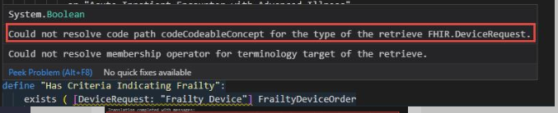

in the cql-to-elm compiler, it throws the same:

