1) Get the patient ophthal-patient-example-0 (Fhir) into FORUM

- Conversion of the FHIR Resource into HL7 (Patient creation) message.

MSH|^~\&|HIS|KIS|||201111281006||ADT^A01|376867|P|2.4|EVN|A01|201111281006|||2745|PID|||02134005^^^http://fhir.medisoft.com~ophthal-patient-example-0^^^||Bill^Eve^^^||19581224|F|||31 Pacquola Street^8272365^Blacktown^NSW^2148^Australia||0475551524|||M||||||||||DEU||PV1||I|OPTHAL^Room57^Bed3^HospID||||ATTDocCode|REFDocCode|||||||||||123456|||||||||||||||||||||||||200401140958||

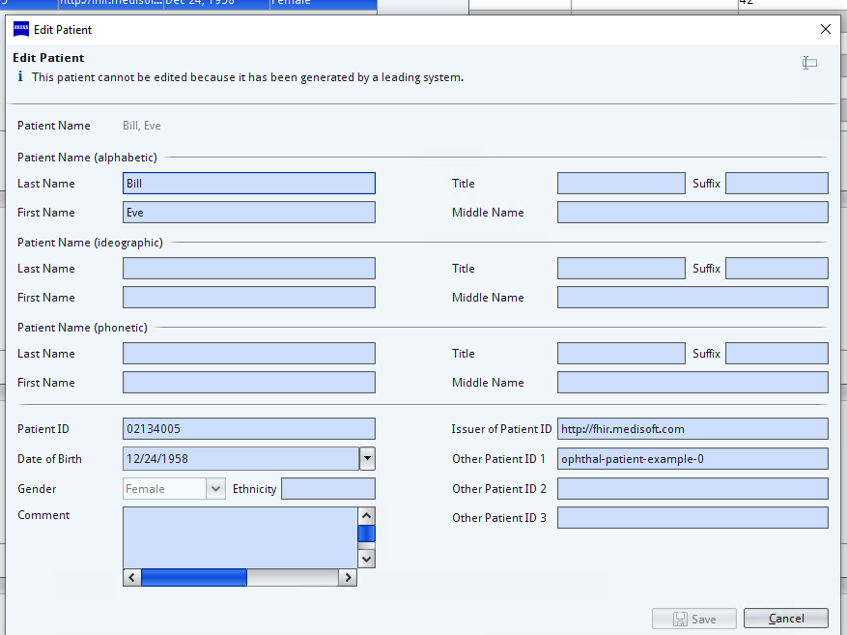

2) Create Order for Tonometer on FORUM

3) Create Acquisition on Tonometer



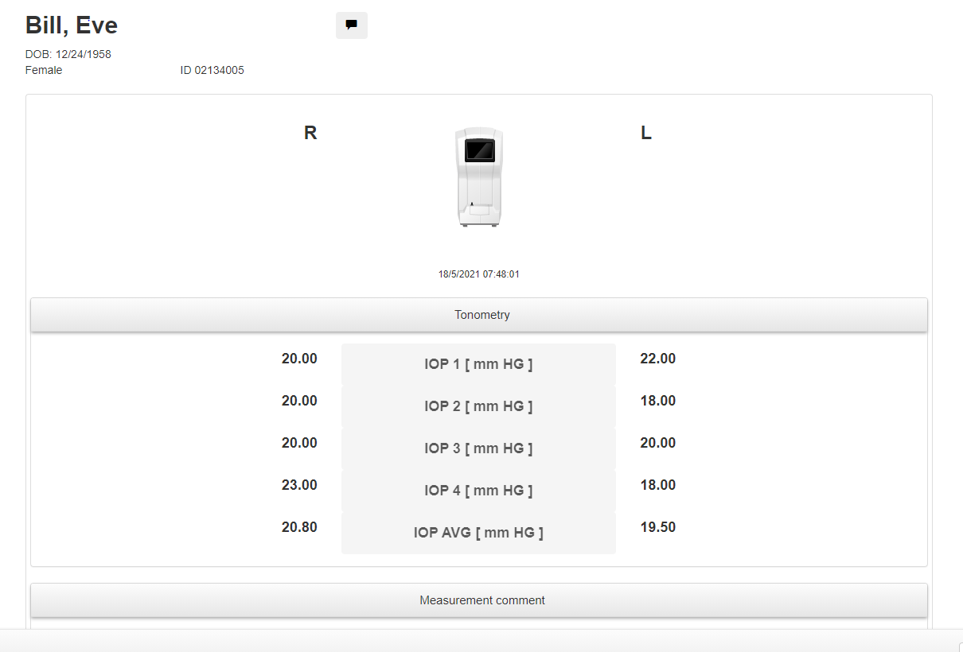

On Forum: Data received on FORUM

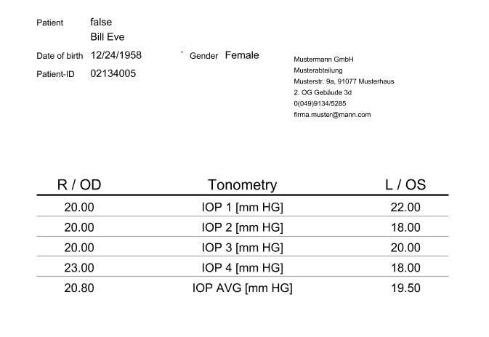

Store IOP Values in FHIR Observation Resourse