FHIR Shorthand

Mark Kramer and Chris Moesel

Sept. 17, 2019

# What is FHIR Shorthand (FSH)?

**FSH (“fish”) is an author-friendly specification for profiling FHIR using a domain-specific language (DSL) to define profiles, extensions, invariants, value sets, examples, search parameters, ......**, paired with a reference implementation of an interpreter/compiler that creates FHIR content ready for the FHIR IG Publisher.

# Why is it needed?

**To better support complex clinical modeling/profiling projects and effectively integrate across projects**.

1. The FHIR community needs scalable, fast, and user-friendly tools for IG creation and maintenance. Profiling projects are difficult and slow, and the resulting IG quality is inconsistent.
2. As a user-facing format, SDs are complex and unwieldy.
3. Available tools (Forge, Trifolia-on-FHIR, Excel spreadsheets) improve this situation. These tools share certain characteristics:
   1. Although the tools provide a friendlier interface, the user must still understand many SD details.
   2. The tools are not particularly agile when it comes to refactoring. Cross-cutting revisions happen all the time in non-trivial profiling projects.
   3. Source code control system (SCCS) features such as differentials and merging changes are not well supported. Excel files cannot be effectively diff’ed, and the other tools can be managed in SCCS only as SDs.
4. It can be difficult make sense of the Profile pages in IGs (see [this example fr­om the September 2019 ballot](https://lightmyfhir.org/2019/09/09/fhir-implementation-guide-presentation/)). FSH compiles to SD, but FSH itself is clearer and more compact and could represent the snapshot and differential.
5. Many years of experience has proven that creating and maintaining complex software projects is best approached with textual languages. As a DSL designed for the job of profiling, FSH is concise, understandable, and aligned to user intentions.
6. FSH is ideal for SCCS, with meaningful differentials, support for merging and conflict resolution, and refactoring through global search/replace operations. These features allow FSH to scale in ways that visual editors and spreadsheets cannot.
7. FSH will provide an easy path to migrate forward and backward between FHIR versions.

# Benefits of FSH

* Agile -- rapid refactoring and revision cycles
* Readable and easy to understand
* Makes the author’s intent clear
* Reduces implementation errors
* Enforces consistency in SDs (compiling FSH into SD using consistent patterns)
* Provides meaningful differentials in SCCS
* Enables merging at the statement/line-level in SCCS
* Supports distributed development under SCCS
* Any text editor can be used to modify an FSH file, but editing environments can provide text colorization, look-ahead syntax, go-to-definition, etc.

# After FSH is authored, then what?

* User runs a FSH compiler (aka SUSHI ("Sushi Unshortens ShortHand Inputs"))
* Syntactic and logical errors will be flagged at “compile time”
* FSH will be translated automatically into SDs that could populate an IG
* Formats such as Mind Maps, “Java doc” and data dictionaries can be generated from FSH
* Profiles created in FSH and the FSH itself can be released and used by other projects

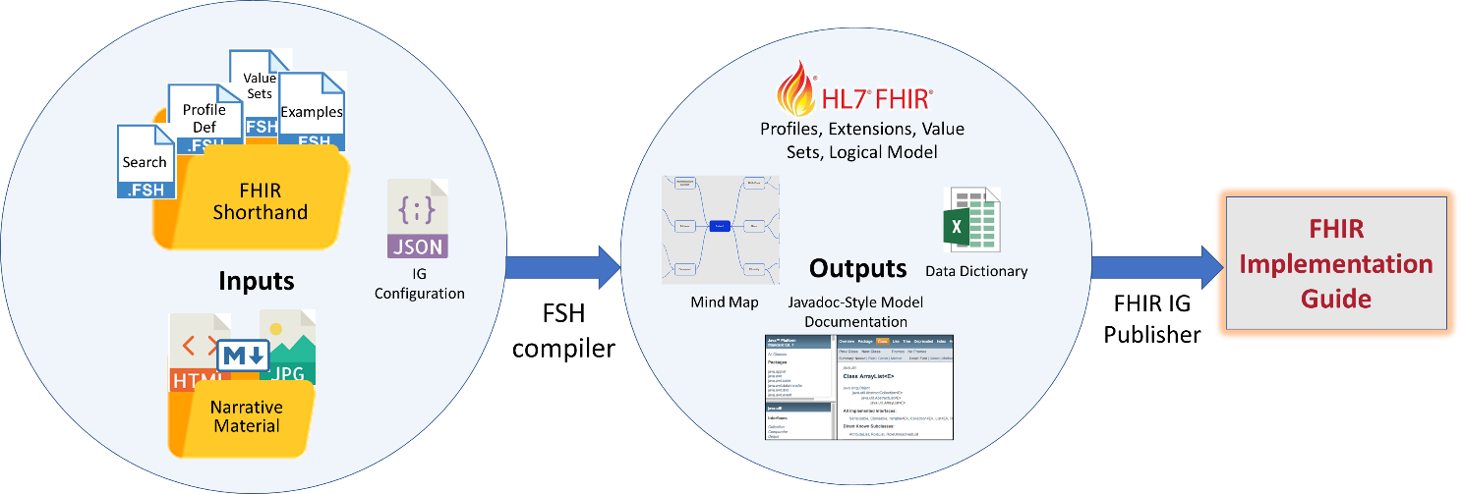

# Why should FSH be standardized?

* Although FSH does not provide a new capability, it plays a role similar to Clinical Quality Language (CQL), a user-friendly interface on Expression Logical Model (ELM), the underlying machine-exchangeable format
* Standardization will build a community of users
* Promotes sharing of profiles in readable form
* Provides an exchange format between profiling tools
* Sharing of tools built to FSH (such as exporters to Mind Maps, “Java doc” and data dictionaries)

# What might FSH look like?

The syntax below is roughly based on grammar developed in the [CIMPL project](http://standardhealthrecord.org/cimpl-doc/). This code would be in one or more text files (multiple instances/profiles/extensions in one file is legal). Color highlighting is provided by a Visual Studio Code plug-in. Explanatory comments are presented in Java style (//).

## Instances (for IG Examples, SearchParameters, OperationDefinitions):

Instance:   EveAnyperson

InstanceOf: http://hl7.org/fhir/us/mcode/StructureDefinition/obf-Patient

Title:      "Eve Anyperson"

* name[0].family = Anyperson

* name[0].given[0] = Eve

* birthDate = 1960-04-25

* us-core-race.ombCategory.valueCoding = RACE#2106-3 "White"

* us-core-ethnicity.ombCategory.valueCoding = RACE#21865 "Non Hispanic or Latino"

Instance:   DrDavidAnydoc

InstanceOf: http://hl7.org/fhir/us/core/StructureDefinition/us-core-practitioner

Title:      "Dr. David Anydoc"

* name[0].family = Anydoc

* name[0].given[0] = David

* name[0].suffix[0] = MD

* identifier[npislice].value = 8274017284

Instance:   PrimaryCancerDiagnosis

InstanceOf: http://hl7.org/fhir/us/mcode/StructureDefinition/onco-core-PrimaryCancerCondition

Title:      "Primary Cancer Diagnosis"

* subject = EveAnyperson

* clinicalStatus = #active

* verificationStatus = #confirmed

* category = CCAT#problem-list-item

* asserter = DrDavidAnydoc

* condition-assertedDate.valueDateTime = 2019-09-13T12:30:00.0Z

* onco-core-HistologyMorphologyBehavior-extension.valueCodeableConcept = SCT#35917007 "Adenocarcinoma, no subtype"

* code = SCT#93864006 "Primary malignant neoplasm of lower lobe of left lung"

## Profiles:

// Assume vitals are a green field, for purposes of example

Profile:    VitalSignParent

Id:         vital-sign-parent

Parent:     Observation  // corresponds to SD baseDefinition and/or type

Title:      "Parent for all vital sign profiles."

Definition: "Sets minimum expectations to record vital signs."

// constraints:

* value[x] only Quantity

* category 1..1

* category = #vital-signs

* hasMember 0..0

+ PreconditionCode 0..*  // No precondition **code** in observation

// Alternate (more explicit) syntax that might work better w/ nested elements:

* extension[PreconditionCode] 0..*

Profile:    BodyWeight

Parent:     VitalSignParent

Title:      "Body Weight Vital Sign"

Definition: "The mass or heaviness of the individual."

* code = LNC#29463-7 "Body weight"

* valueQuantity units from http://example.com/VS/kg-lb-stone-VS(required)

* method from BodyWeightMethodVS (extensible)

* PreconditionCode from BodyWeightPreconditionVS (extensible)

* bodySite 0..0

* component 0..0

Profile:    USBodyWeight

Parent:     BodyWeight

Title:      "Body weight in pounds (lbs)"

* valueQuantity units = 'lb_av'

### “Implements” Keyword: (addresses the [Deadly Diamond of Death](https://en.wikipedia.org/wiki/Multiple_inheritance))

Profile:    USColonCancerCondition

Parent:     ColonCancerCondition

Implements: USCoreCondition

## Extensions:

Extension:  PreconditionCode

Title:      "The circumstance of an observation."

Definition: "Conditions or context of an observation."

* value[x] only CodeableConcept

## Slicing in Profiles:

Profile:    BloodPressure

Parent:     VitalSign

Definition: "Records blood pressure measurements."

* code = LNC#85354-9 "Blood pressure panel with all children optional"

* value 0..0

* method from BloodPressureMethodVS (extensible)

* bodySite from http://example.com/VS/bp-body-location (extensible)

* PreconditionCode from CardiopulmonaryPreconditionVS (extensible)

* component discriminates by value at code.coding.code and code.coding.system

* component.slice[SystolicBP] 1..1

* component.slice[DiastolicBP] 1..1

// If we can intuit the discriminator from the slices since they both are

// fixed to unique codes? Then you need only the slice statements...

* component includes SystolicBP 1..1

* component includes DiastolicBP 1..1

Slice:      SystolicBP

Slices:     Observation.component

Definition: "The blood pressure during left ventricle contraction."

* code = LNC#8480-6 "Systolic blood pressure"

* value[x] only Quantity

* valueQuantity units = UCUM#mm[Hg] "mmHg"

## Invariants:

Invariant:  USCoreNameInvariant

Id:         us-core-8

Definition: "Patient.name.given  or Patient.name.family or both SHALL be present"

Expression: "family.exists() or given.exists()"

XPath:      "f:given or f:family"

... declaring the Invariant in the profile...

* name constrained by USCoreNameInvariant

## Value Sets:

// Extensional

ValueSet:    BodyWeightPreconditionVS

Title:       "Body weight preconditions."

Definition:  "Circumstances for body weight measurement."

SCT#971000205103 "Wearing street clothes with shoes"

SCT#961000205106 "Wearing street clothes, no shoes"

SCT#951000205108 "Wearing underwear or less"

// Intensional

ValueSet:       PrimaryCancerDisorderVS

Description:    "Types of primary malignant neoplastic disease."

SCT#363346000  "Malignant neoplastic disease (disorder)"

* include descendent-of SCT#363346000 "Malignant neoplastic disease (disorder)"

* exclude descendent-of SCT#128462008 "Secondary malignant neoplastic disease"